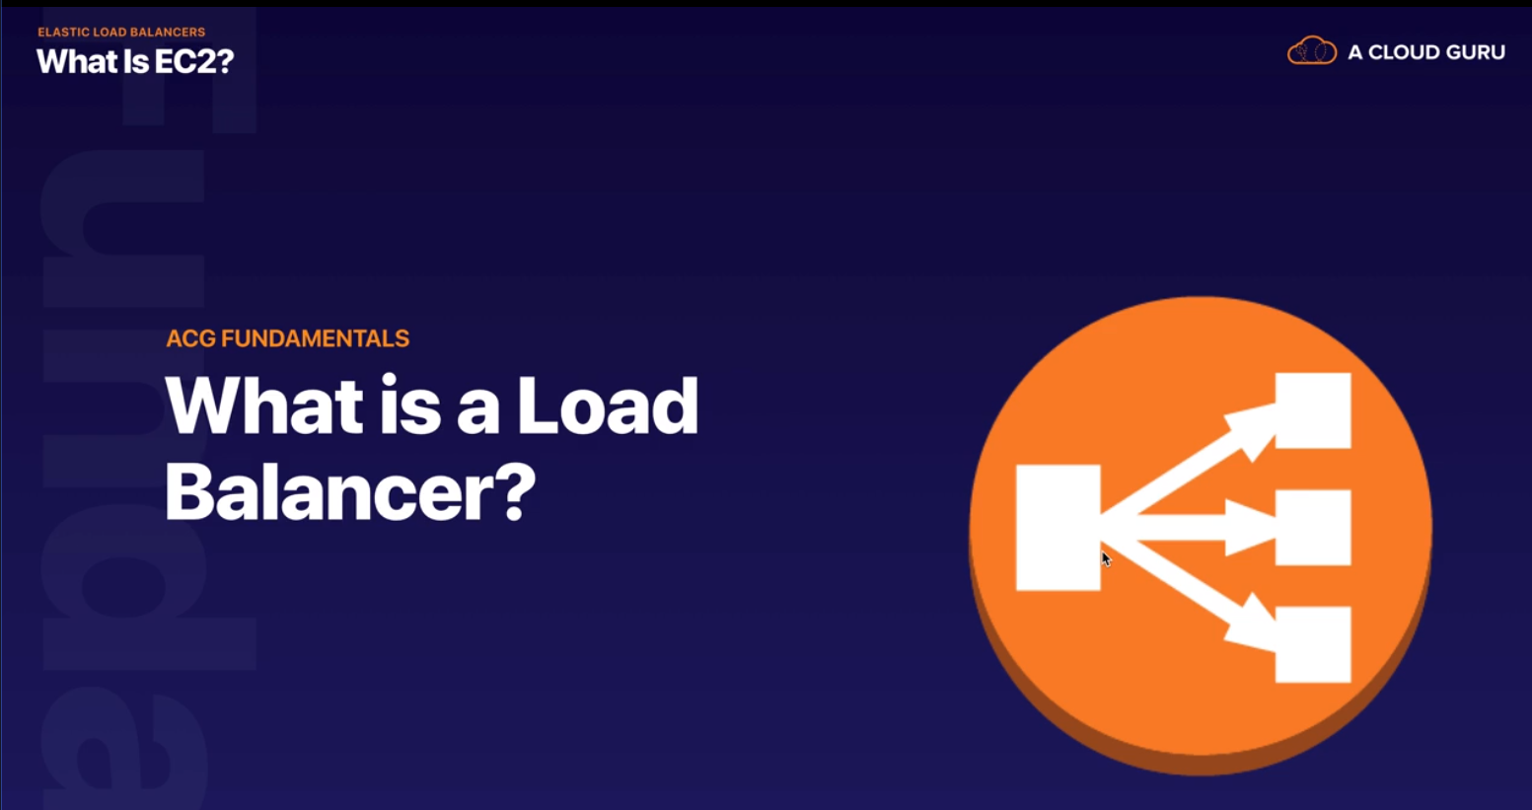

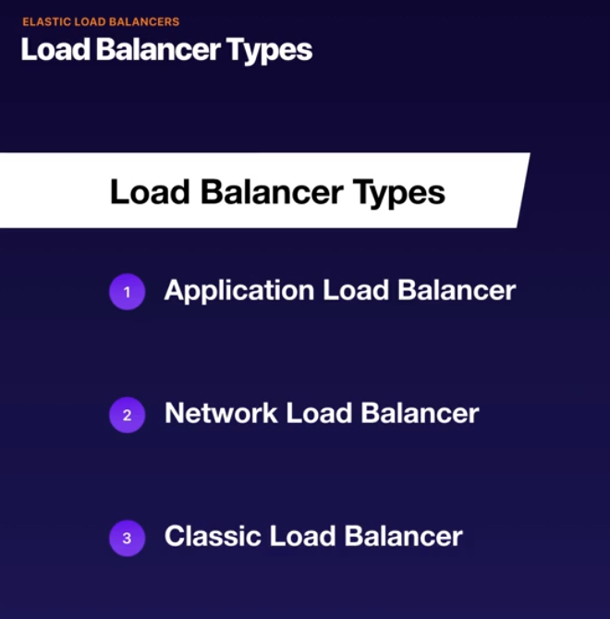

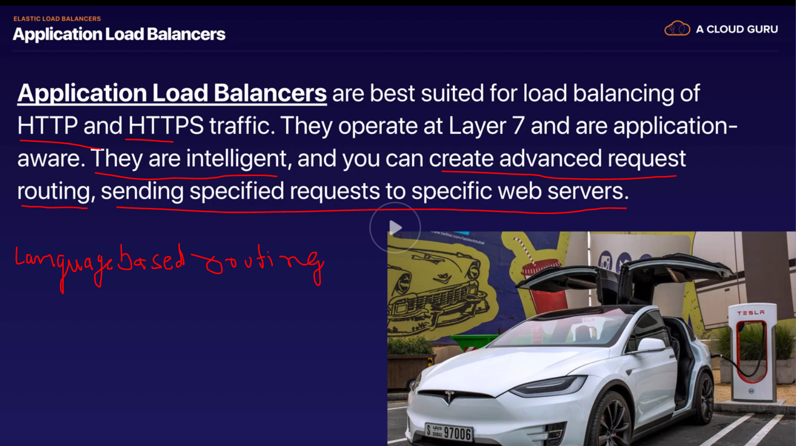

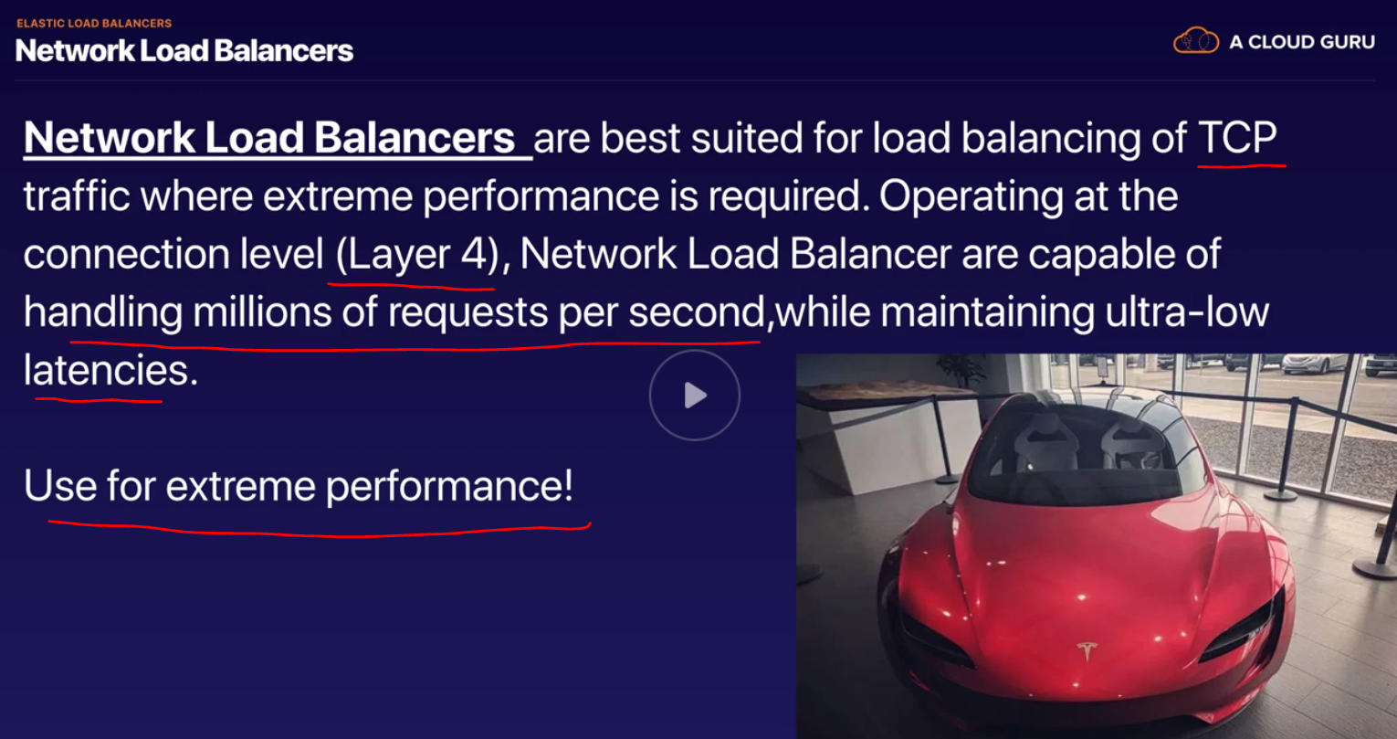

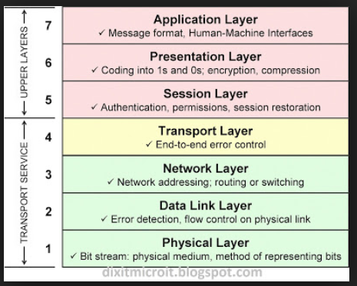

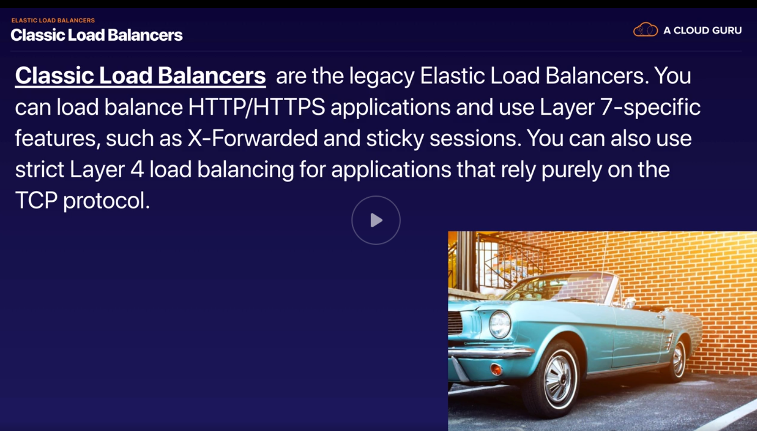

* Basic round robbin pattern
* Classic load balancer is cheaper

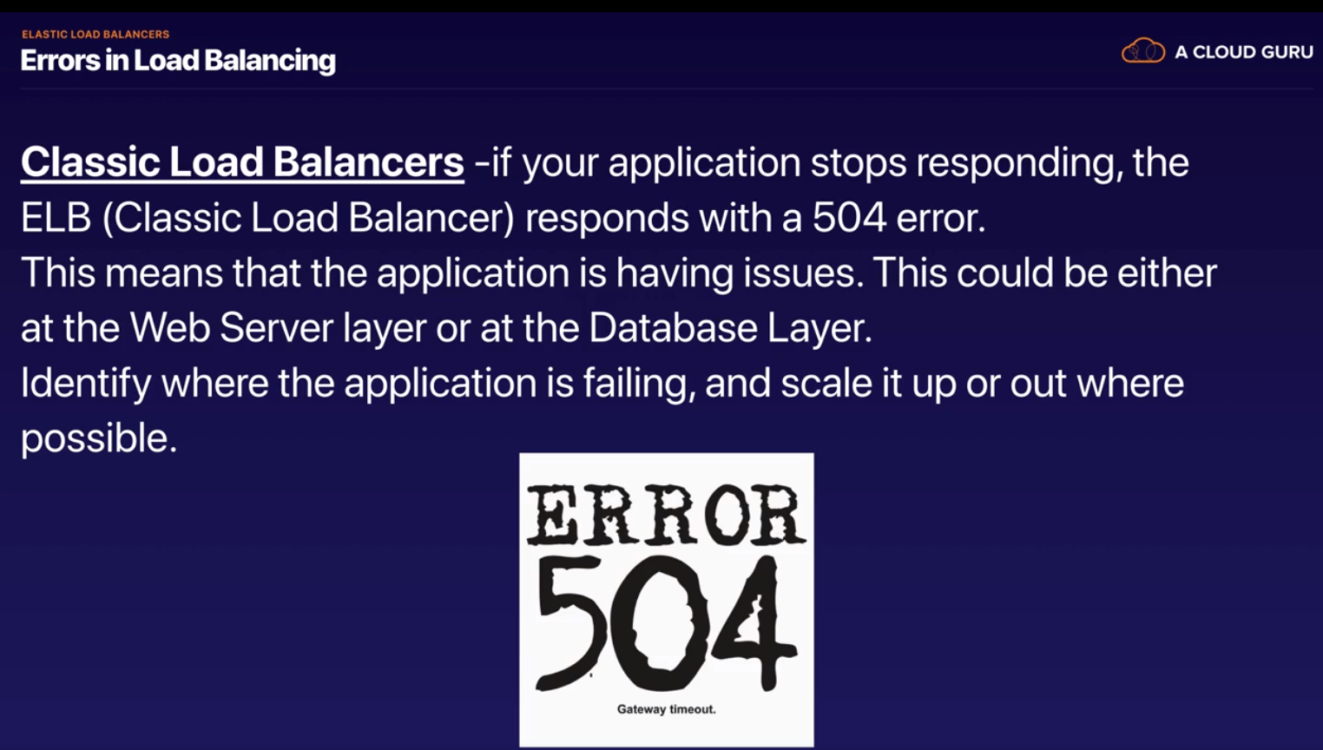

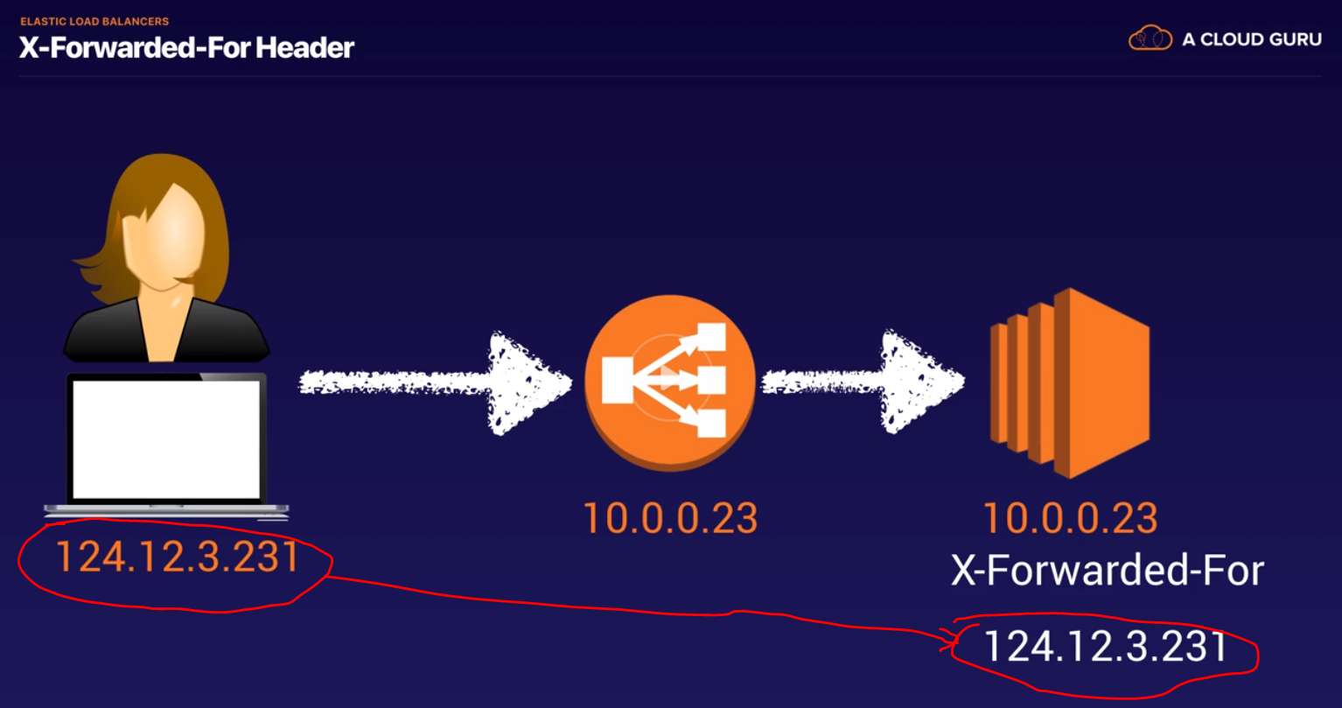

The **X-Forwarded-For** (XFF) header is a de-facto standard header for identifying the originating IP address of a client connecting to a web server through an HTTP proxy or a load balancer. When traffic is intercepted between clients and servers, server access logs contain the IP address of the proxy or load balancer only. To see the original IP address of the client, the X-Forwarded-For request header is used.

This header is used for debugging, statistics, and generating location-dependent content and by design it exposes privacy sensitive information, such as the IP address of the client. Therefore the user's privacy must be kept in mind when deploying this header.

A standardized version of this header is the HTTP [Forwarded](https://developer.mozilla.org/en-US/docs/Web/HTTP/Headers/Forwarded) header.

X-Forwarded-For is also an email-header indicating that an email-message was forwarded from another account.

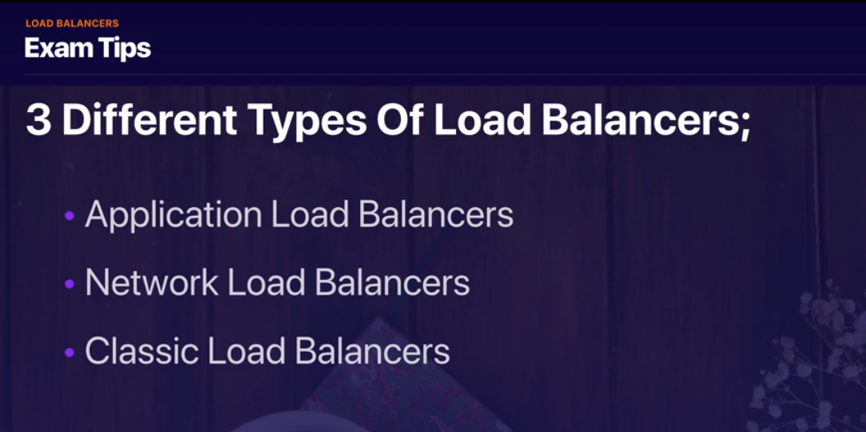

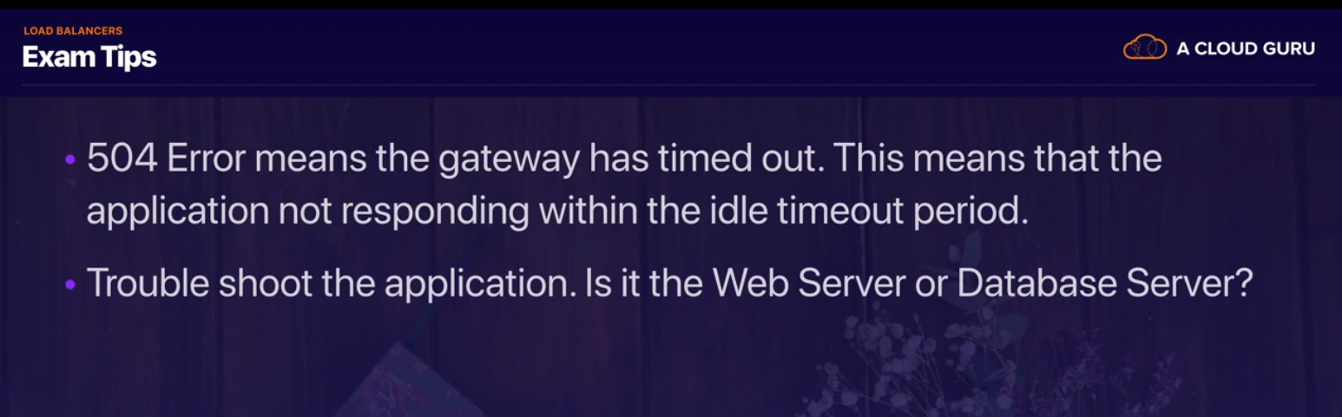



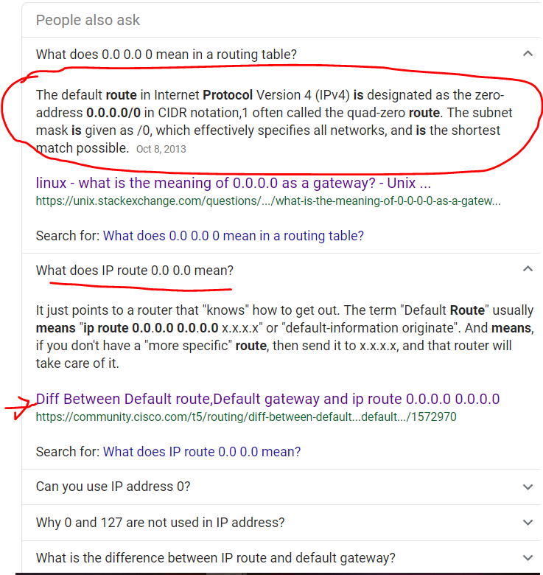

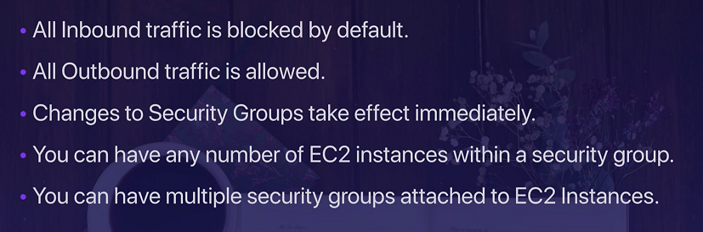

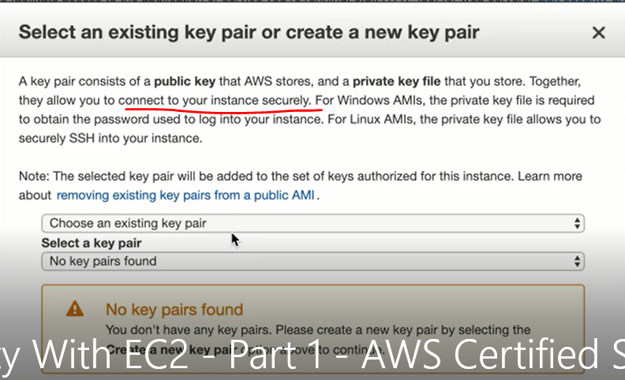



Create 2 EC2 instances under default VPC and 2 different public subnet2 with below boot strap script

#!/bin/bash

yum update -y

yum install httpd -y

service httpd start

chkconfig httpd on

cd /var/www/html

echo "<html><h1>This is WebServer 01</h1></html>" > index.html

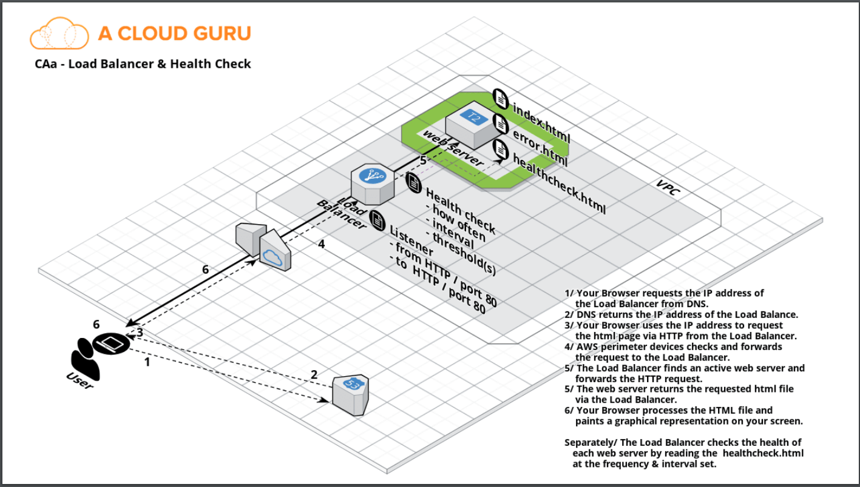

<https://docs.aws.amazon.com/elasticloadbalancing/latest/classic/elb-backend-instances.html>

<https://docs.aws.amazon.com/elasticloadbalancing/latest/userguide/what-is-load-balancing.html>

<https://aws.amazon.com/elasticloadbalancing/features/#compare>

Load balancer comes from free tier, but if you forget deleting it it might cost

LETS CREATE 2 EC2 instances and name it web-01 and web-02

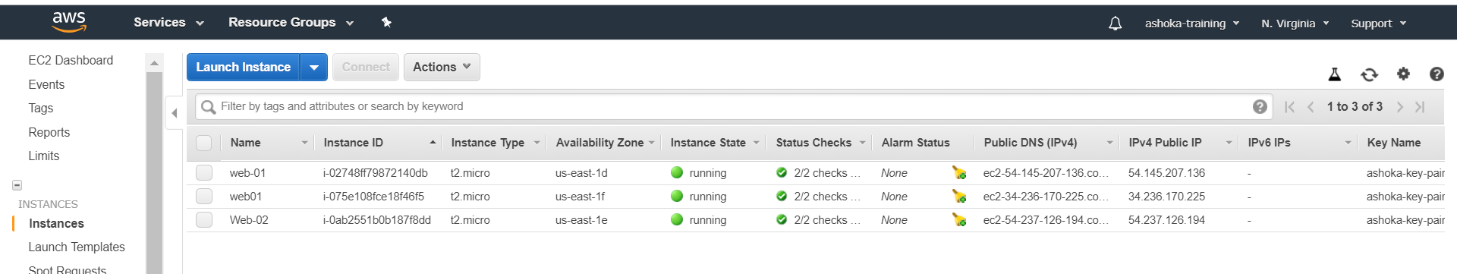

With the bootstrap script we can hit the sites

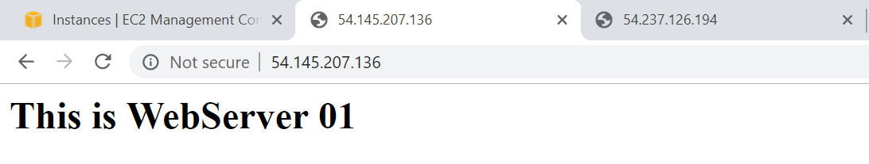

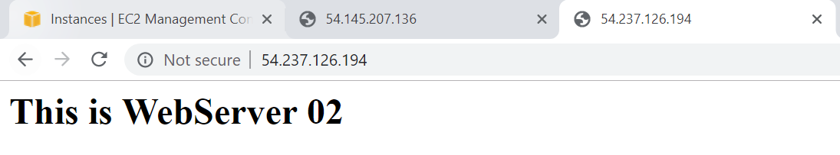

Lets create Classic load balancer

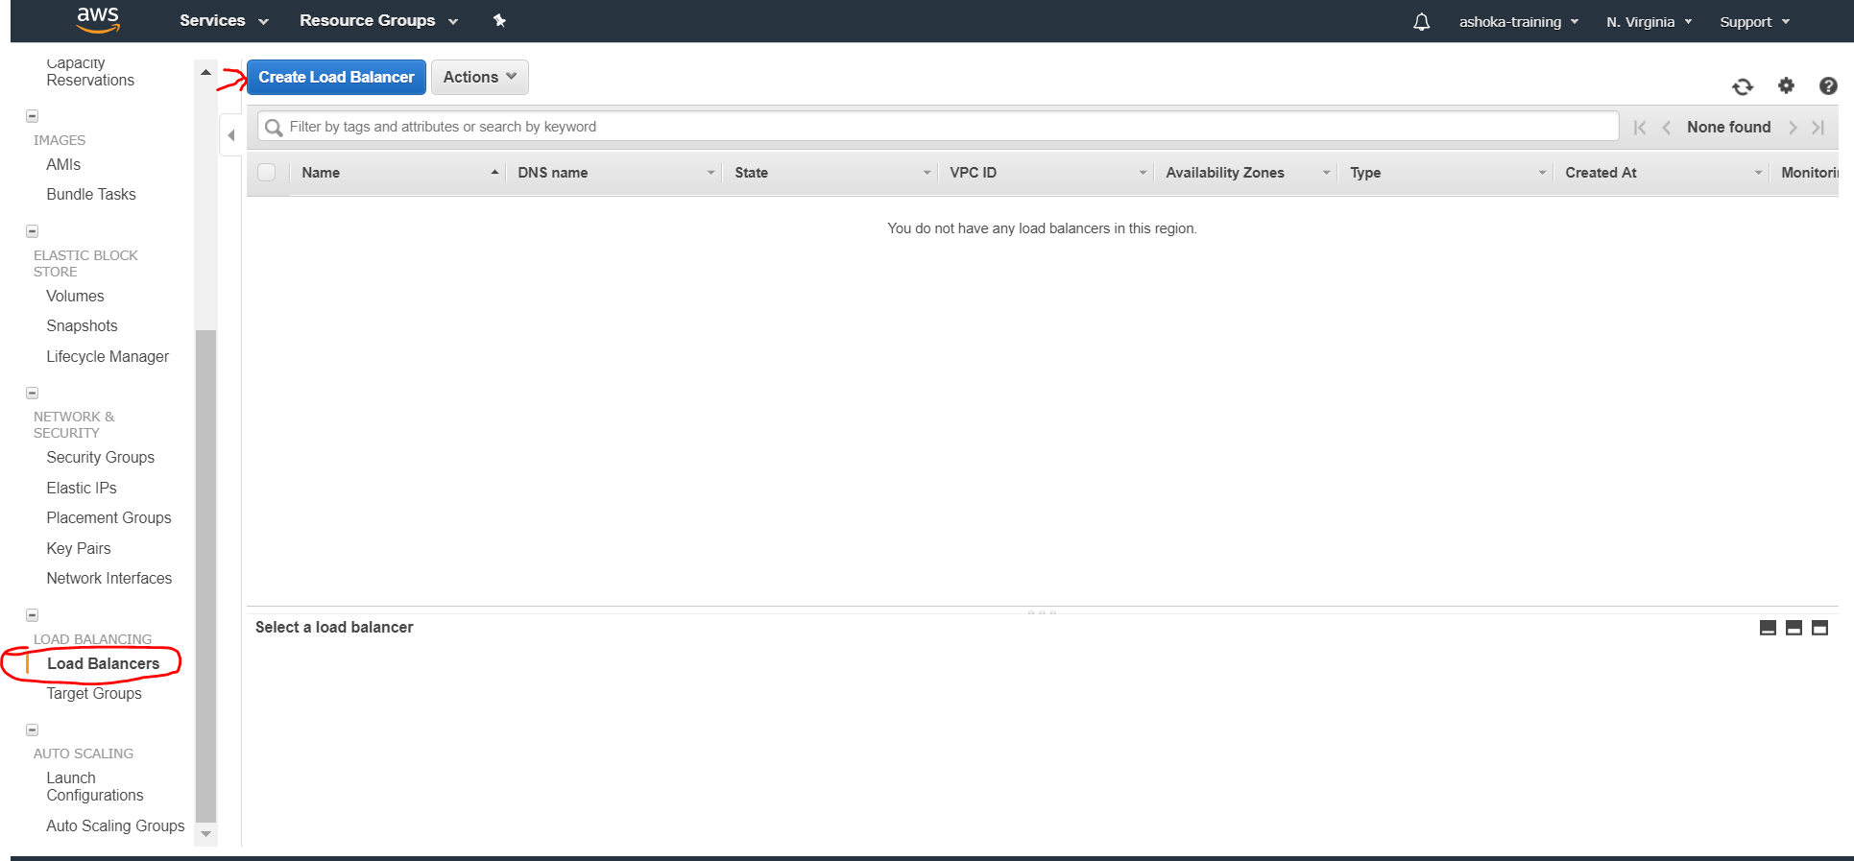

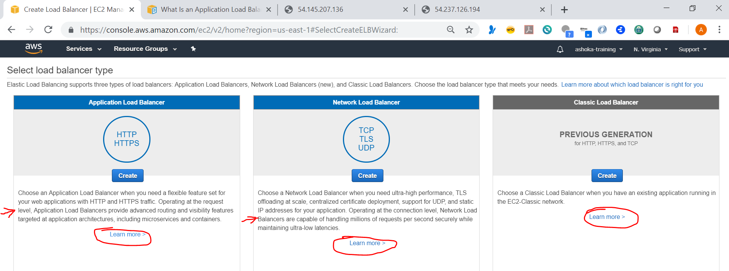

<https://docs.aws.amazon.com/elasticloadbalancing/latest/application/introduction.html>

<https://docs.aws.amazon.com/elasticloadbalancing/latest/network/introduction.html>

<https://docs.aws.amazon.com/elasticloadbalancing/latest/classic/introduction.html>

**Benefits of Migrating from a Classic Load Balancer**

Using an Application Load Balancer instead of a Classic Load Balancer has the following benefits:

* Support for path-based routing. You can configure rules for your listener that forward requests based on the URL in the request. This enables you to structure your application as smaller services, and route requests to the correct service based on the content of the URL.
* Support for host-based routing. You can configure rules for your listener that forward requests based on the host field in the HTTP header. This enables you to route requests to multiple domains using a single load balancer.
* Support for routing based on fields in the request, such as standard and custom HTTP headers and methods, query parameters, and source IP addresses.
* Support for routing requests to multiple applications on a single EC2 instance. You can register each instance or IP address with the same target group using multiple ports.
* Support for redirecting requests from one URL to another.
* Support for returning a custom HTTP response.
* Support for registering targets by IP address, including targets outside the VPC for the load balancer.
* Support for registering Lambda functions as targets.
* Support for the load balancer to authenticate users of your applications through their corporate or social identities before routing requests.
* Support for containerized applications. Amazon Elastic Container Service (Amazon ECS) can select an unused port when scheduling a task and register the task with a target group using this port. This enables you to make efficient use of your clusters.
* Support for monitoring the health of each service independently, as health checks are defined at the target group level and many CloudWatch metrics are reported at the target group level. Attaching a target group to an Auto Scaling group enables you to scale each service dynamically based on demand.
* Access logs contain additional information and are stored in compressed format.
* Improved load balancer performance.

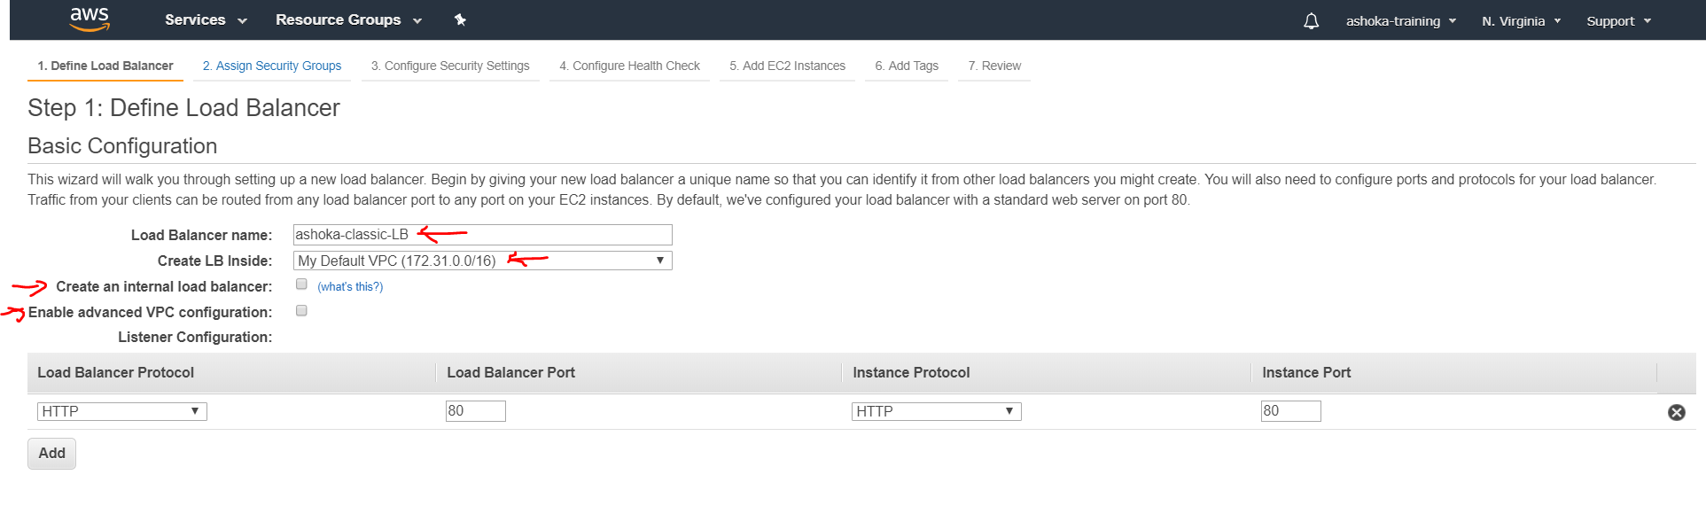

Create an internal load balancer option – Enable this for LB within private subnet

If you enable advanced VPC option it will provide option to deploy your LB into one or many of the subnets

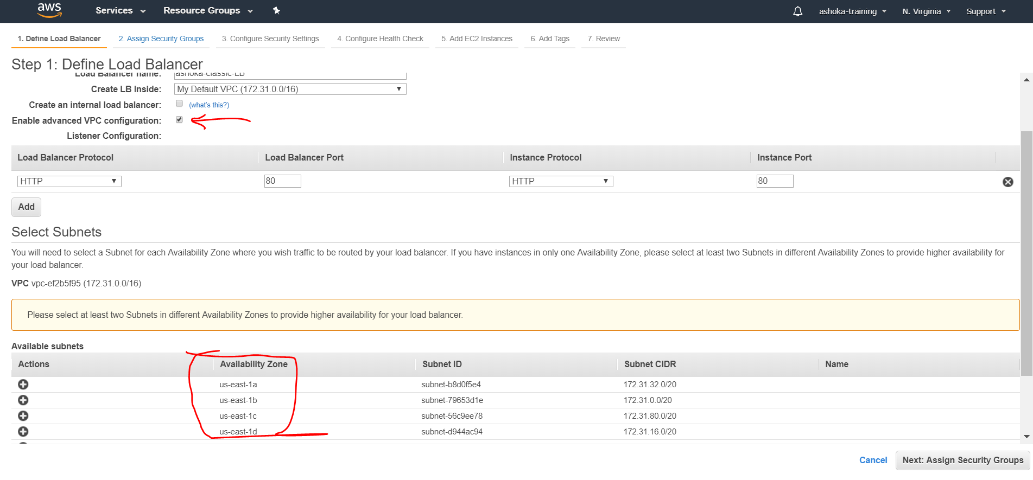

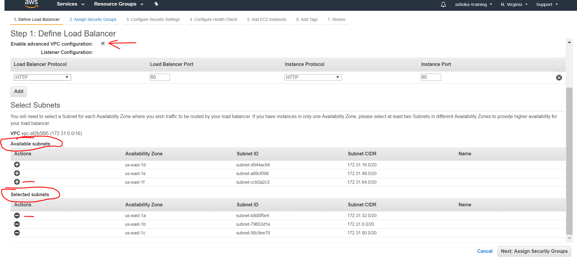

We are not going to use both options now

Move ahead and select security group

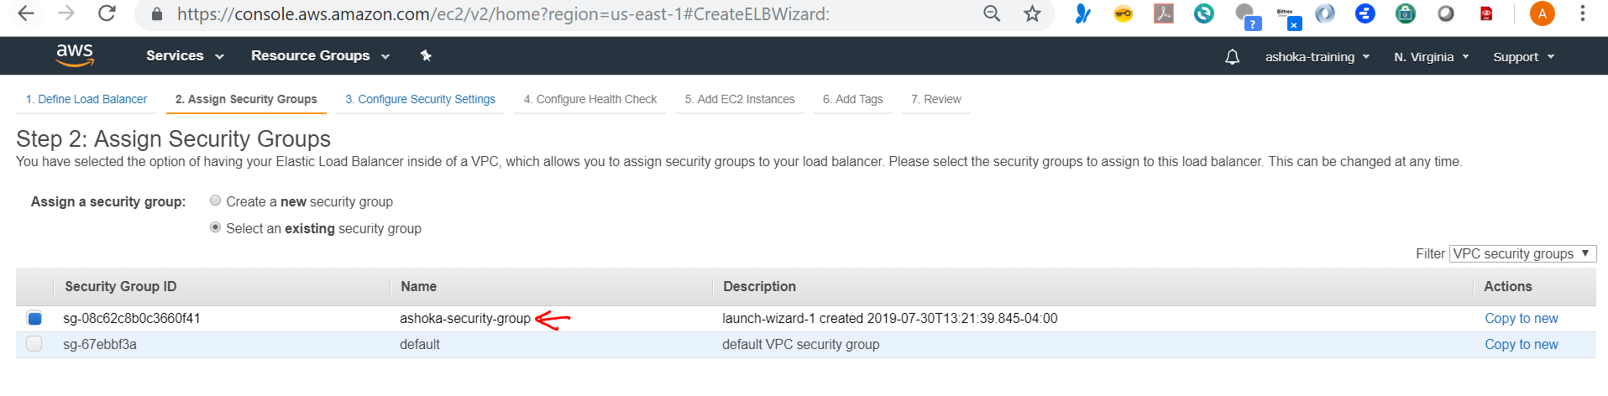

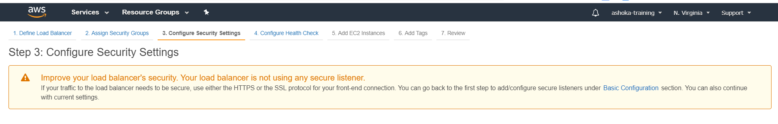

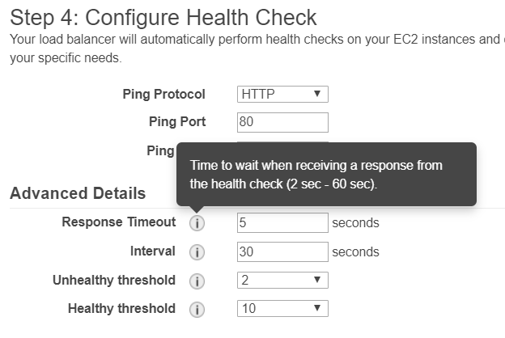 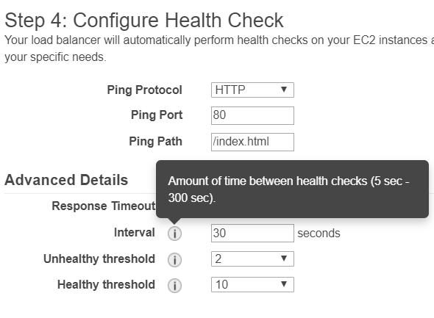

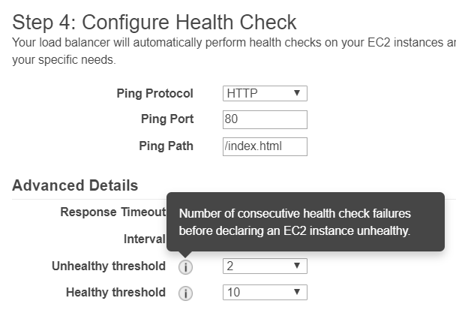 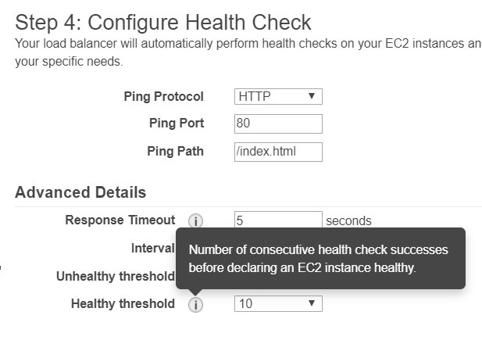

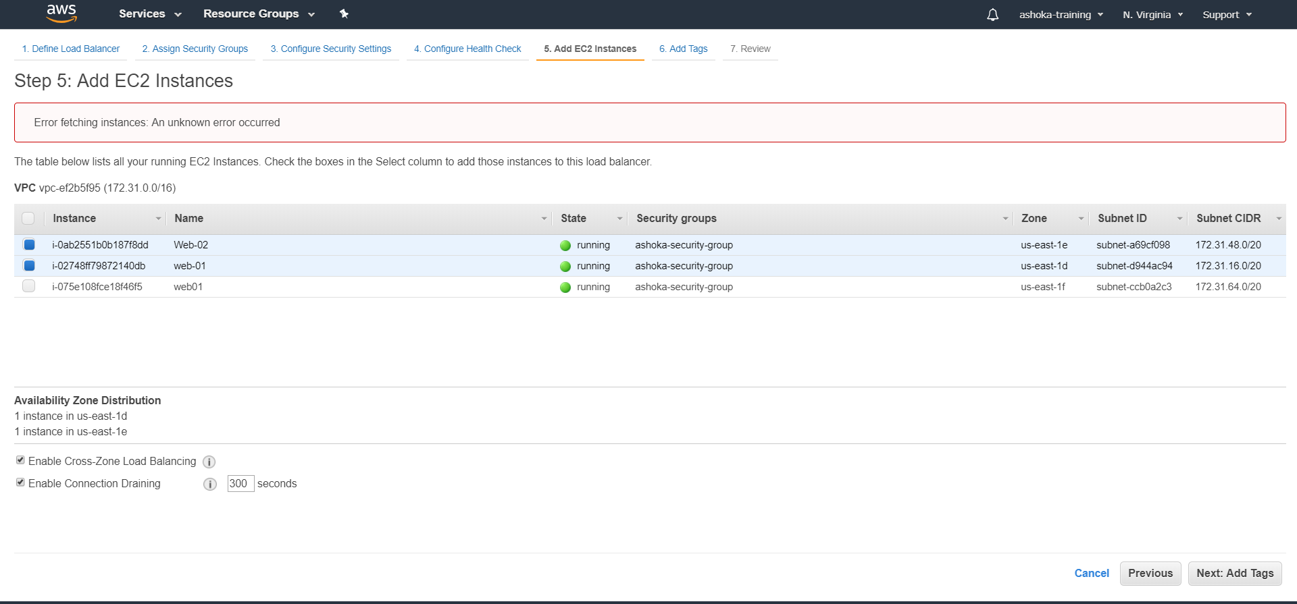

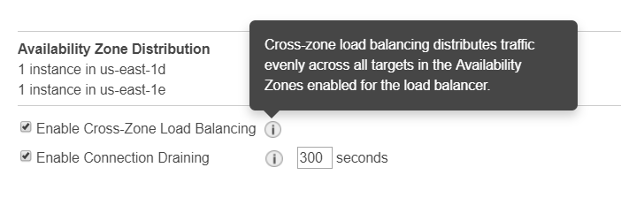 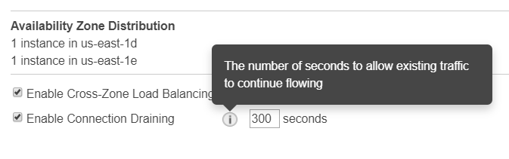

No tags

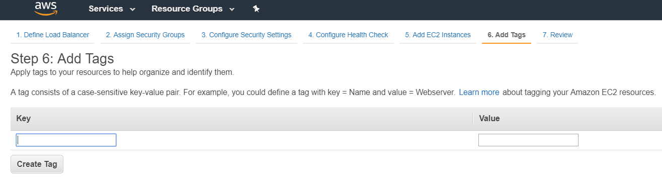

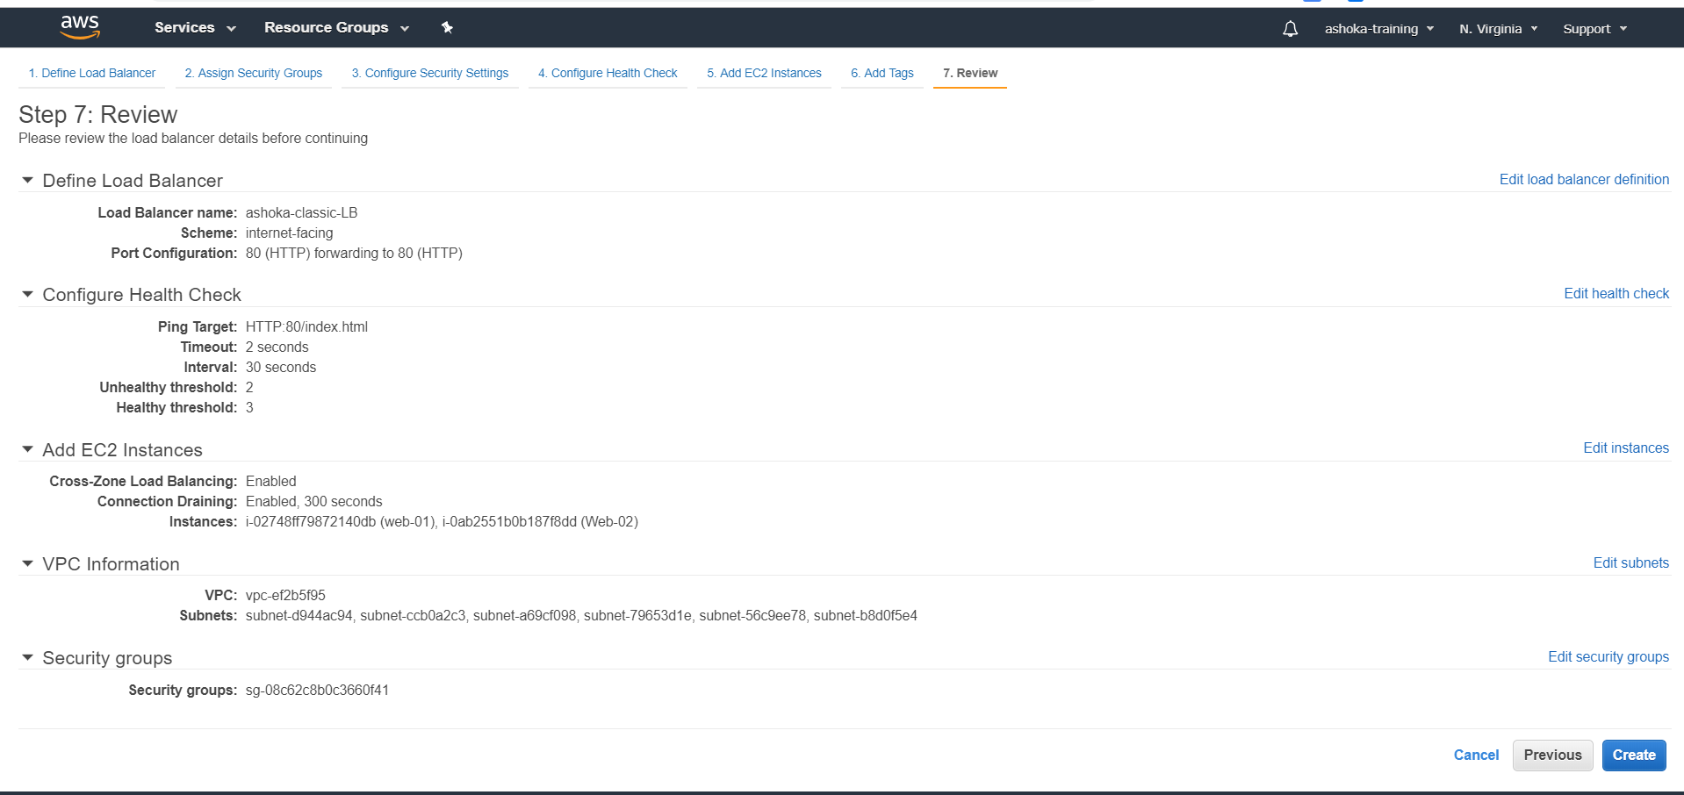

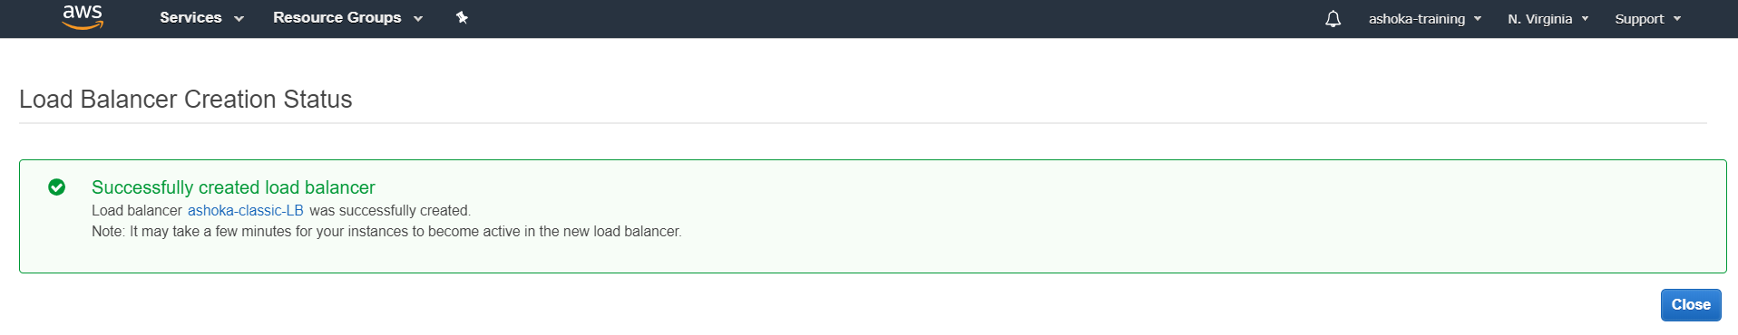

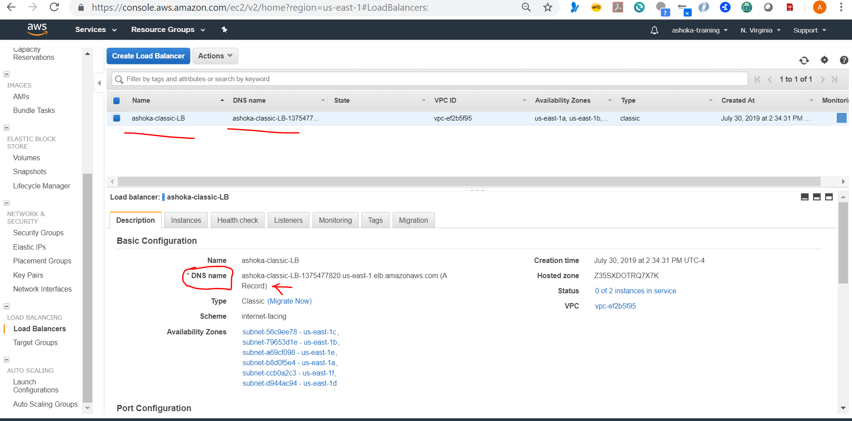

Note : No IP address provided for a load balancer

Now hit the dns name

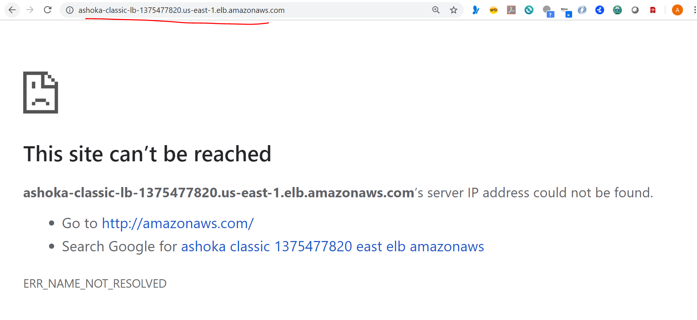

Its is not working because instances are out of service as shown below , wait for few minutes for it to come up

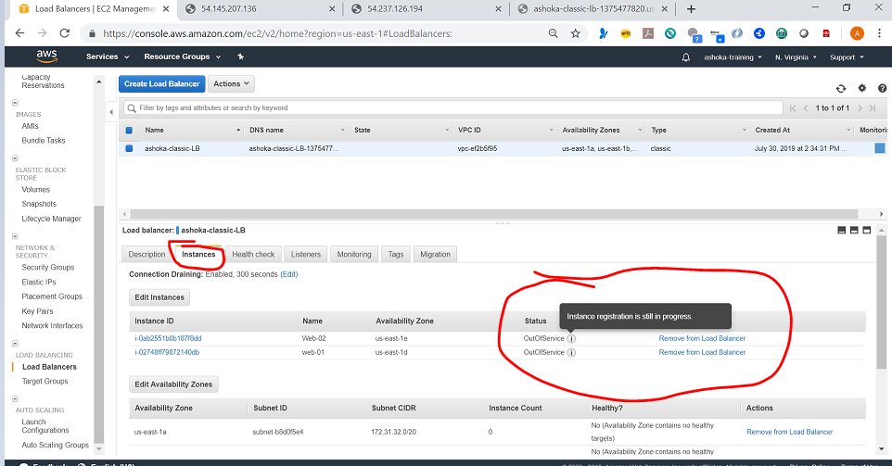

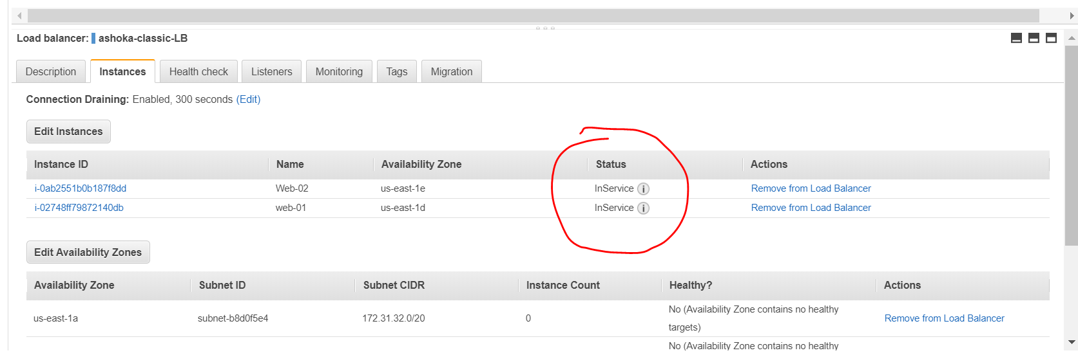

Now you can see the browser request randomly hit server1 or server2

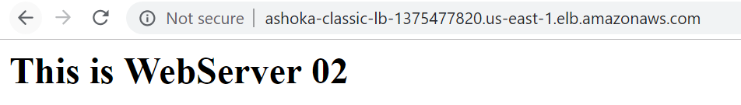

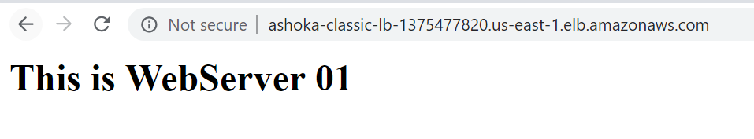next test is to stop one of the instances and see that browser hits only the one which is active

We can do monitoring with cloud watch

Basically this is dumb LB

Lets create Application LB with target groups

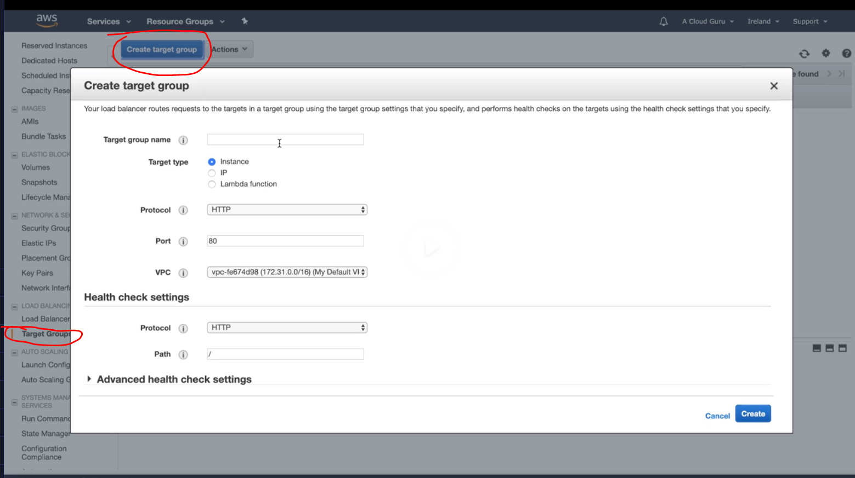

Add targets

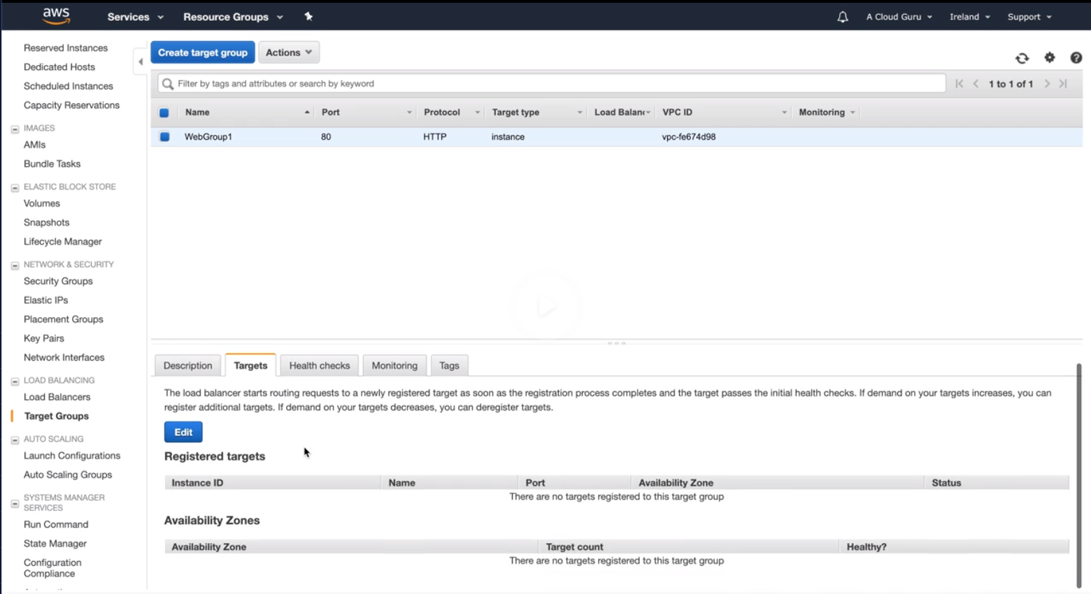

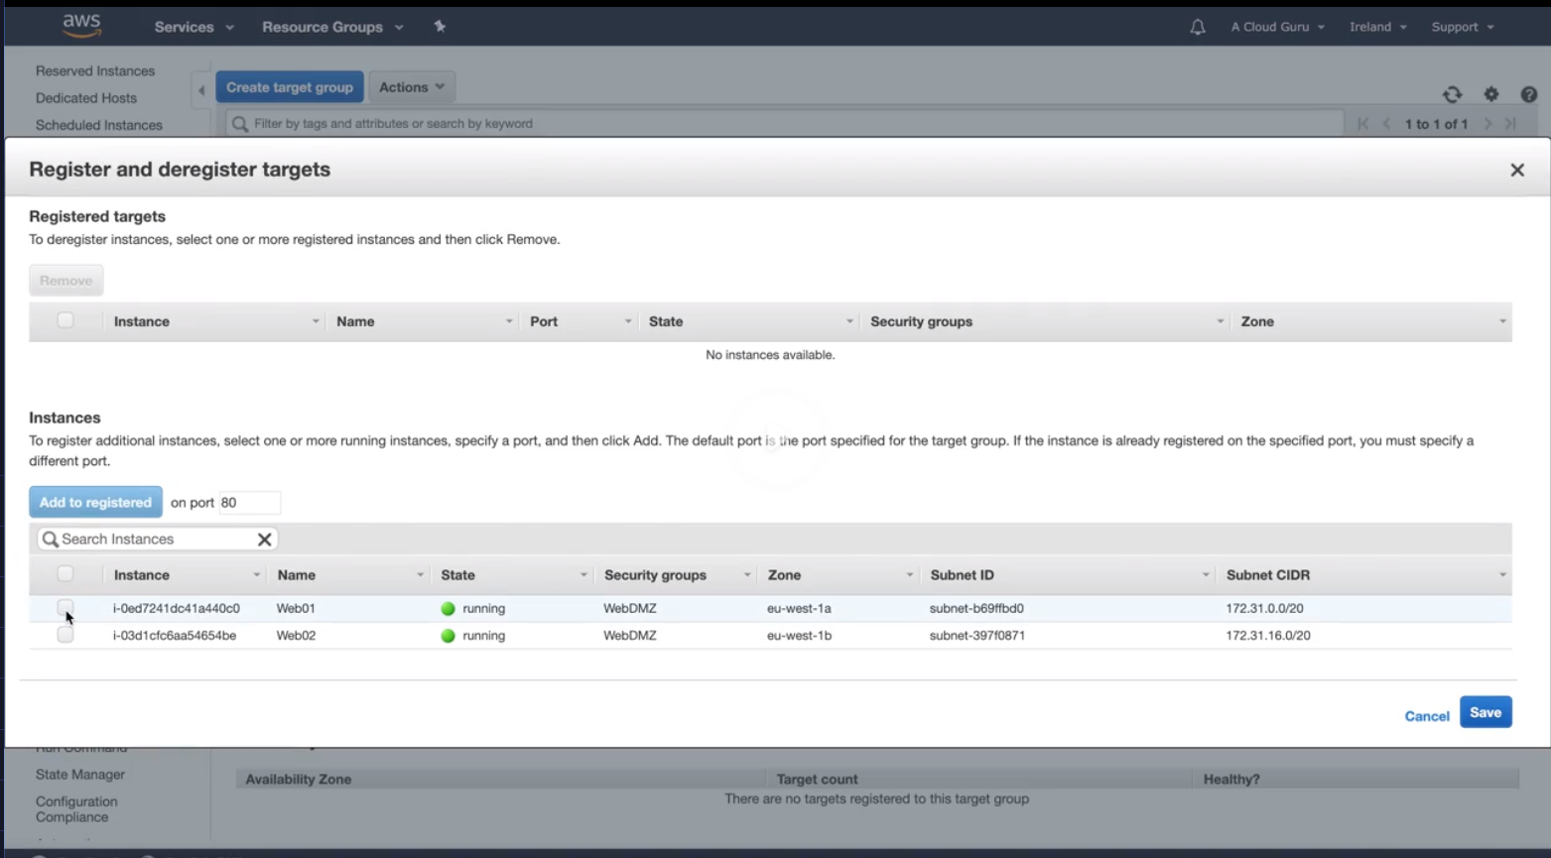

Next create LB

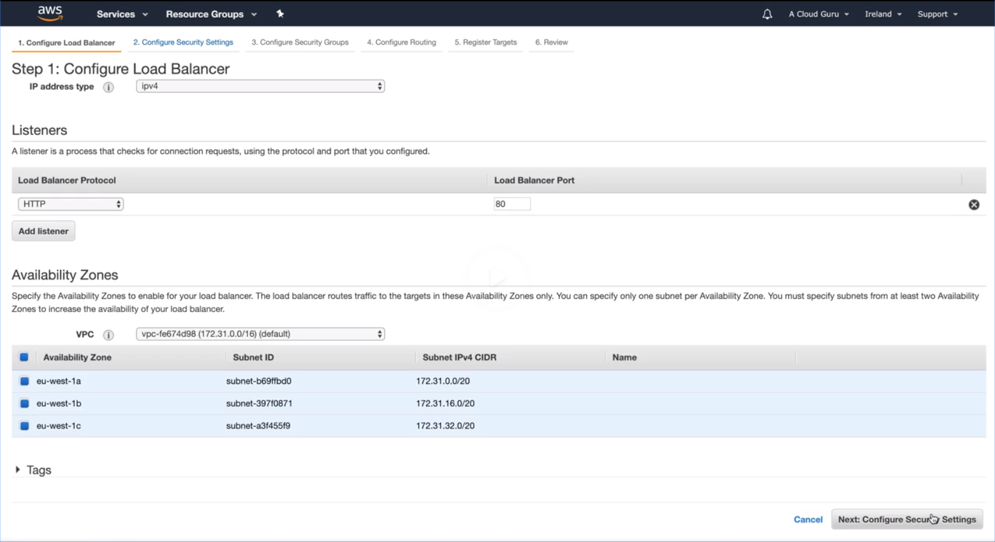

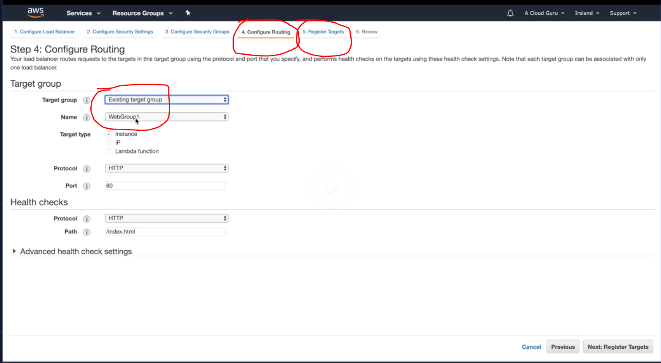

Observer : The above steps are different from classic load balancer

See below there are no targets yet , but lets go ahead and create the LB without targets and add it later

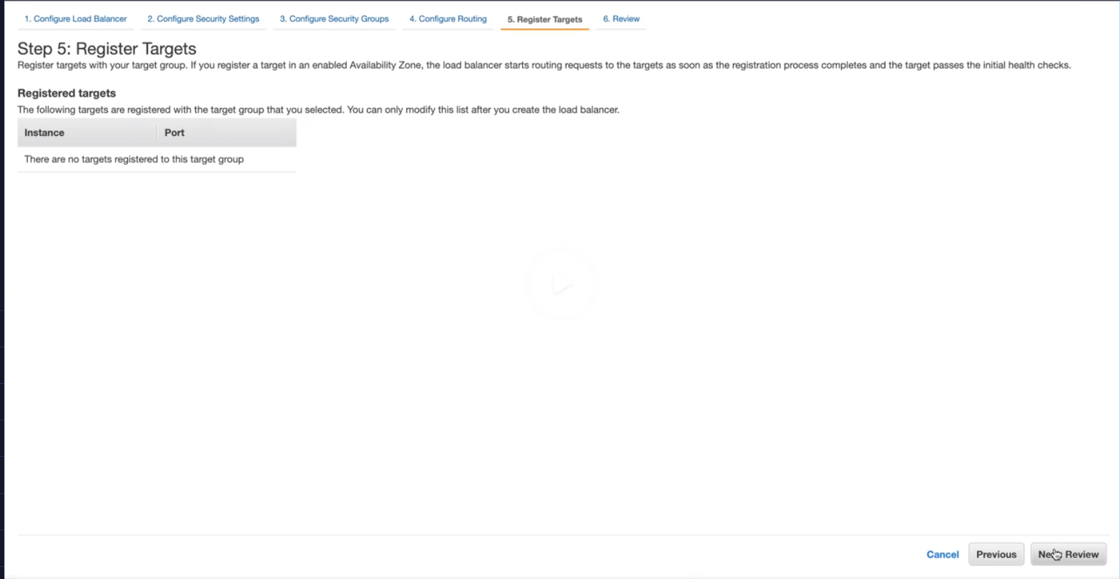

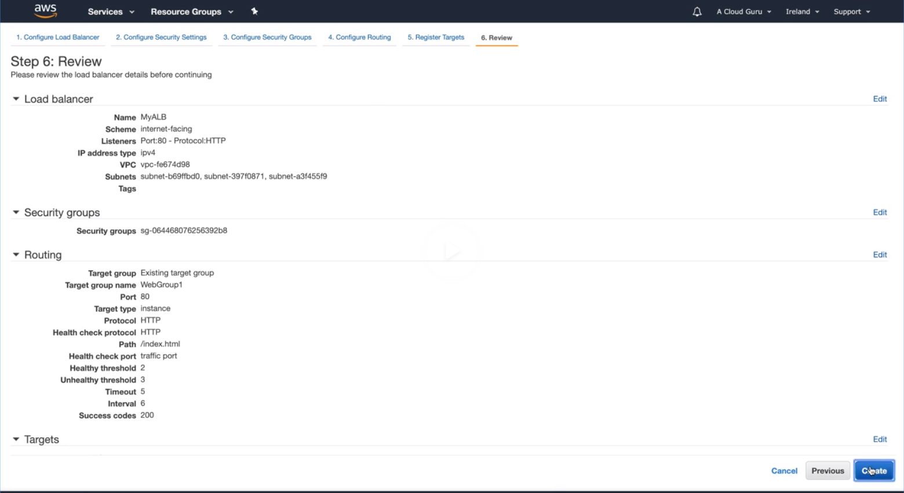

Now add the targets to LB also

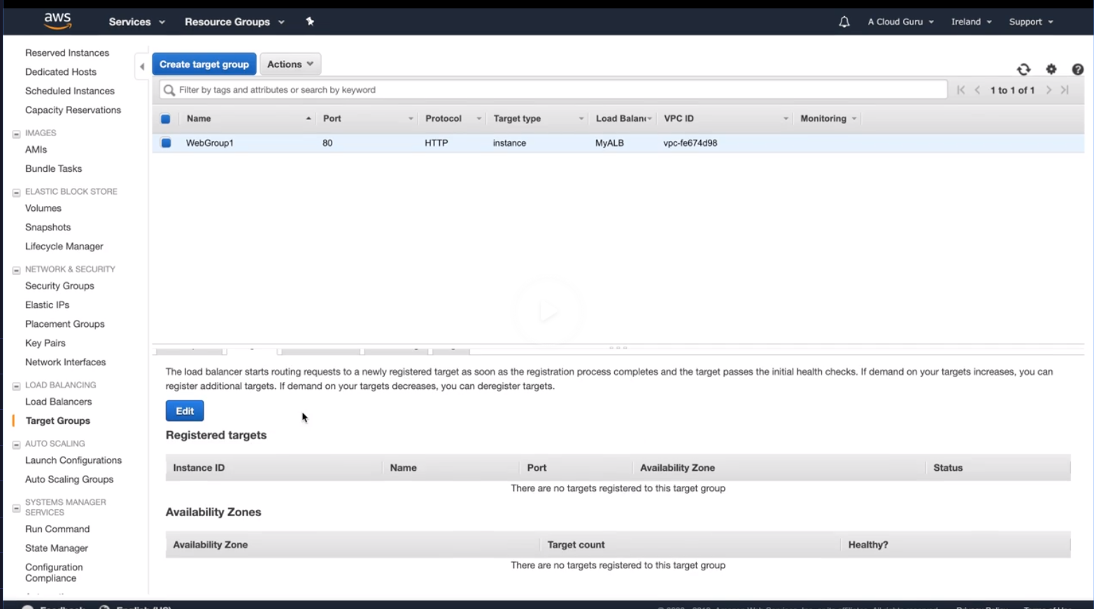

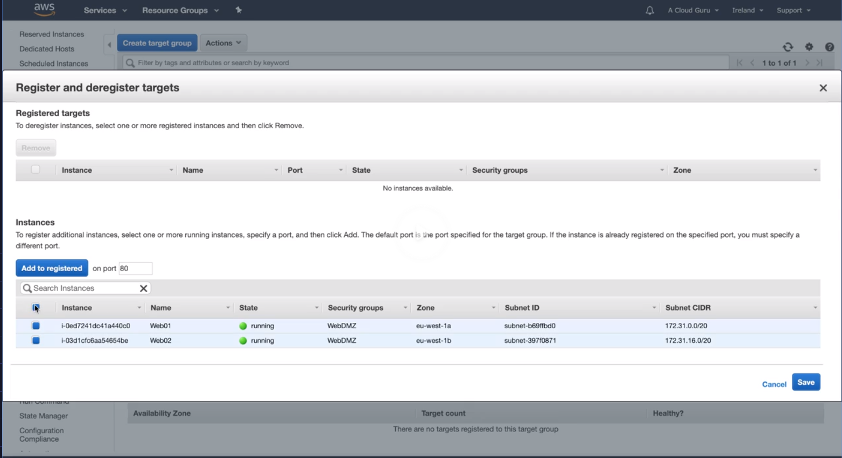

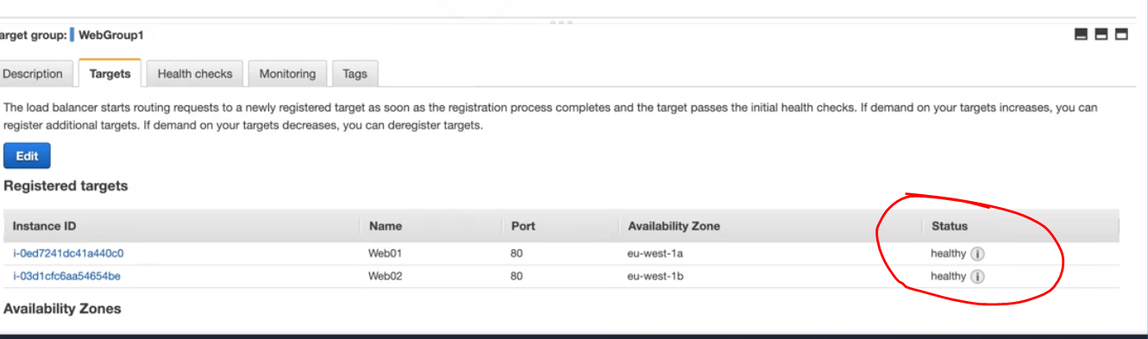

How it is intelligent than classic load balancer is because you can go and add rules to your listener

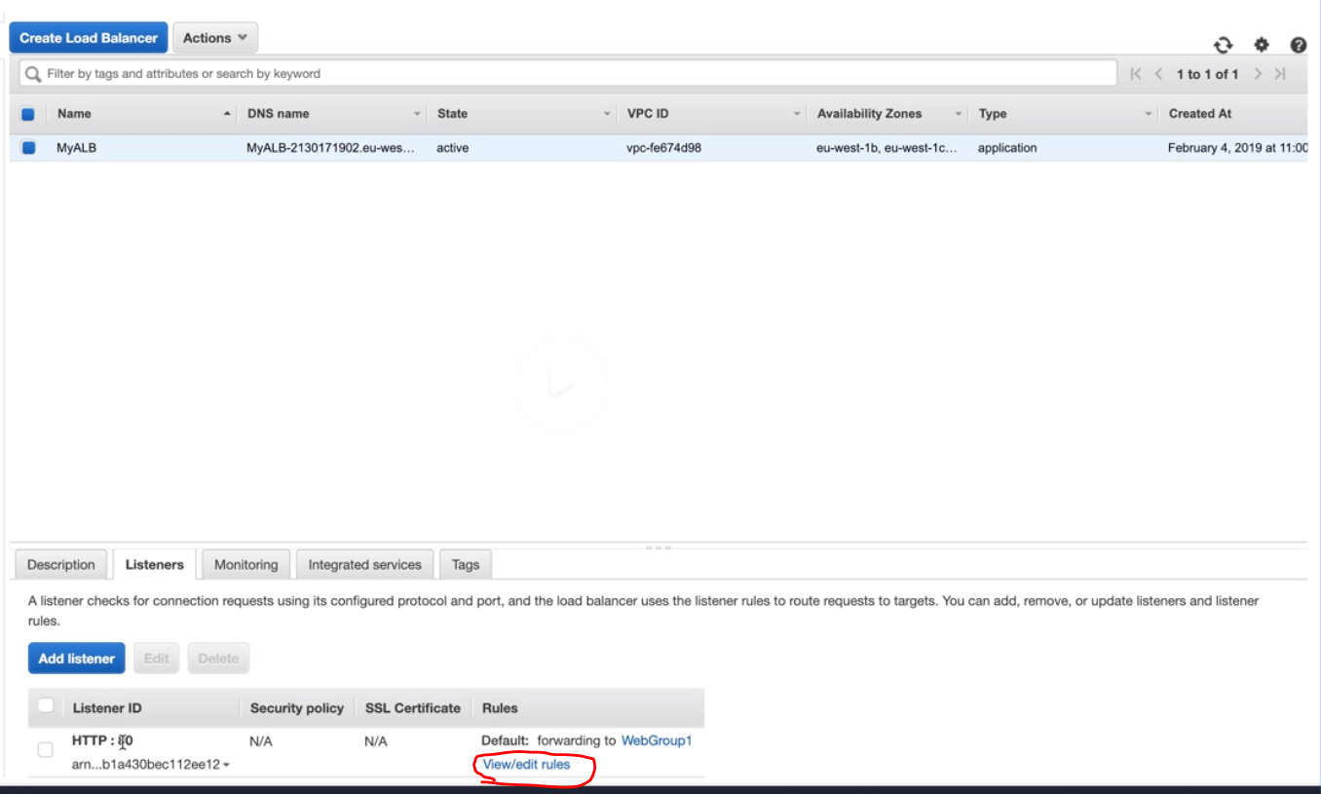

Application load balancers are intelligent a they can accommodate routing rules

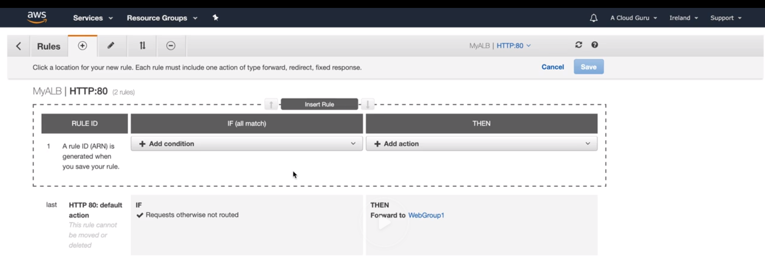

**Benefits of Migrating from a Classic Load Balancer**

Using an Application Load Balancer instead of a Classic Load Balancer has the following benefits:

* Support for path-based routing. You can configure rules for your listener that forward requests based on the URL in the request. This enables you to structure your application as smaller services, and route requests to the correct service based on the content of the URL.
* Support for host-based routing. You can configure rules for your listener that forward requests based on the host field in the HTTP header. This enables you to route requests to multiple domains using a single load balancer.
* Support for routing based on fields in the request, such as standard and custom HTTP headers and methods, query parameters, and source IP addresses.
* Support for routing requests to multiple applications on a single EC2 instance. You can register each instance or IP address with the same target group using multiple ports.
* Support for redirecting requests from one URL to another.
* Support for returning a custom HTTP response.
* Support for registering targets by IP address, including targets outside the VPC for the load balancer.
* Support for registering Lambda functions as targets.
* Support for the load balancer to authenticate users of your applications through their corporate or social identities before routing requests.
* Support for containerized applications. Amazon Elastic Container Service (Amazon ECS) can select an unused port when scheduling a task and register the task with a target group using this port. This enables you to make efficient use of your clusters.
* Support for monitoring the health of each service independently, as health checks are defined at the target group level and many CloudWatch metrics are reported at the target group level. Attaching a target group to an Auto Scaling group enables you to scale each service dynamically based on demand.
* Access logs contain additional information and are stored in compressed format.
* Improved load balancer performance.

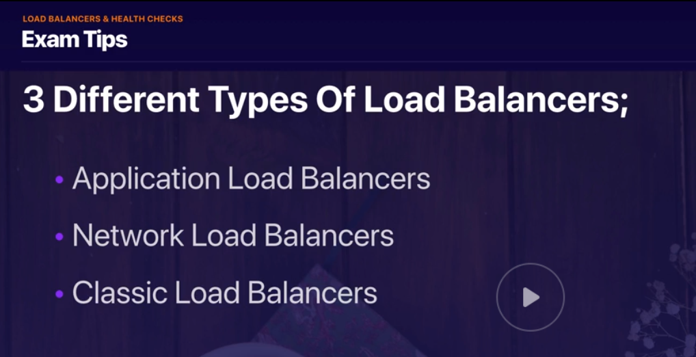

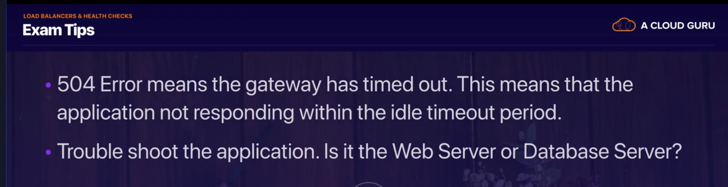



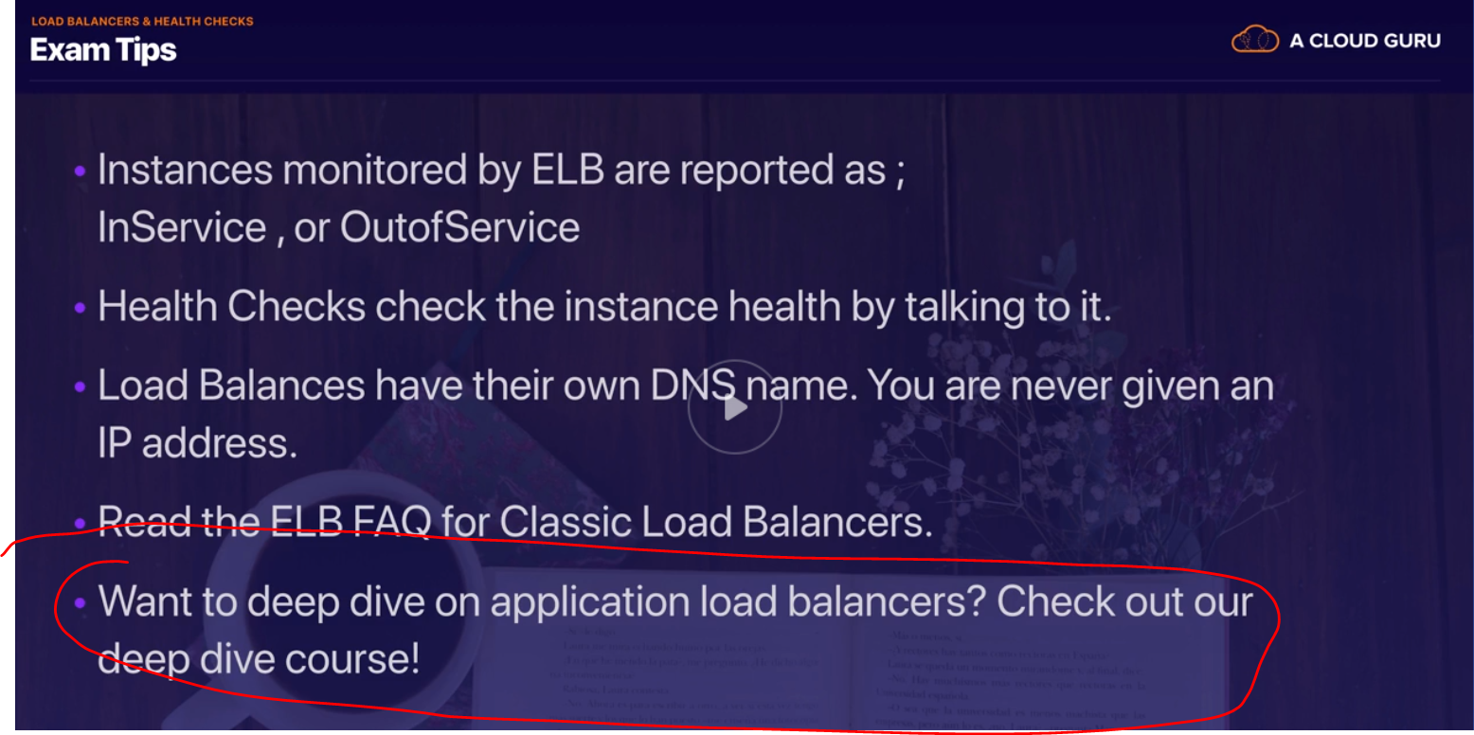

NOTE : At least 10 questions on load balancers in exam



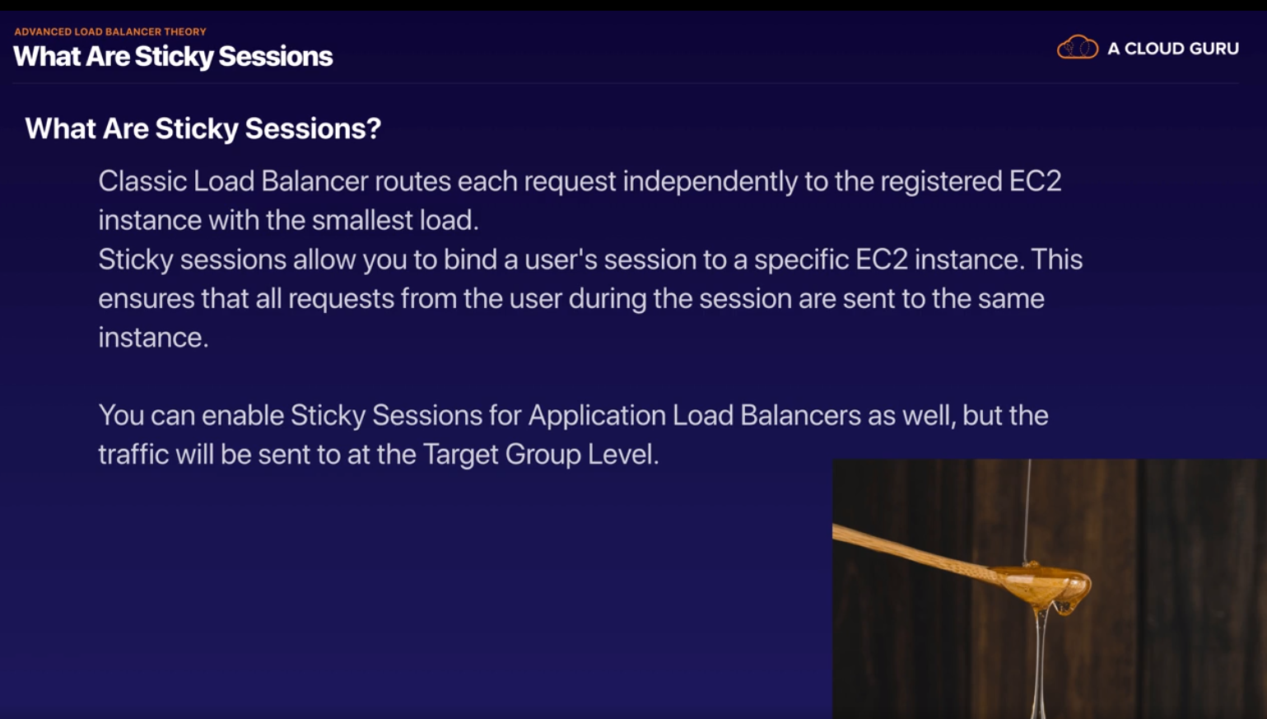

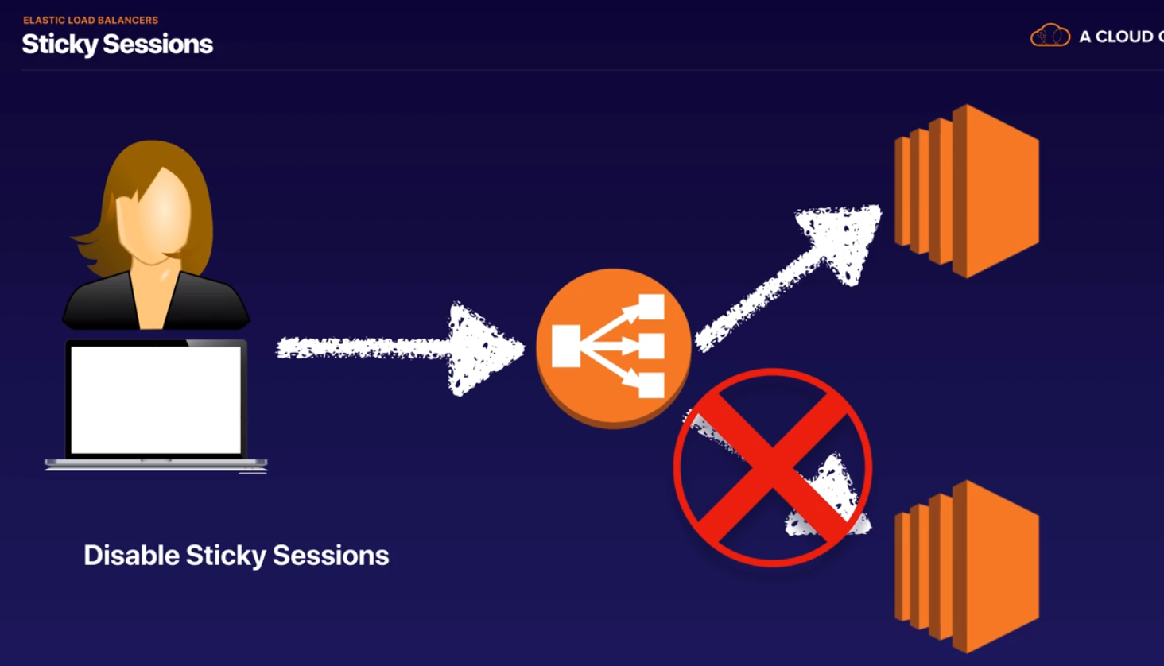

You will need sticky sessions when you are writing a file to disk

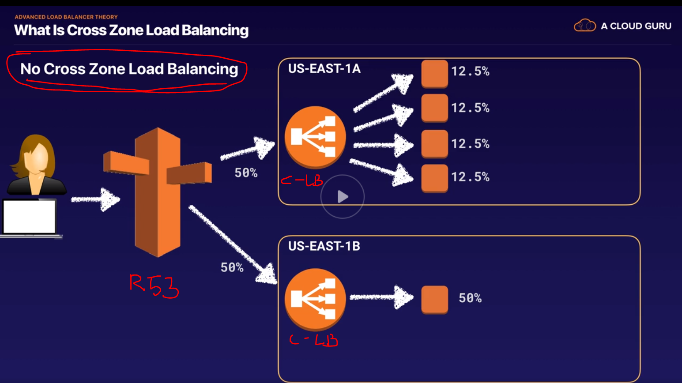

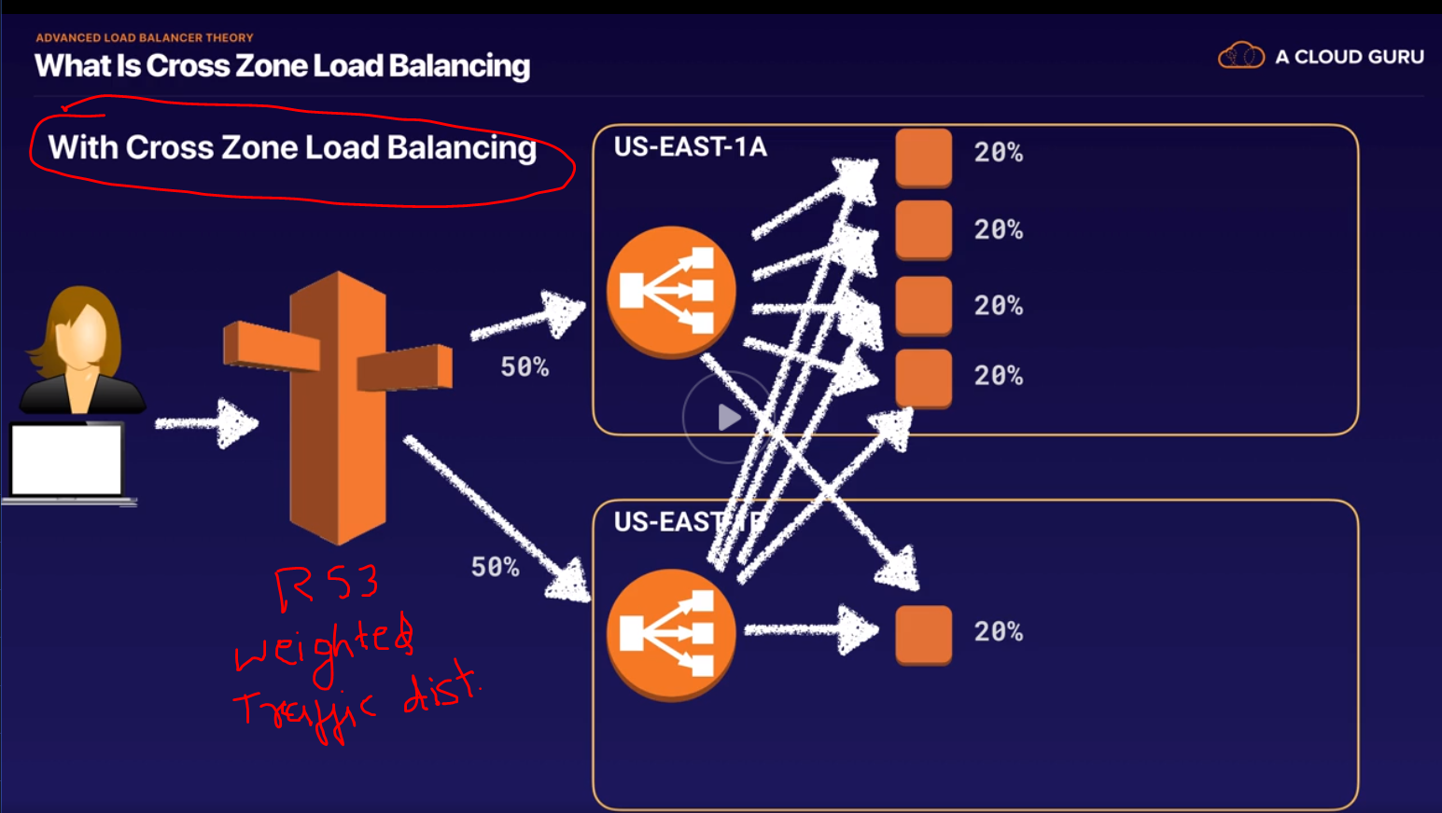

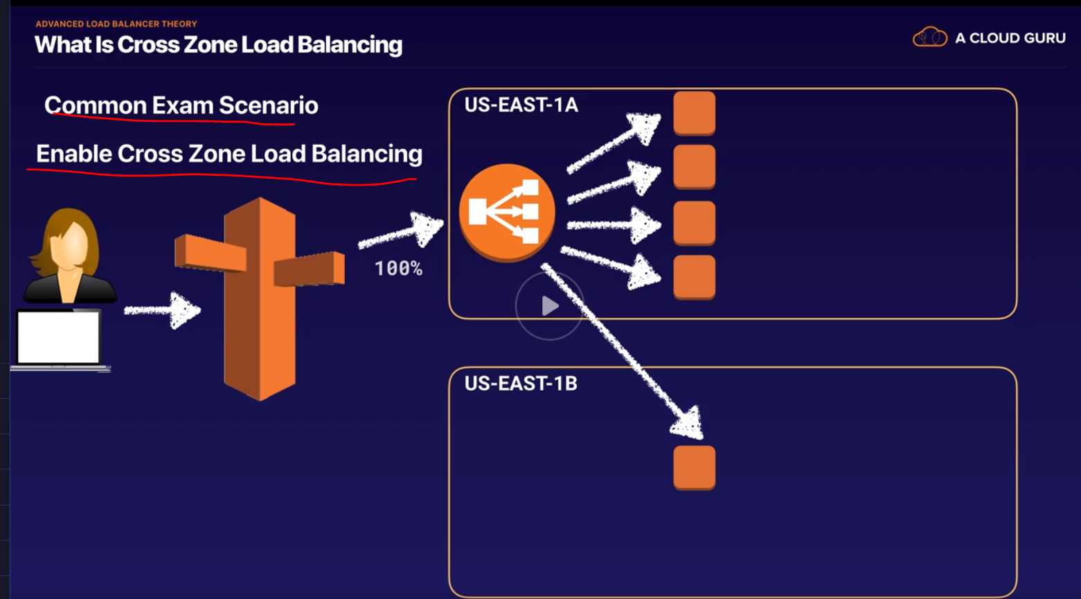

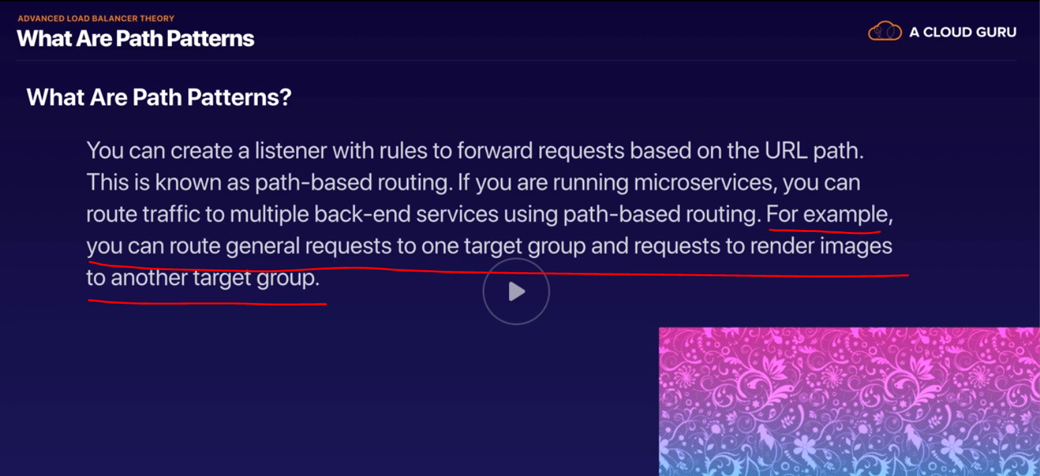

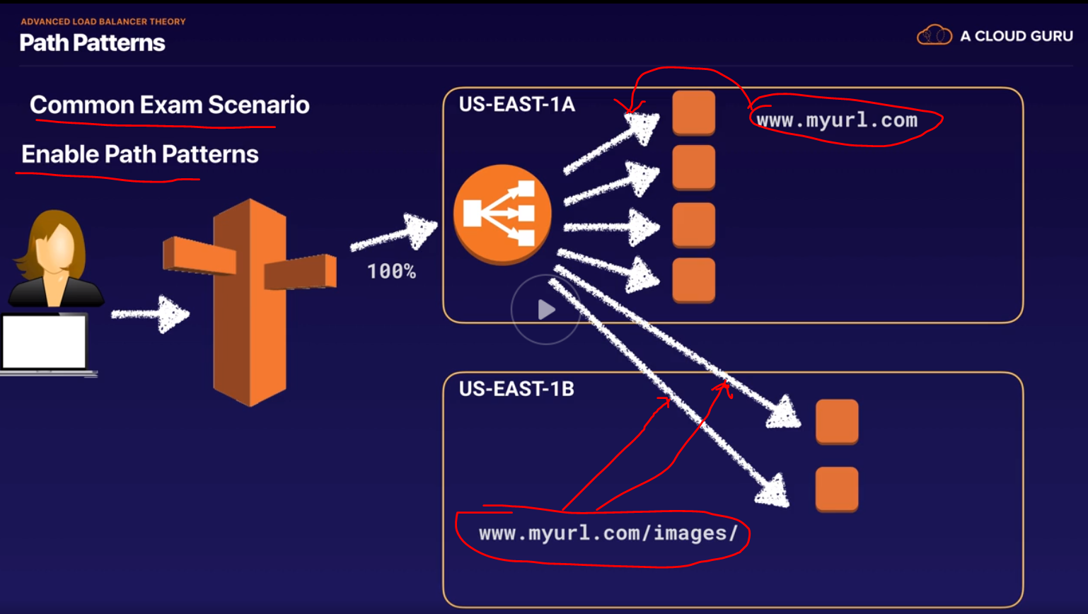

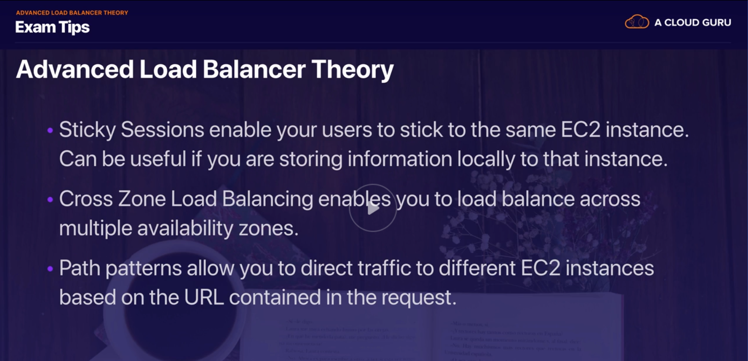



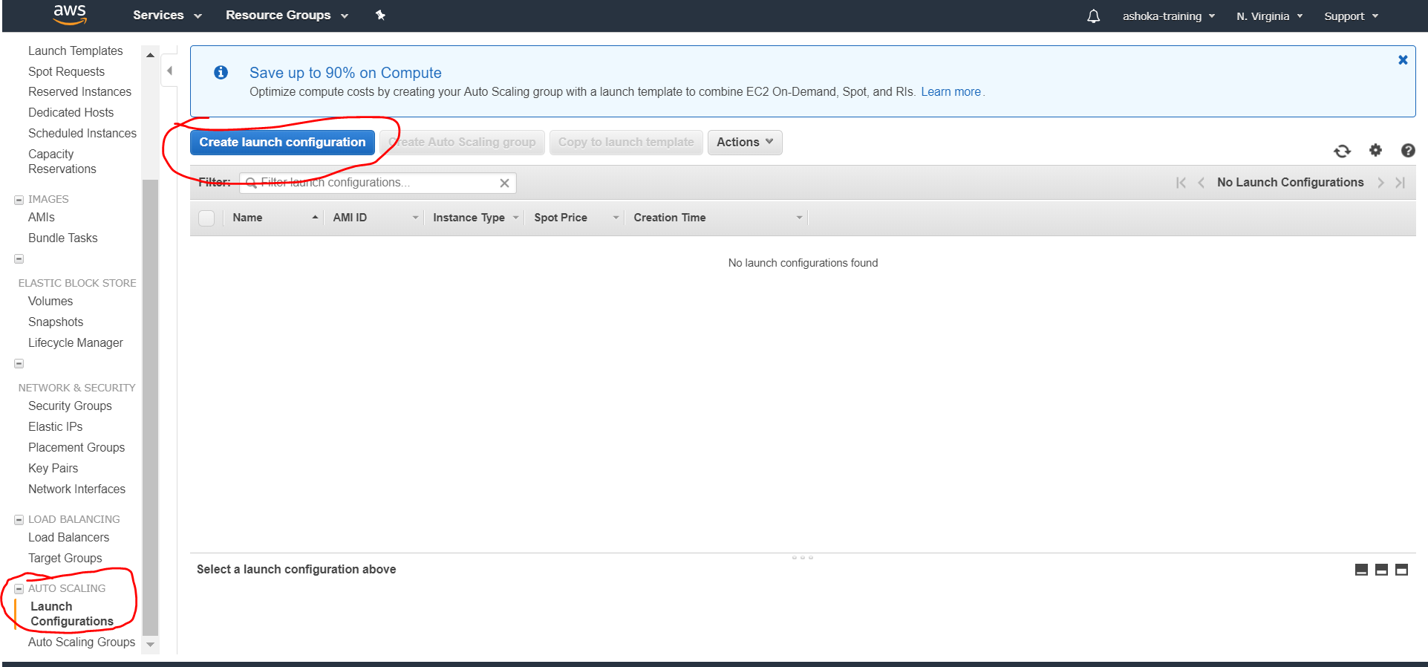

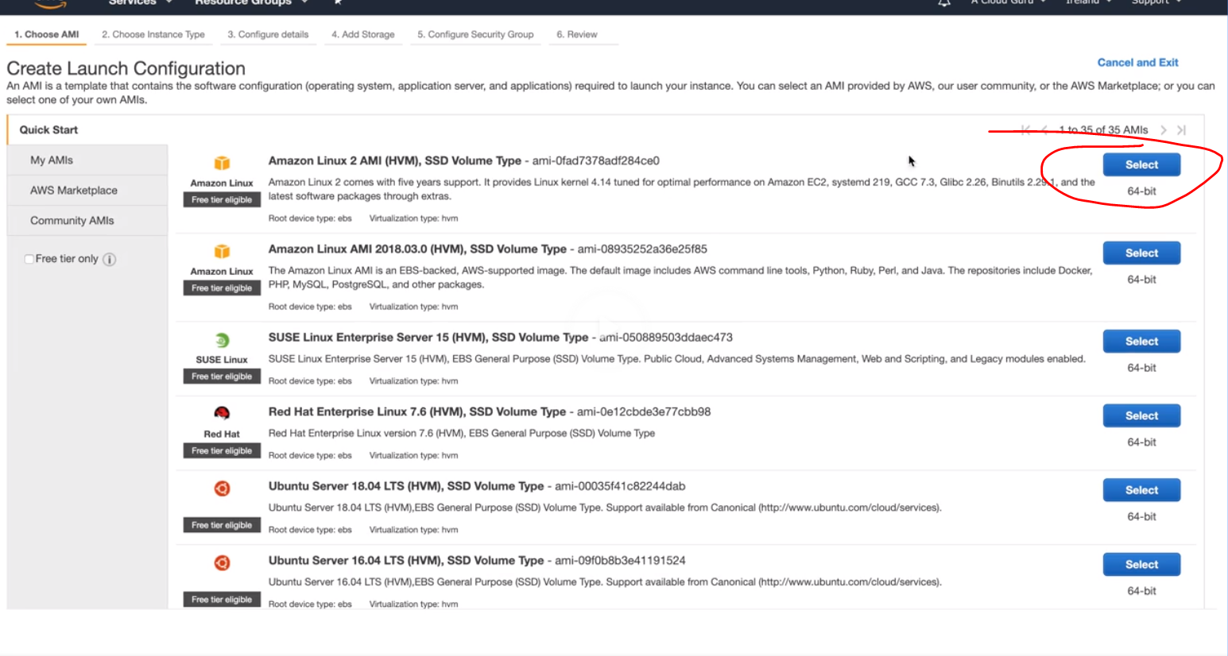 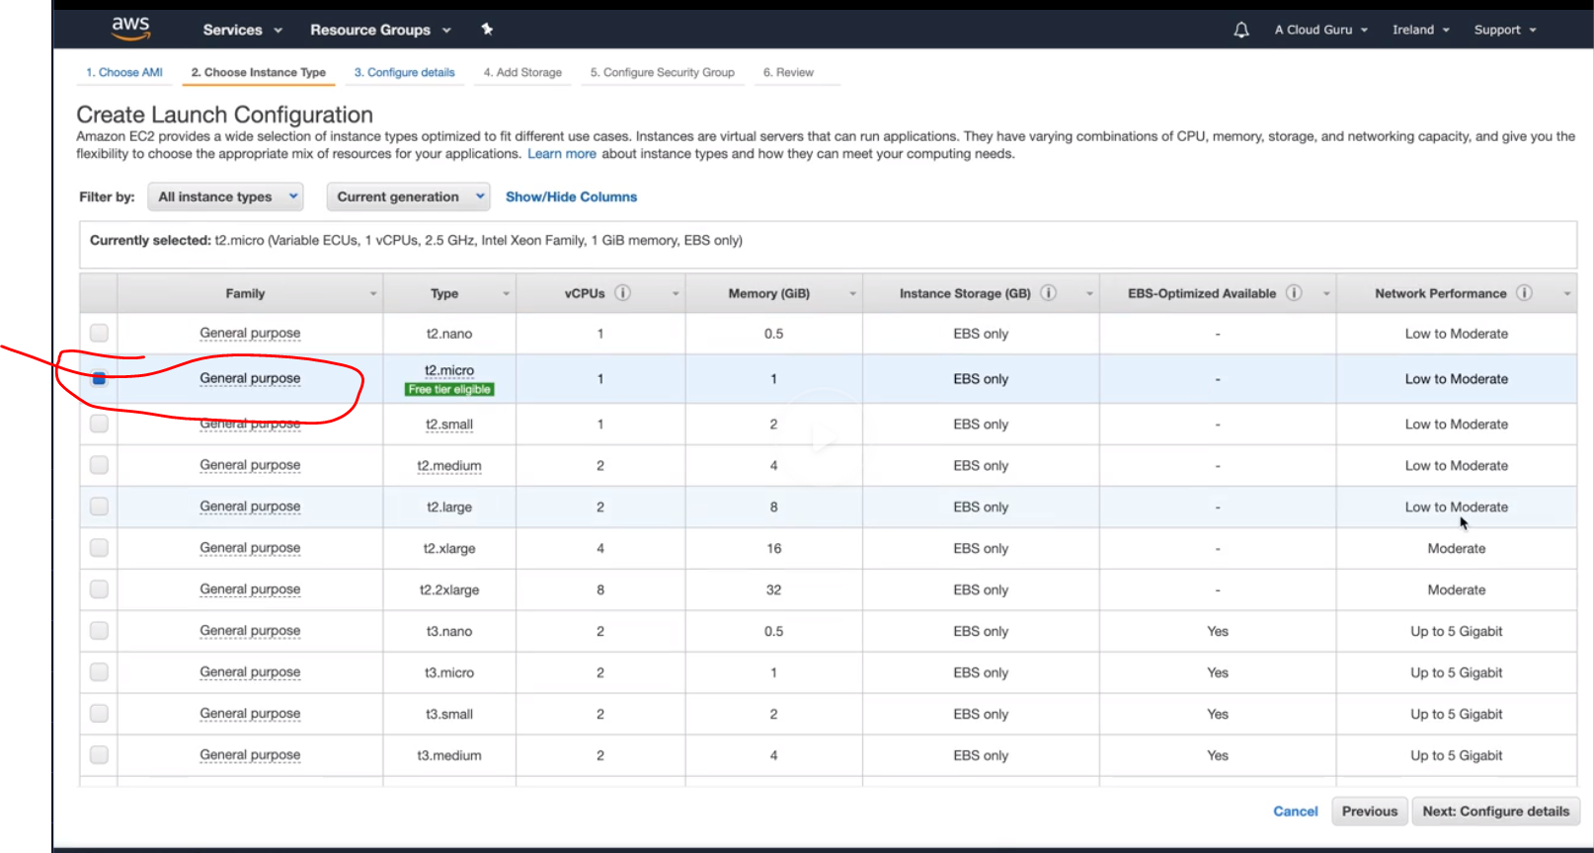

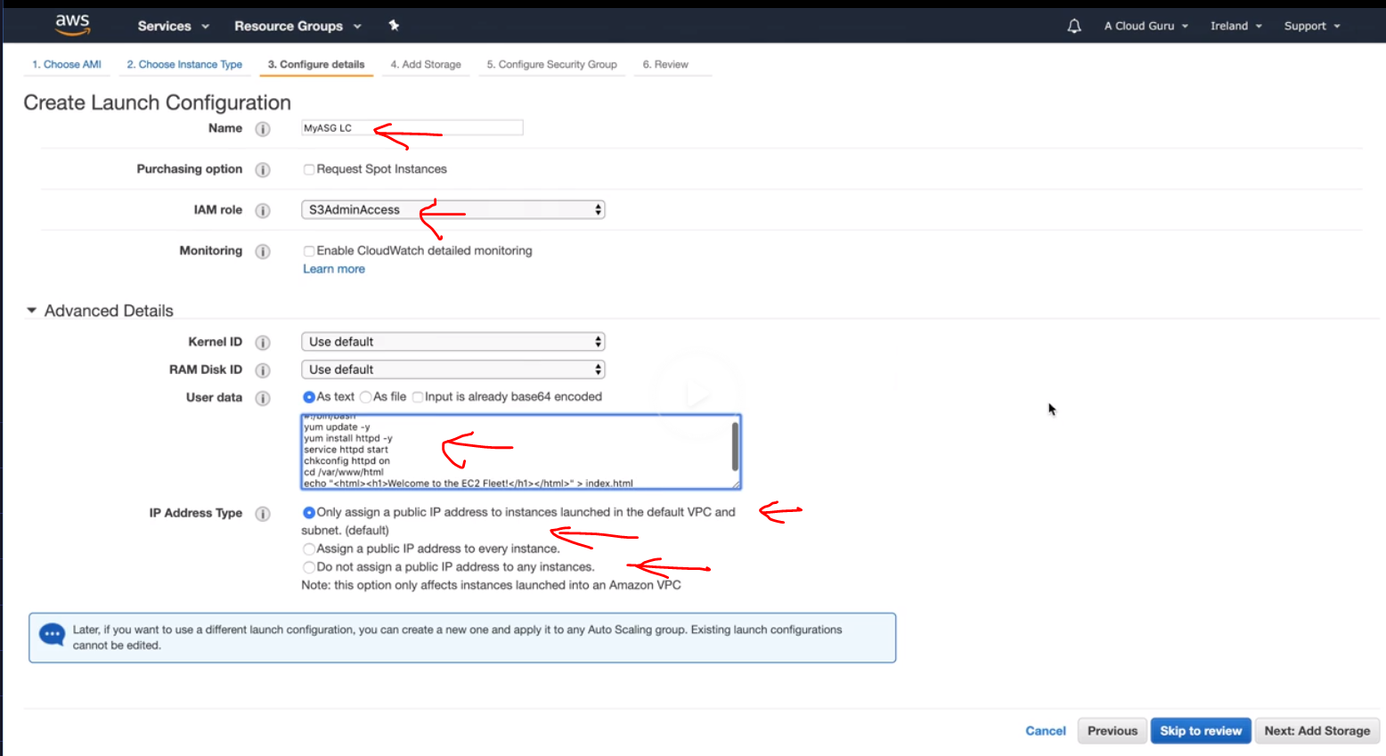 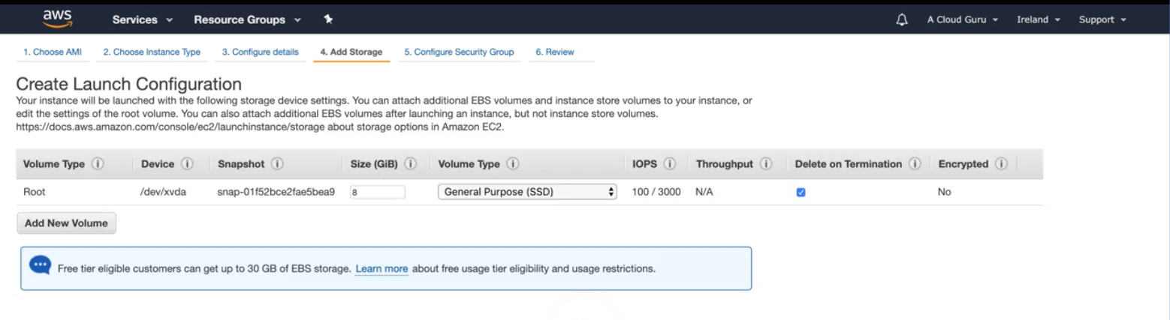 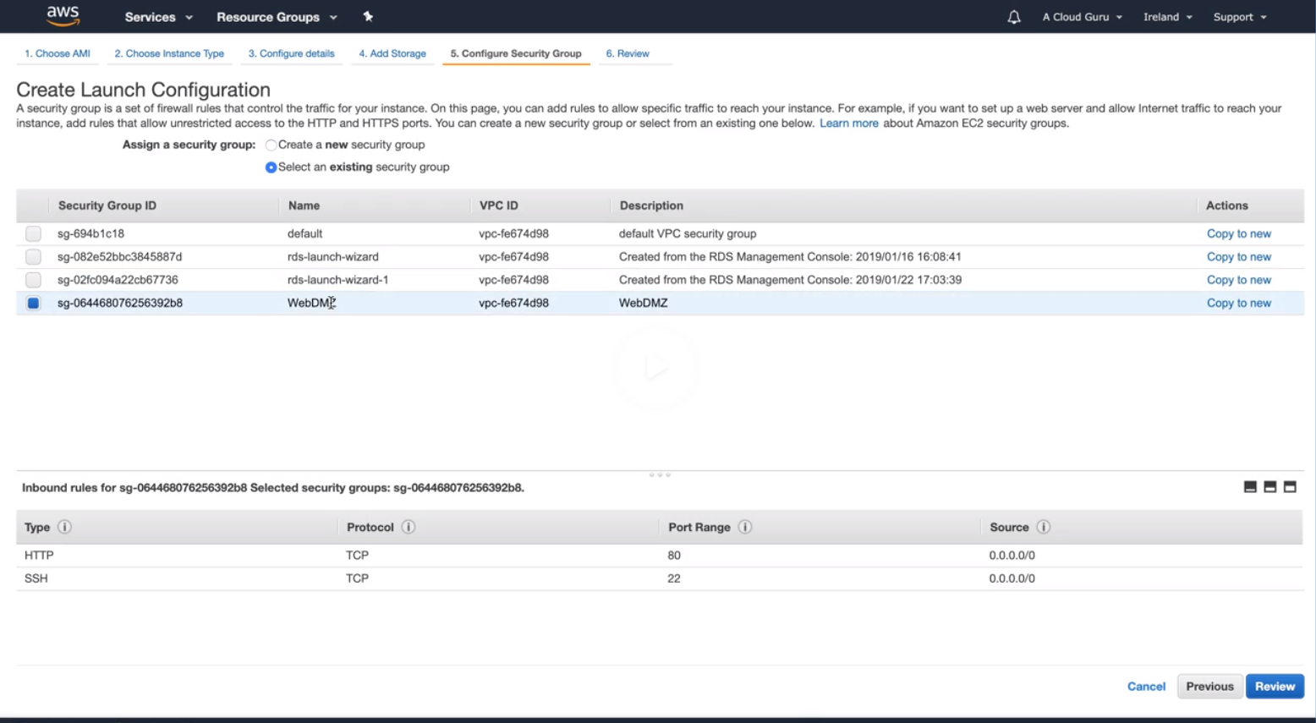

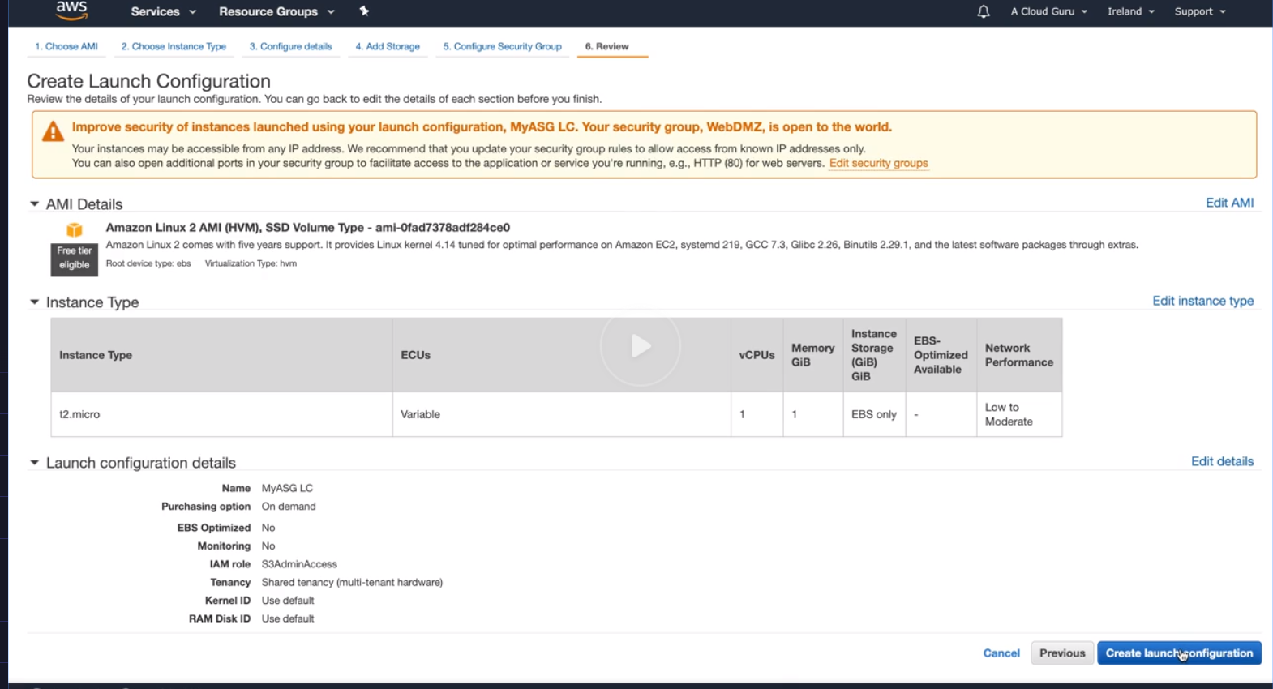

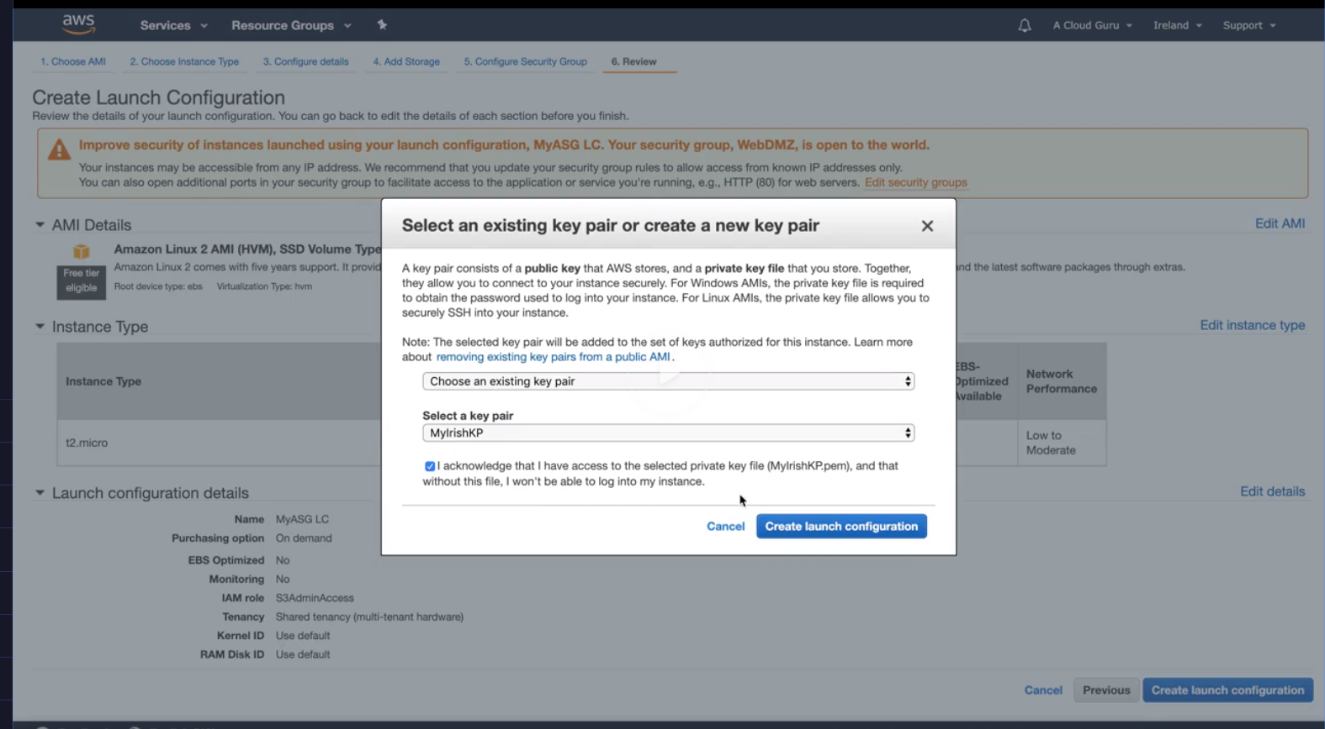

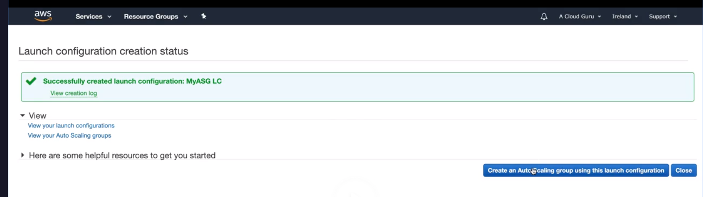

Till now nothing has happened , nothing is launched , it has just created a configuration, now using this configuration we can create a autoscaling group configuration

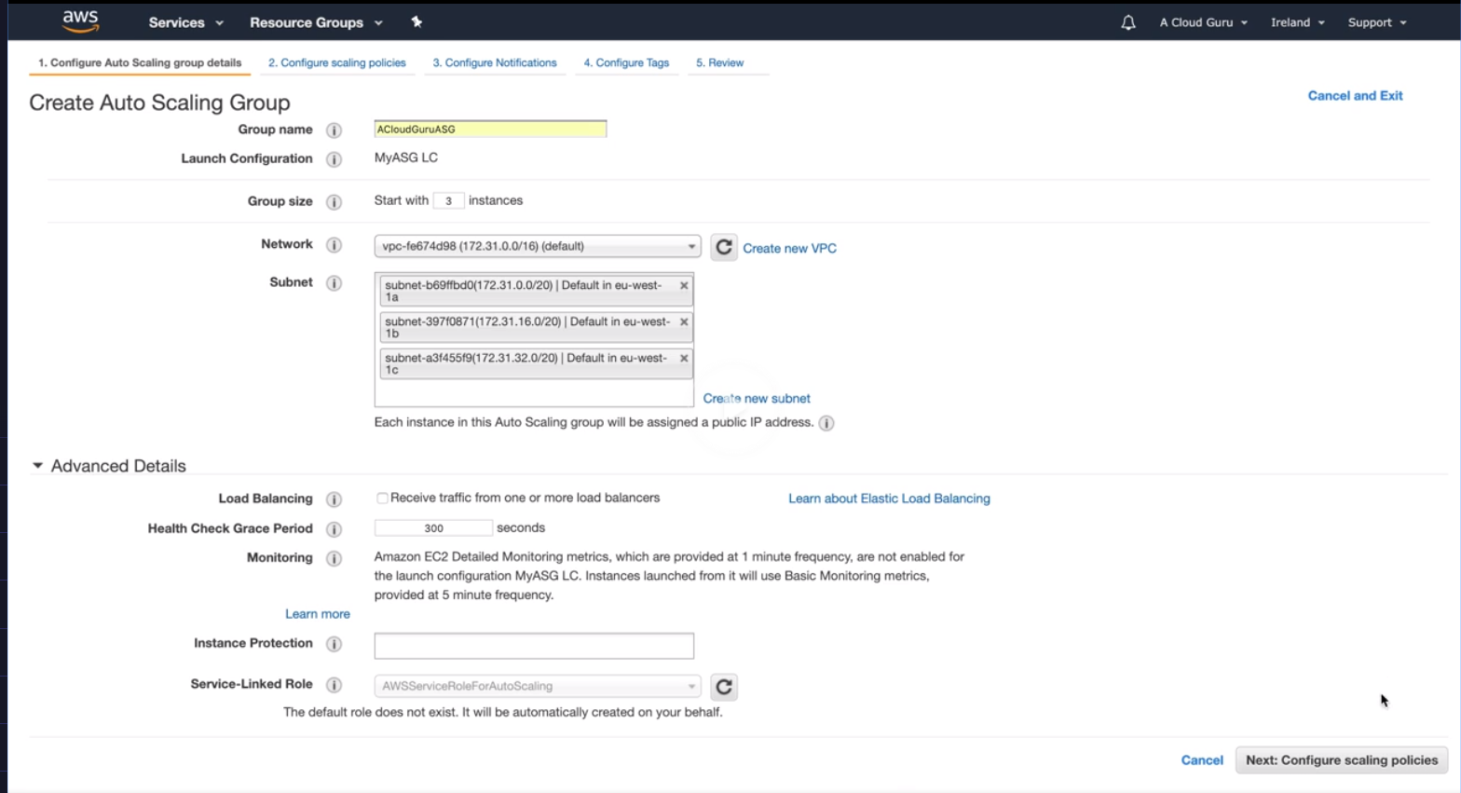

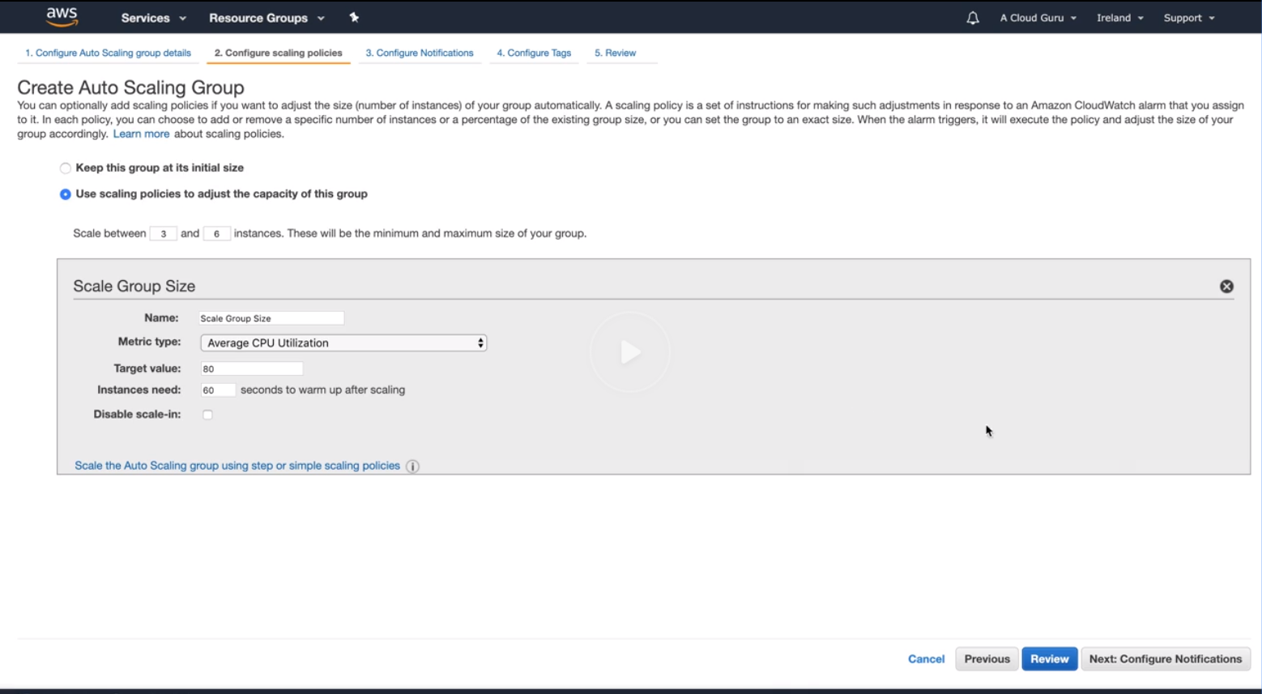

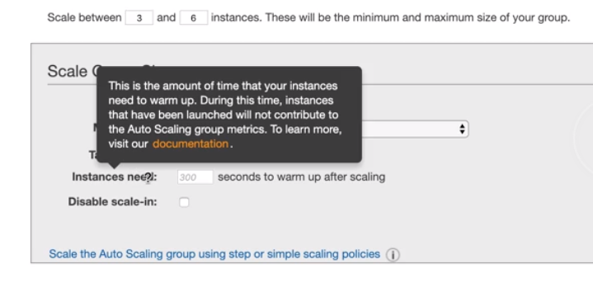 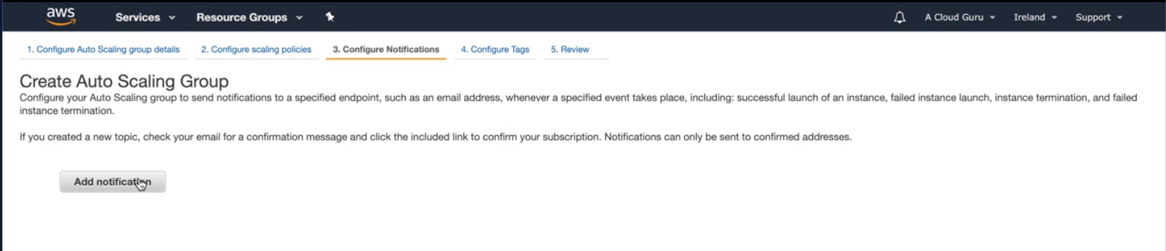 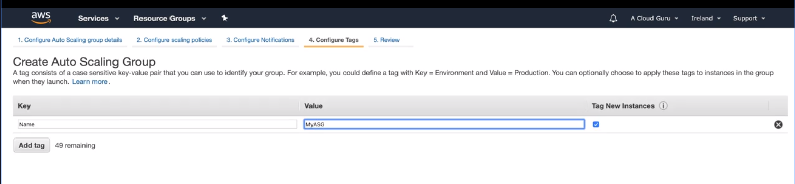 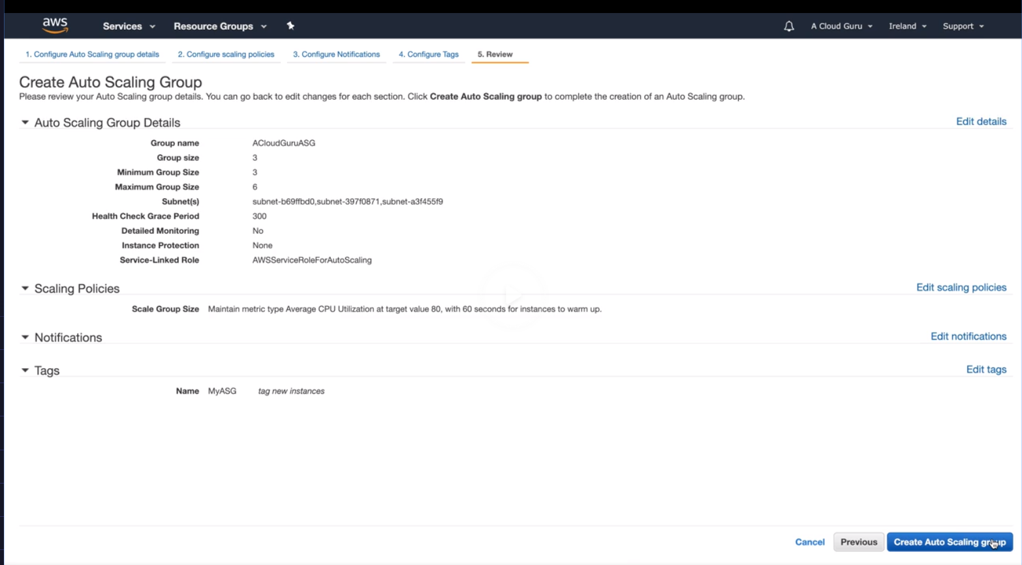 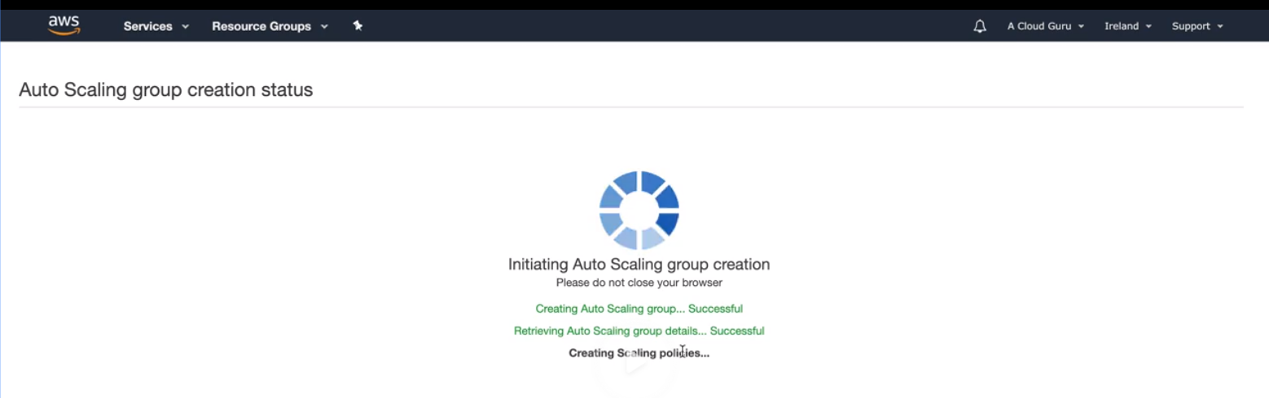 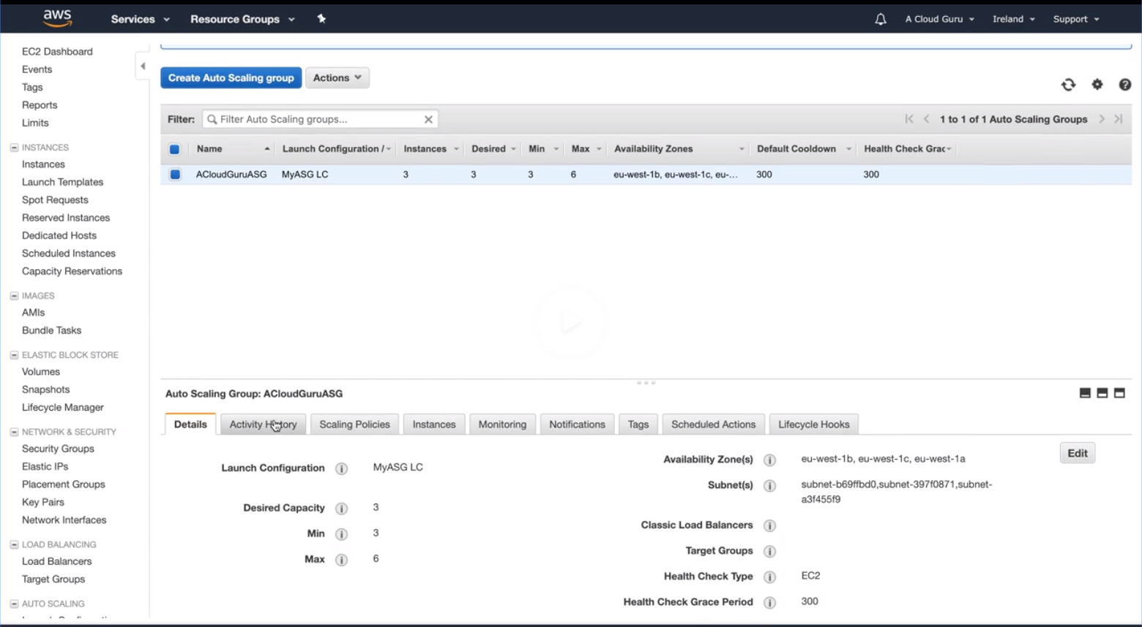

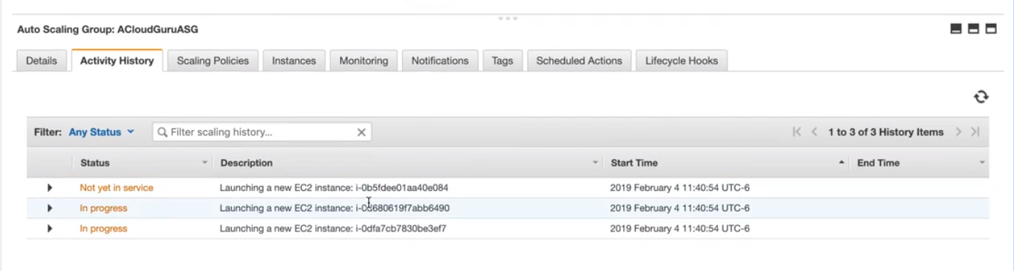

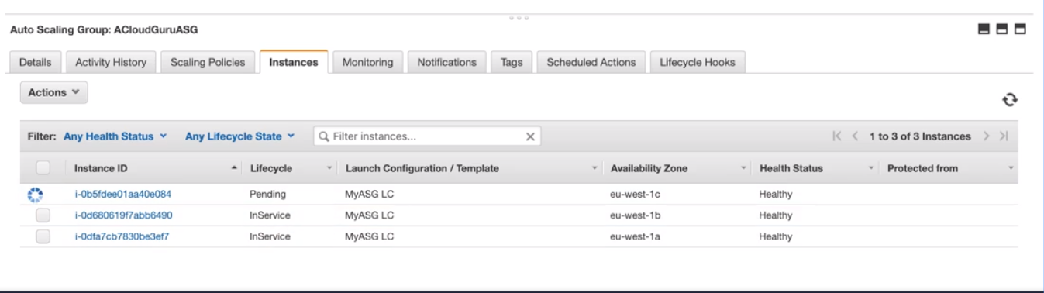

If you terminate the instance and refresh the autoscaling group automatically creates new EC2 instances- see below

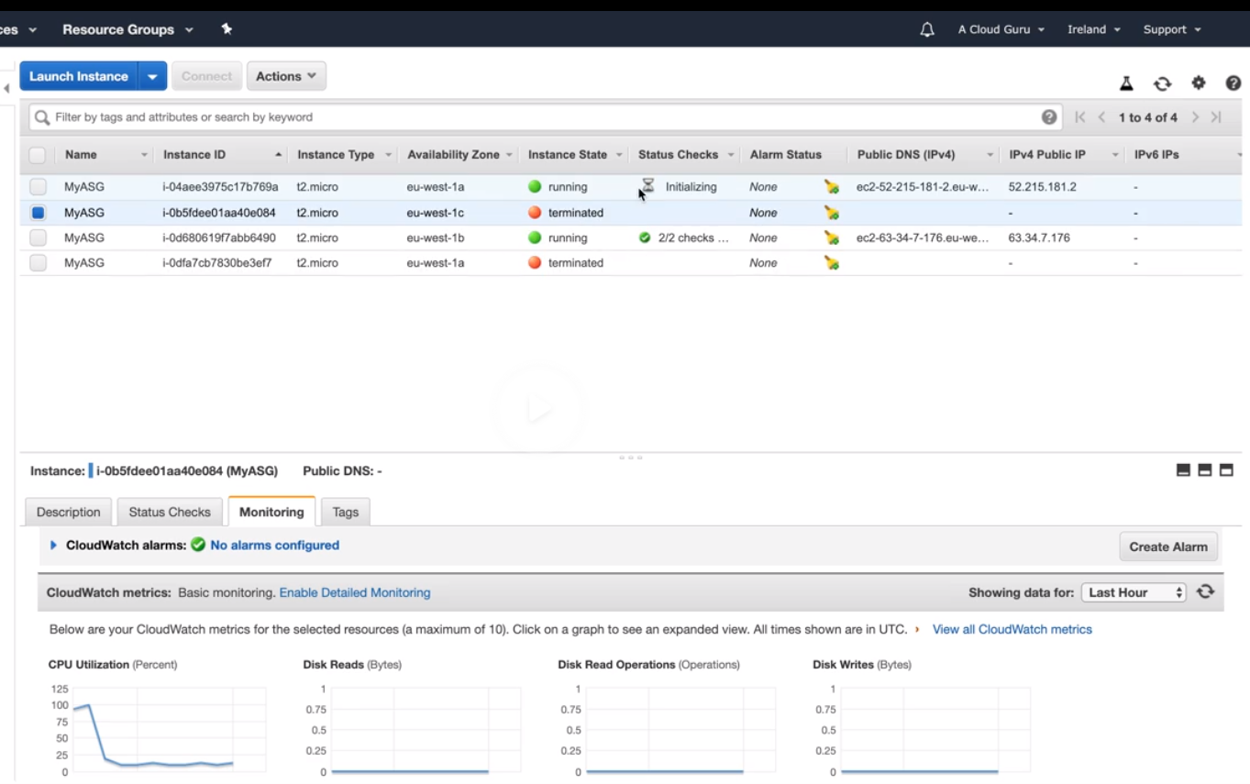

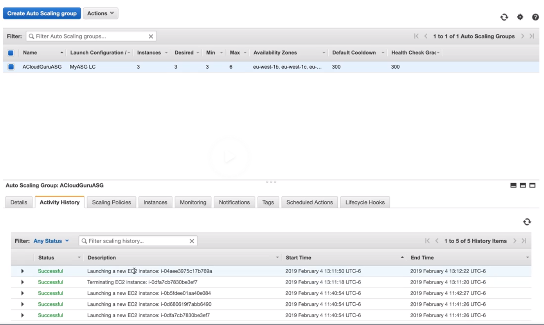

The reason for scaling to 3 is because of below

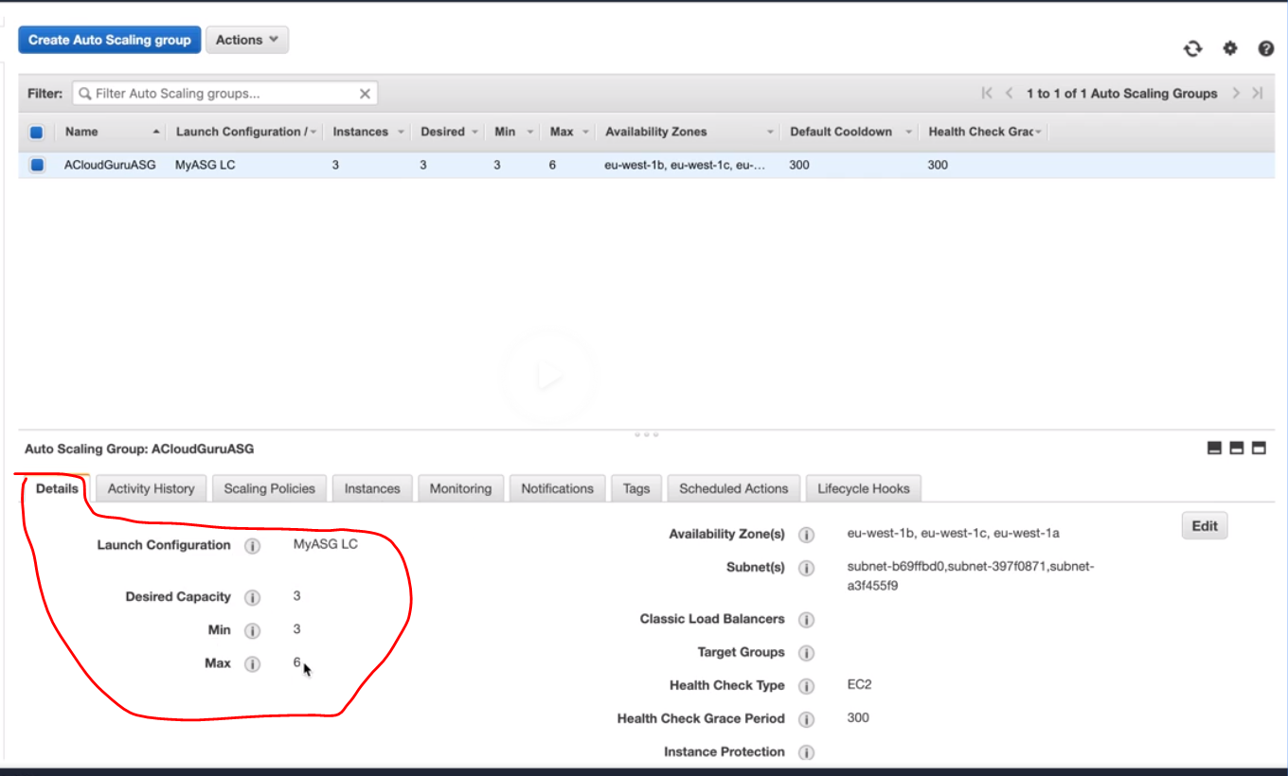

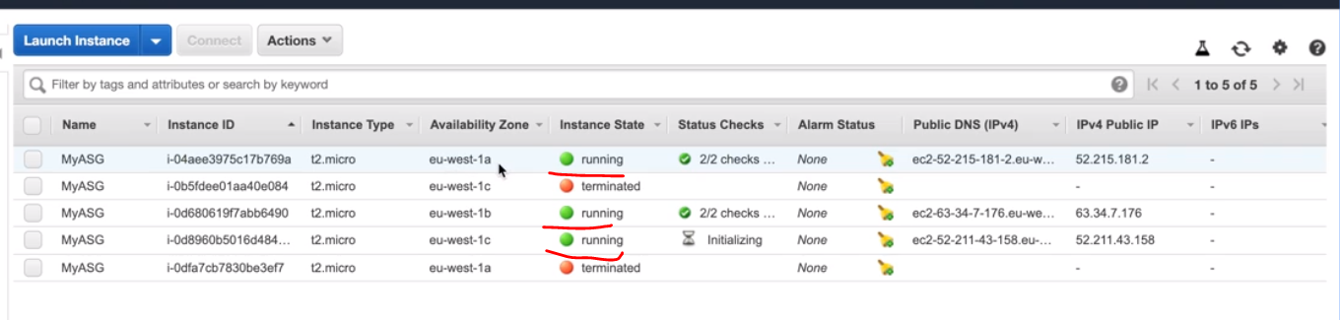

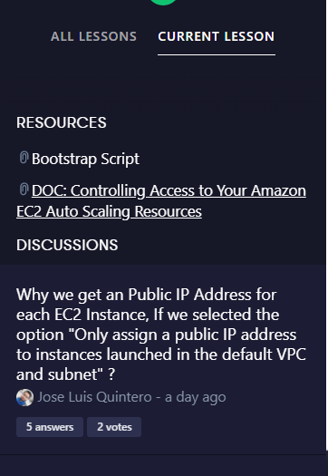

#!/bin/bash

yum update -y

yum install httpd -y

service httpd start

chkconfig httpd on

cd /var/www/html

echo "<html><h1>Welcome to the EC2 Fleet!</h1></html>" > index.html

<https://docs.aws.amazon.com/autoscaling/ec2/userguide/control-access-using-iam.html>





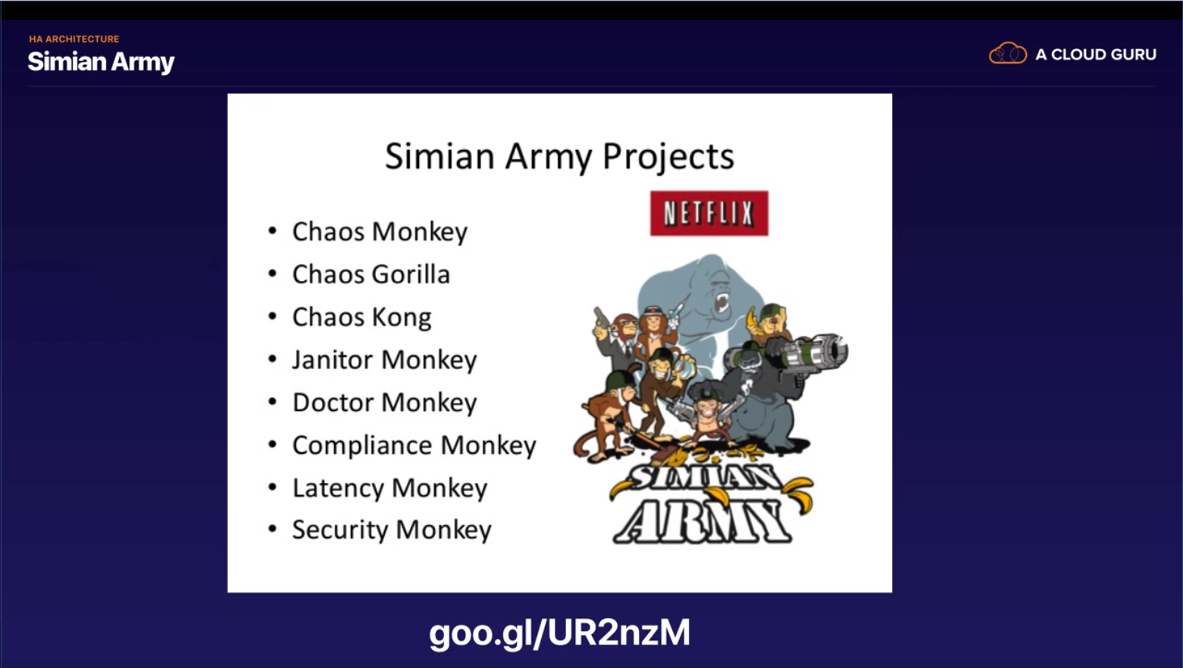

<https://medium.com/netflix-techblog/the-netflix-simian-army-16e57fbab116>

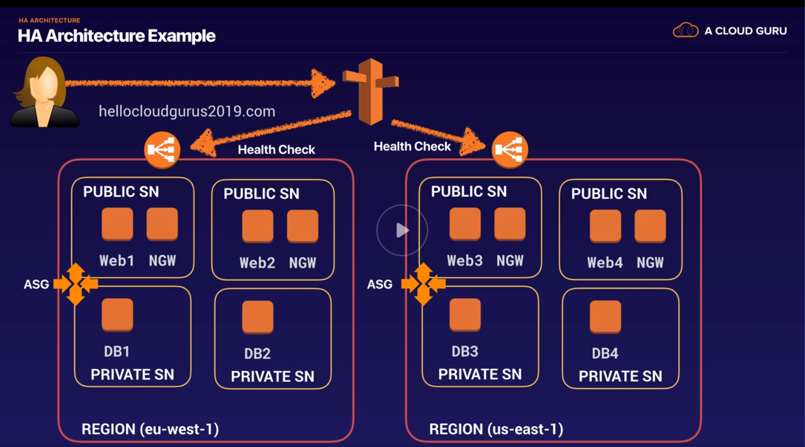

Example of highly available architecture , availability b/w regions , availability zones

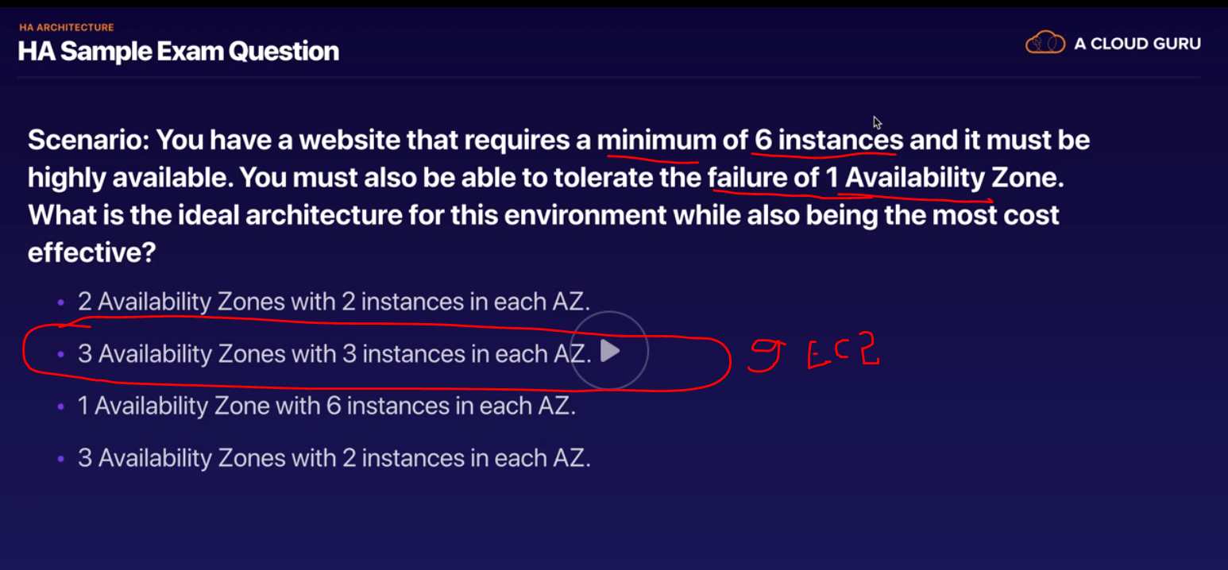

The reason for 3 AZ with 3 instances(total 9 instances) is because even if 1 AZ goes down we have 6 out of 9 instances available which is requirement in the question.

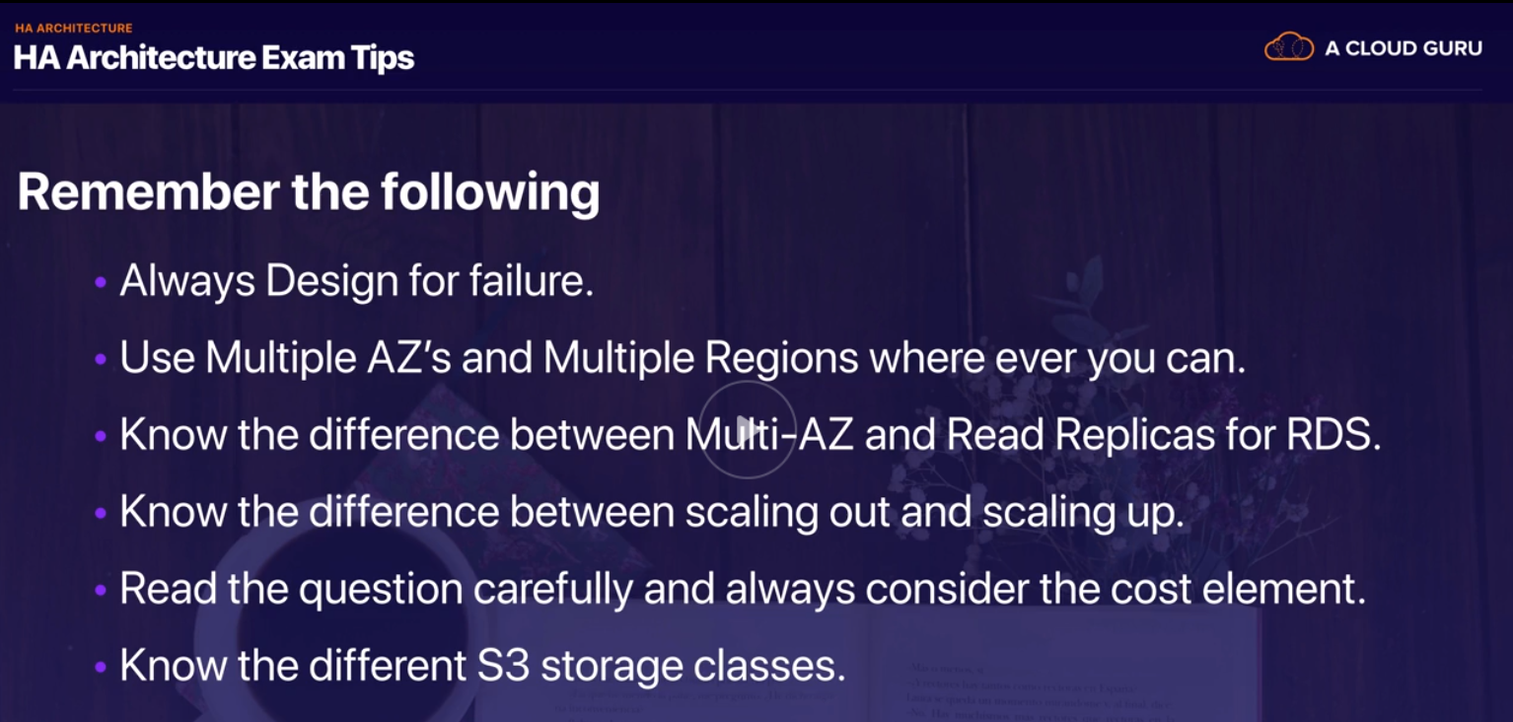

Multi AZ- is for disaster recovery

Read Replicas for RDS – is for performance

Scaling out – Achieved by auto scaling group configuration by adding additional EC2 instances

Scaling up - Achieved by adding resources into a single EC2 instances example from t2 micro to 6x large , increase CPU or RAM etc.

Cost

S3 – Standard S3 and Standard S3 in frequently accessed are highly available. S3 single AZ reduce redundancy storage are not highly available

LETS BUILD WORD PRESS SITE



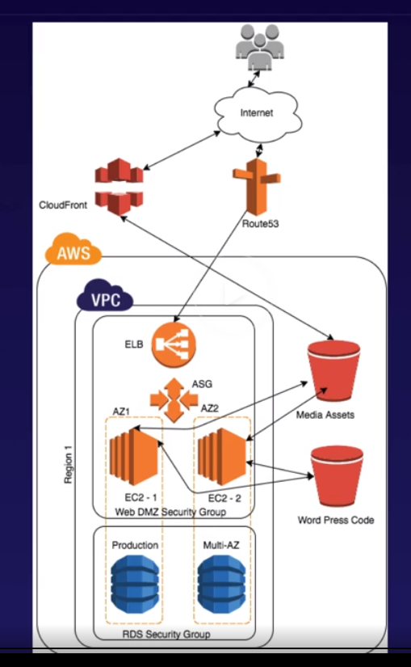

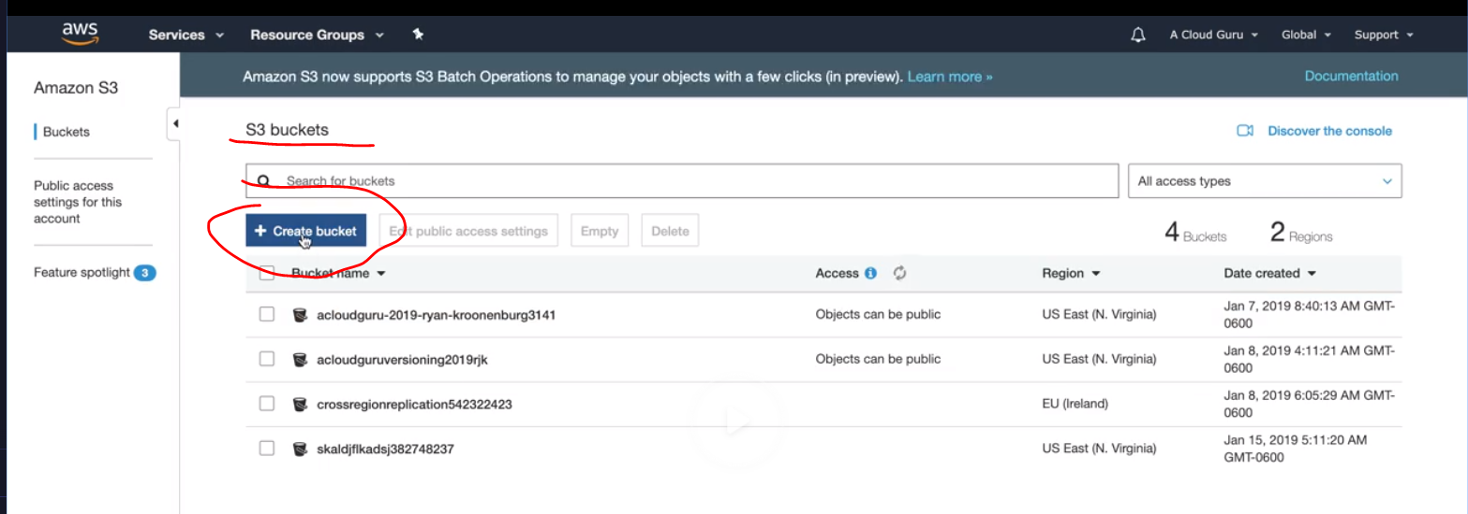

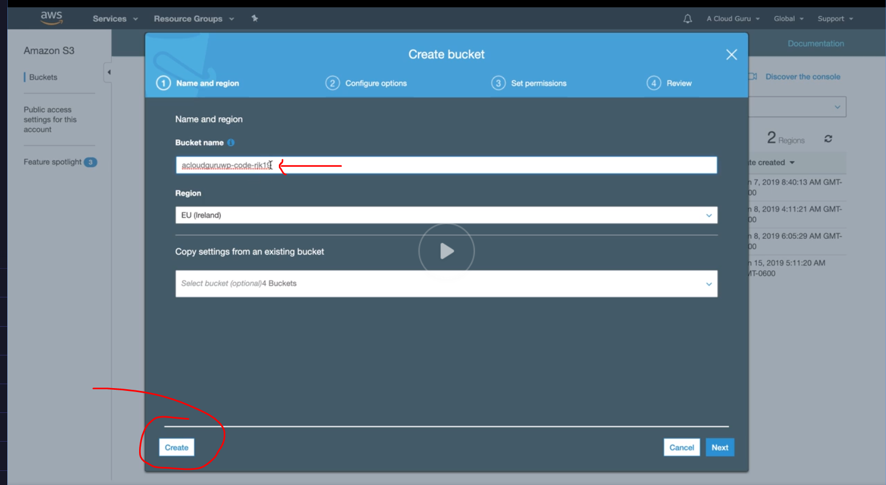

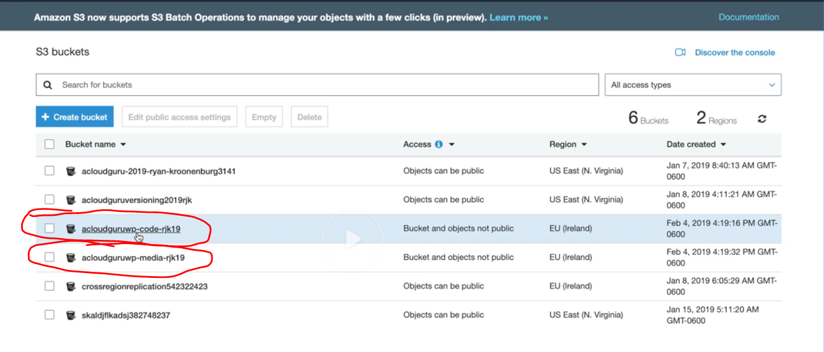

Create 2 buckets

Lets create a cloud front

# What Is Amazon CloudFront?

Amazon CloudFront is a web service that speeds up distribution of your static and dynamic web content, such as .html, .css, .js, and image files, to your users. CloudFront delivers your content through a worldwide network of data centers called edge locations. When a user requests content that you're serving with CloudFront, the user is routed to the edge location that provides the lowest latency (time delay), so that content is delivered with the best possible performance.

* If the content is already in the edge location with the lowest latency, CloudFront delivers it immediately.
* If the content is not in that edge location, CloudFront retrieves it from an origin that you've defined—such as an Amazon S3 bucket, a MediaPackage channel, or an HTTP server (for example, a web server) that you have identified as the source for the definitive version of your content.

As an example, suppose that you're serving an image from a traditional web server, not from CloudFront. For example, you might serve an image, sunsetphoto.png, using the URL <http://example.com/sunsetphoto.png>.

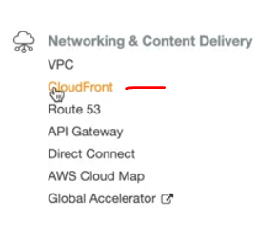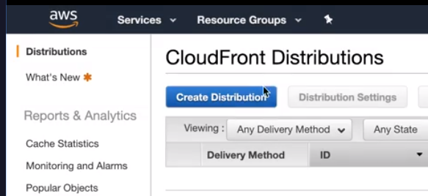

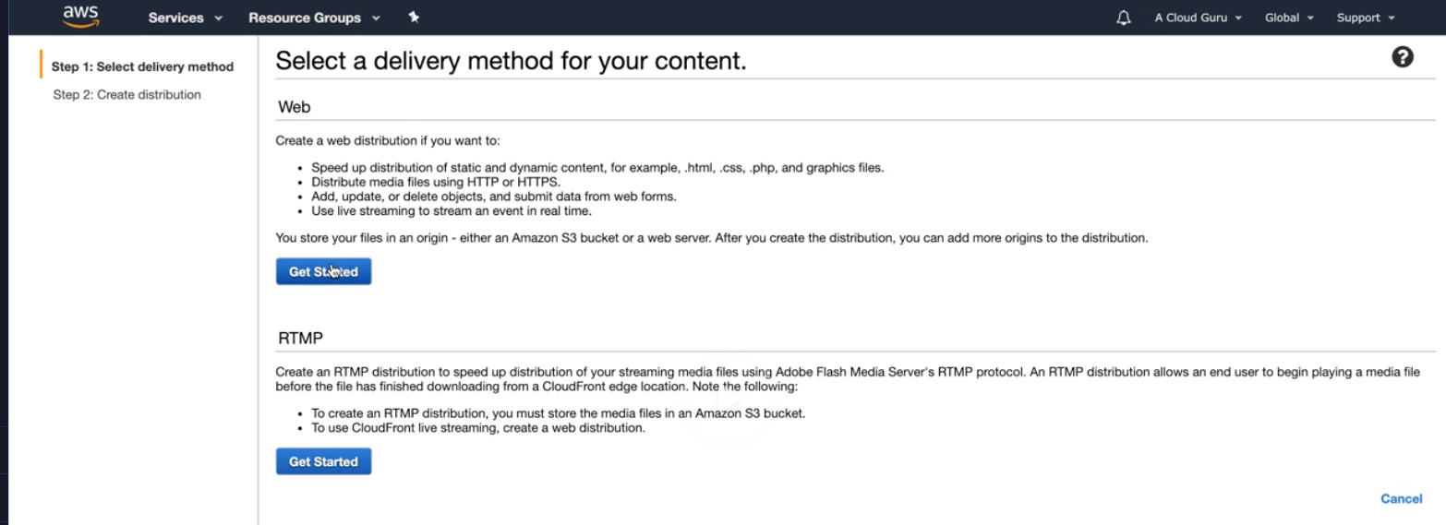

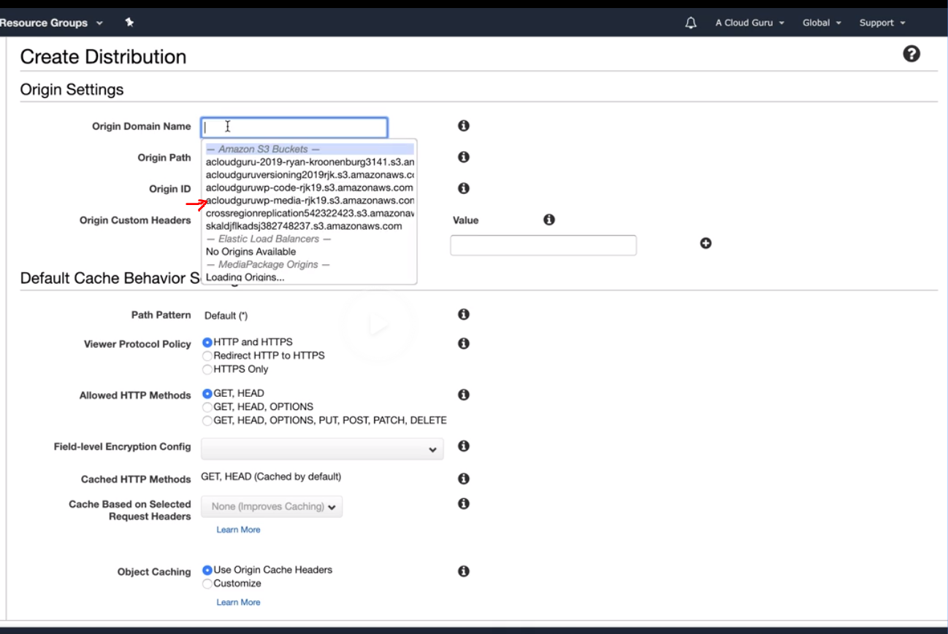

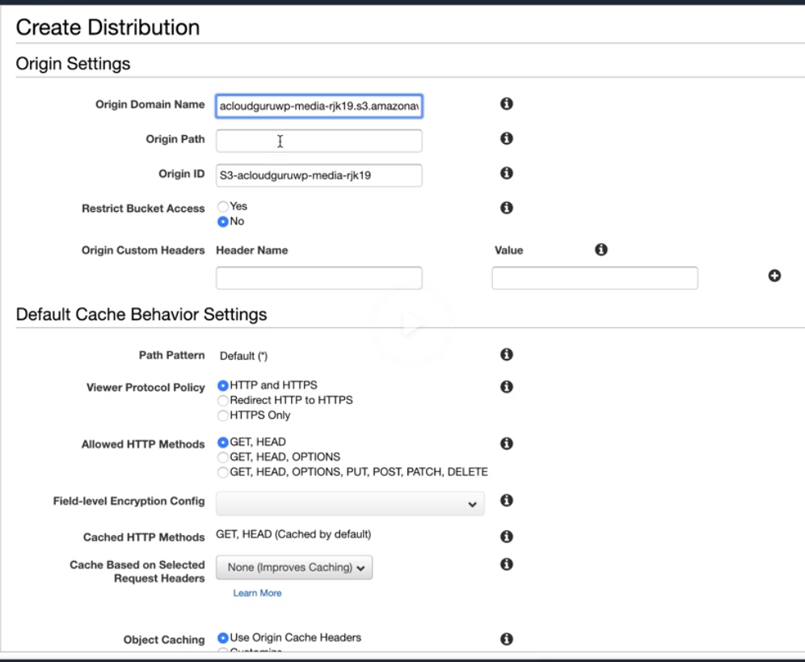

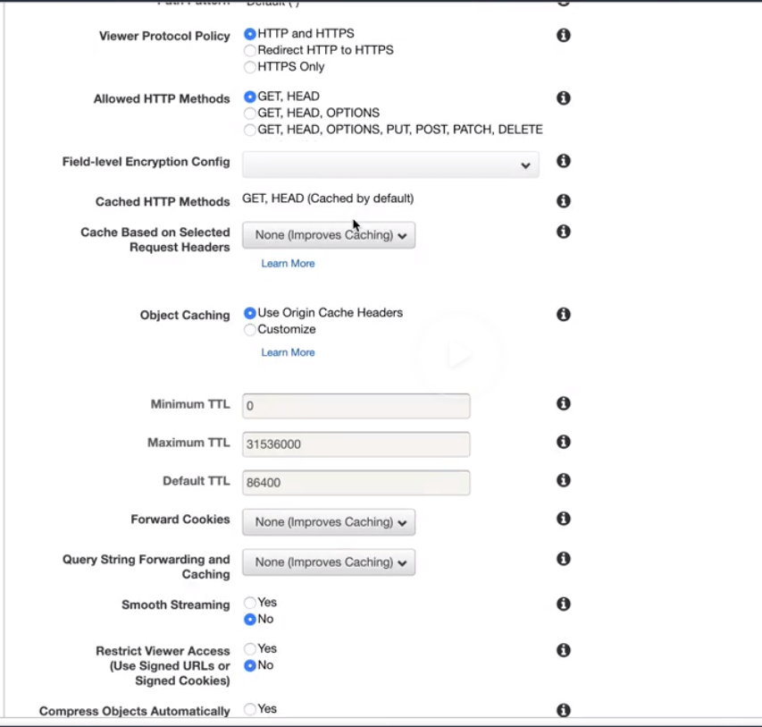

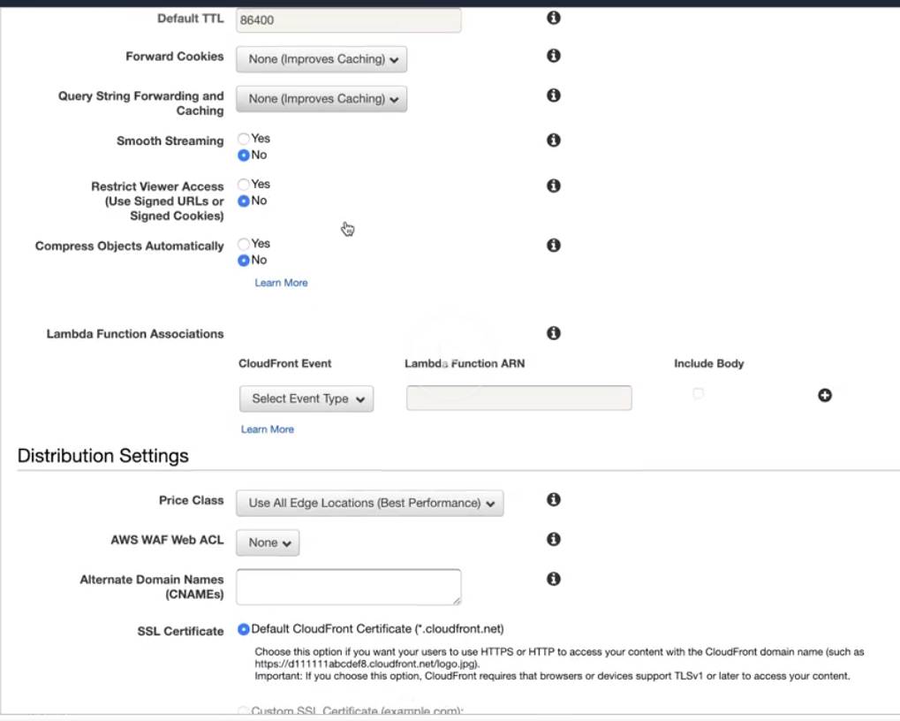

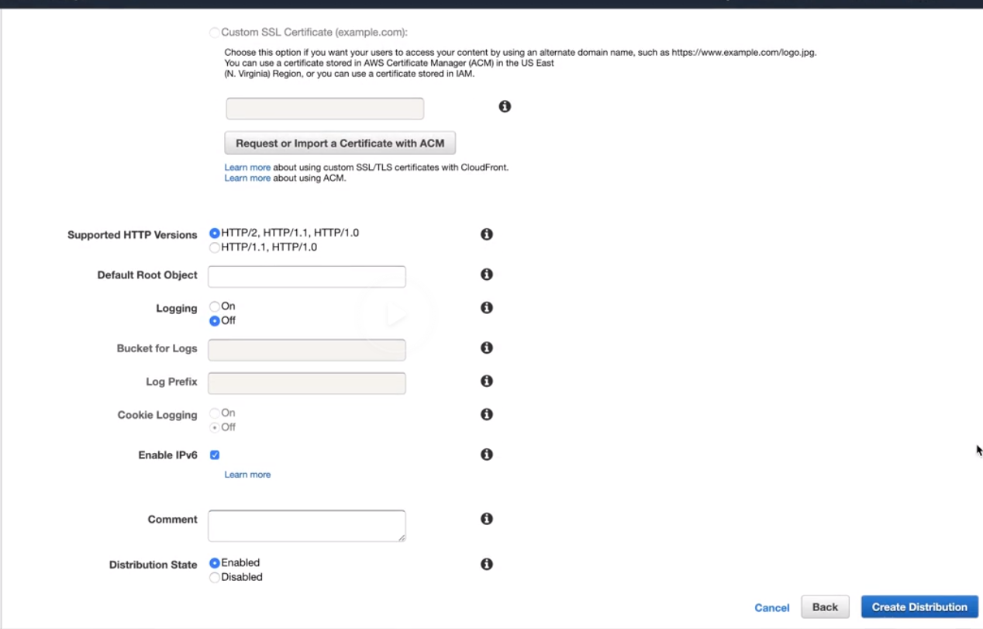

Go to VPC

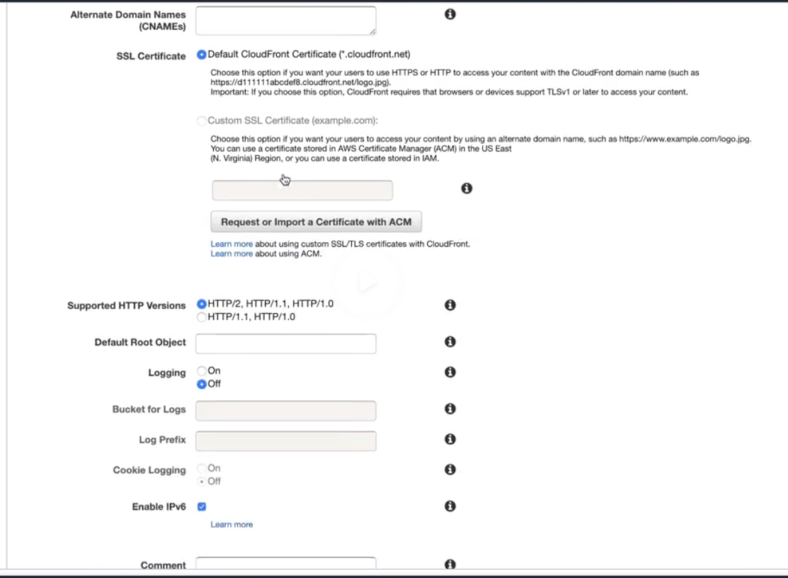

Go to VPC and verify the security groups

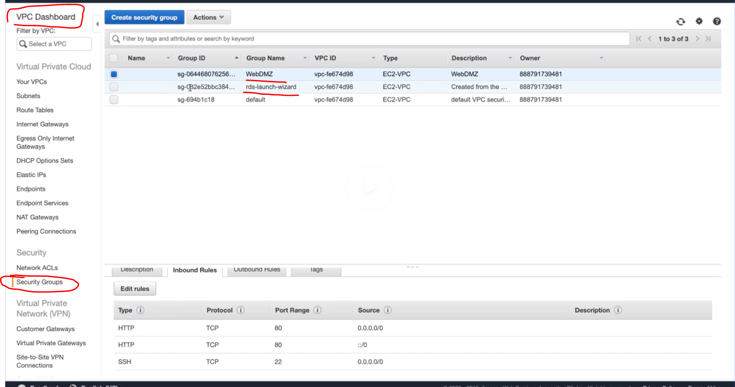 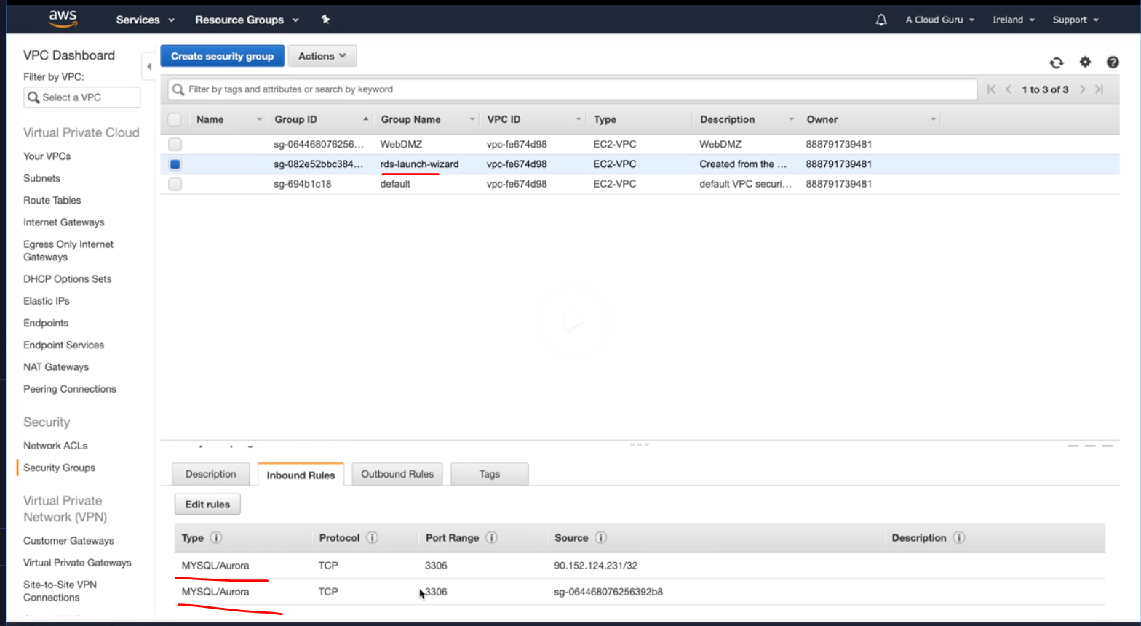

Next Provisiton RDS instance

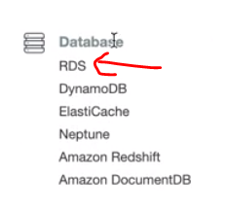

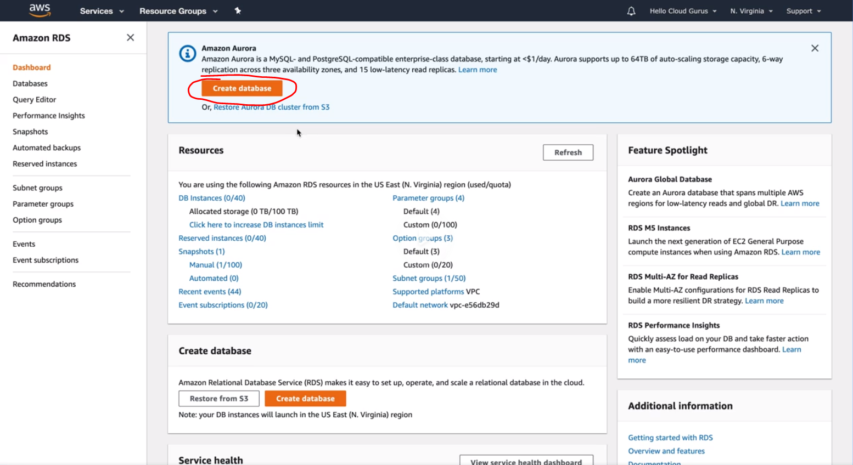

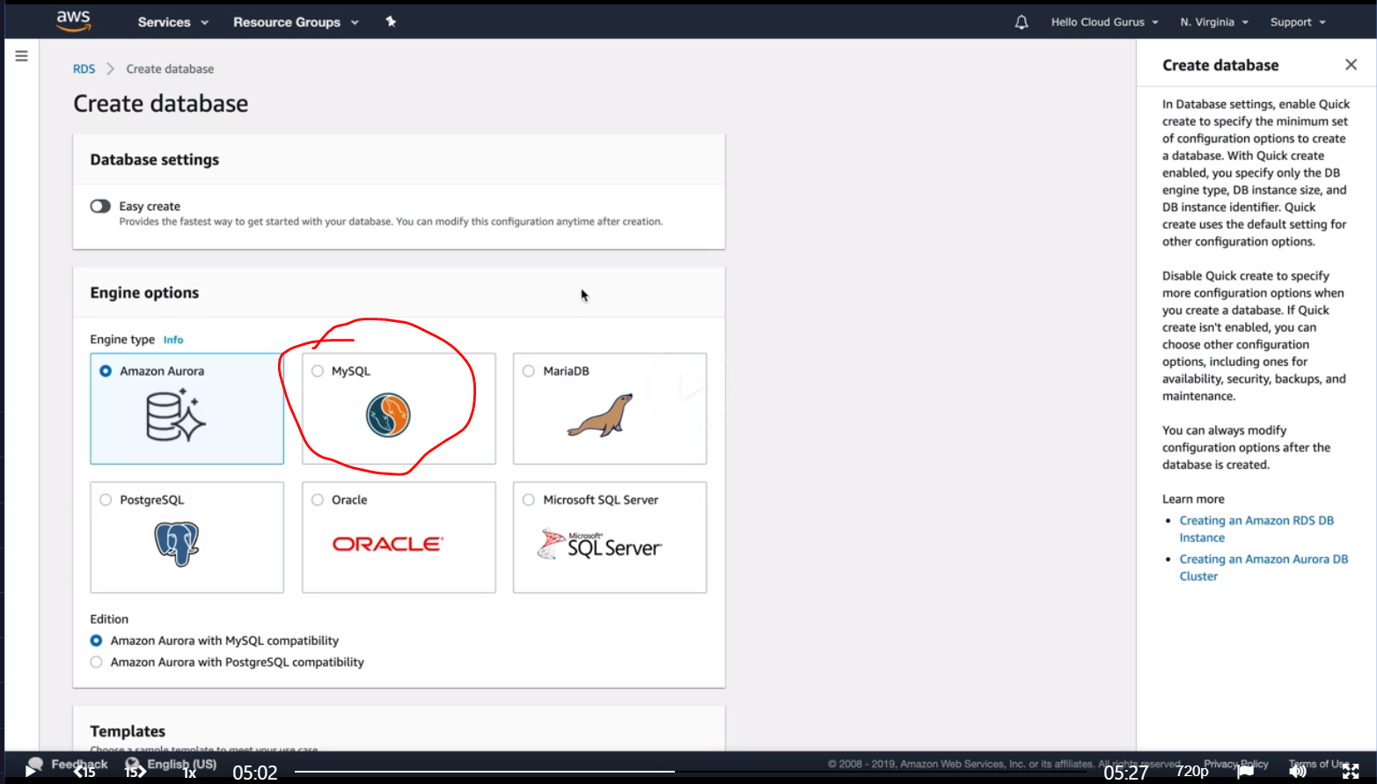 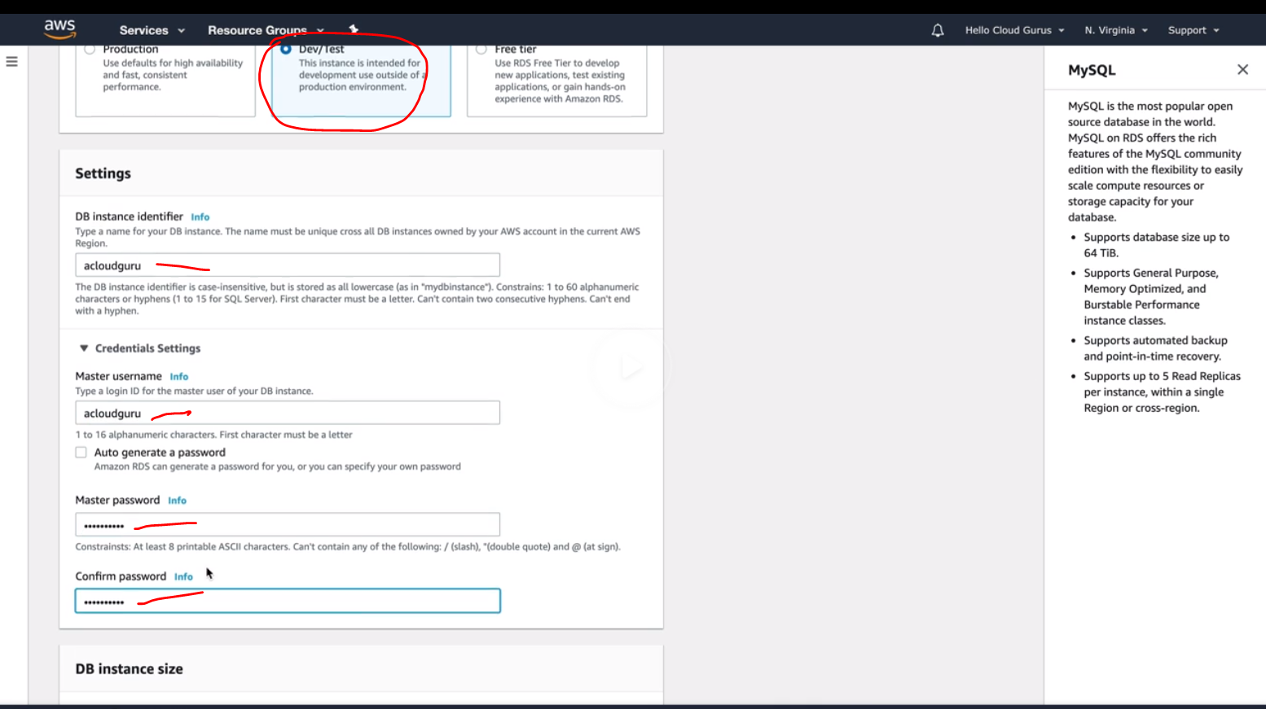 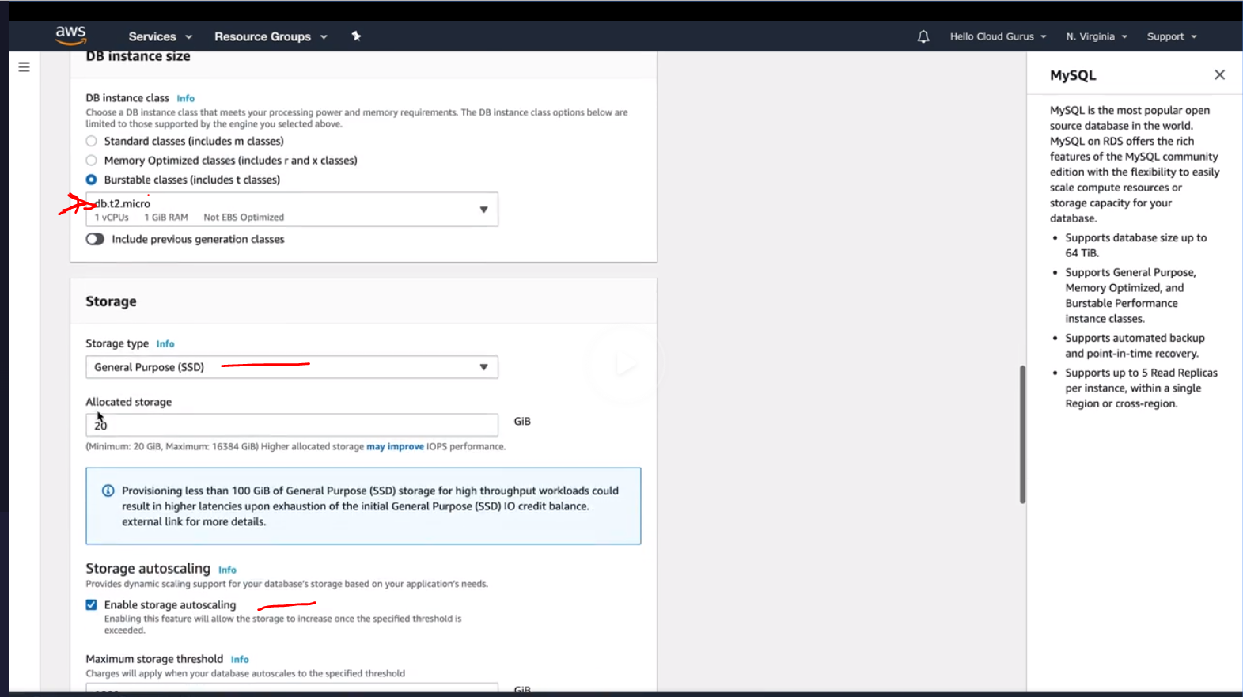 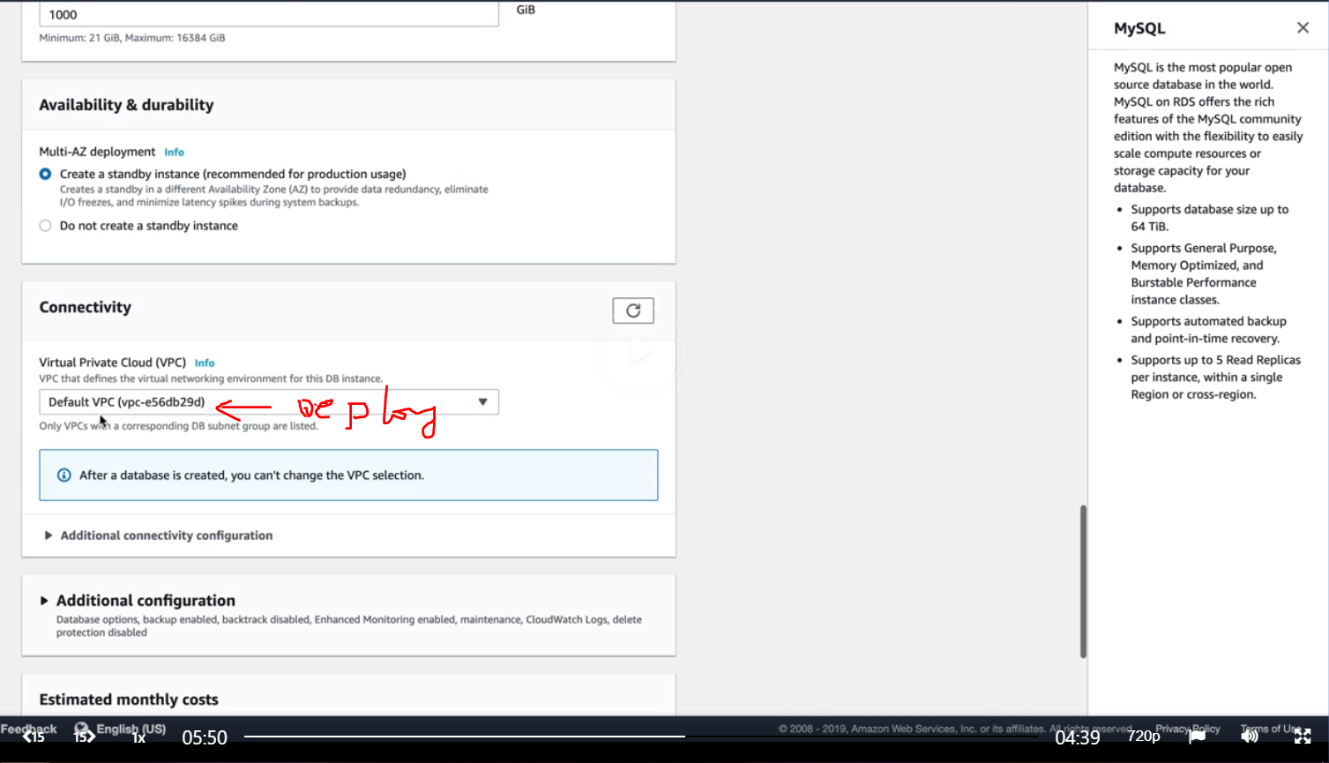 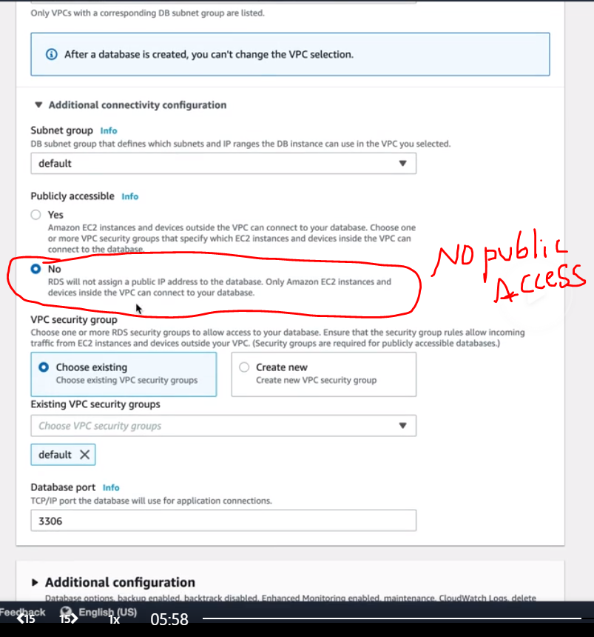

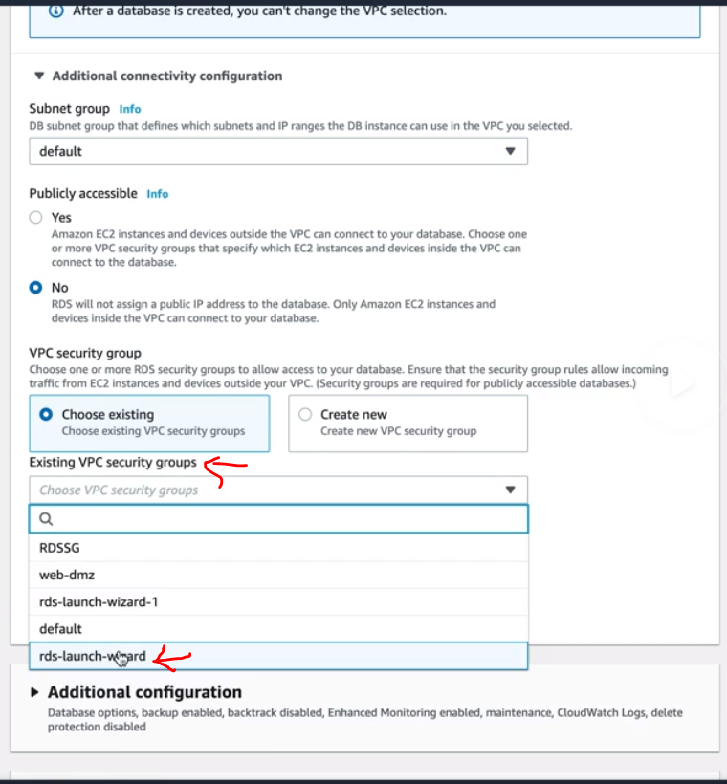 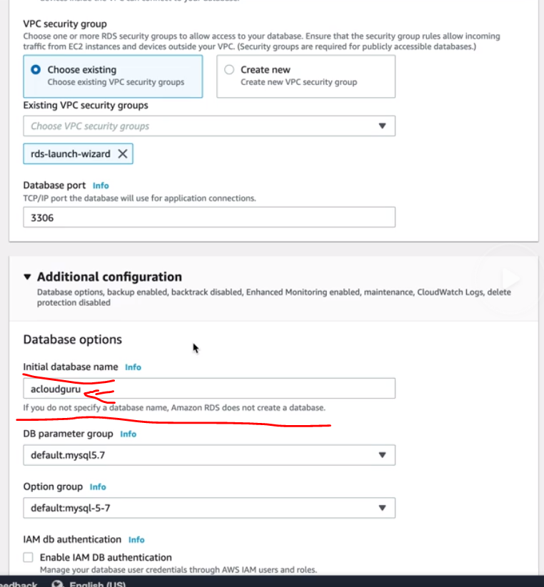 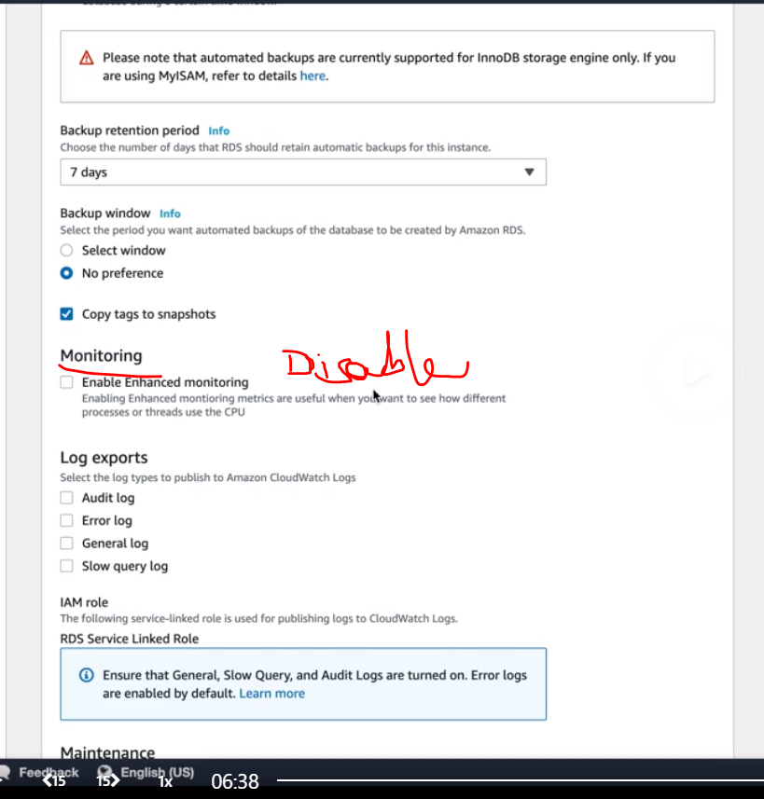

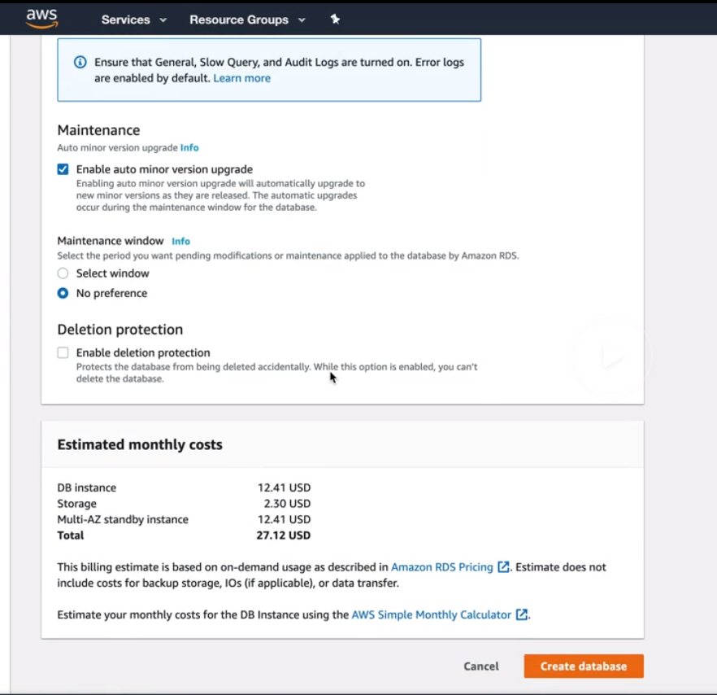 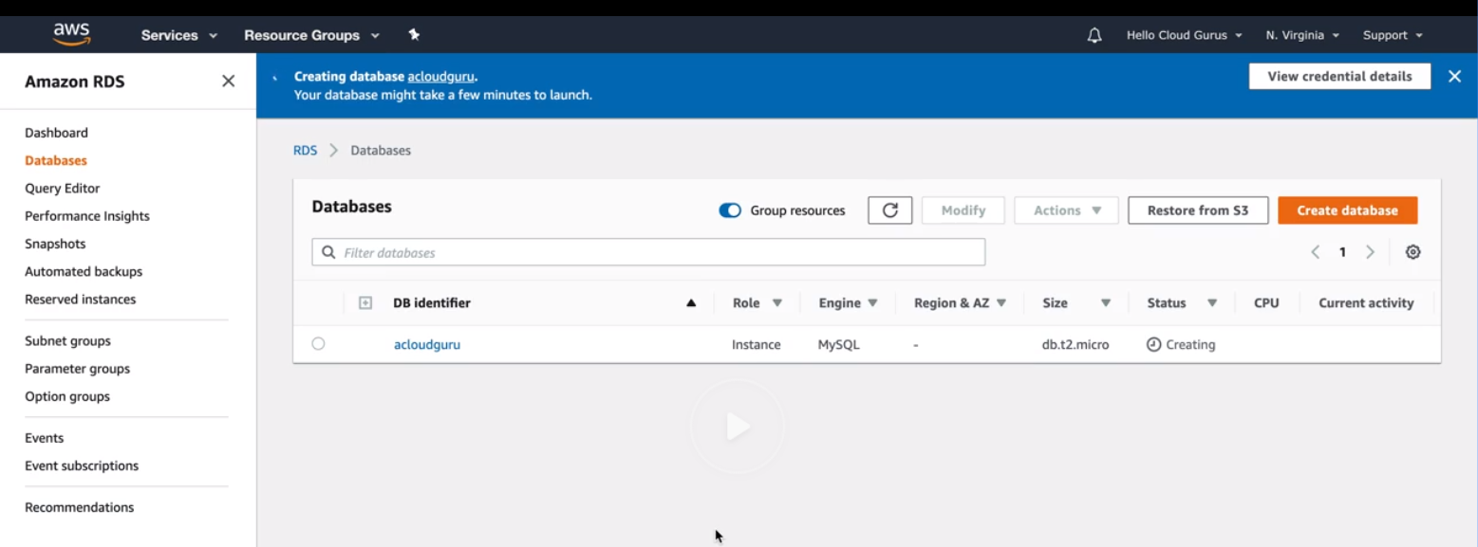

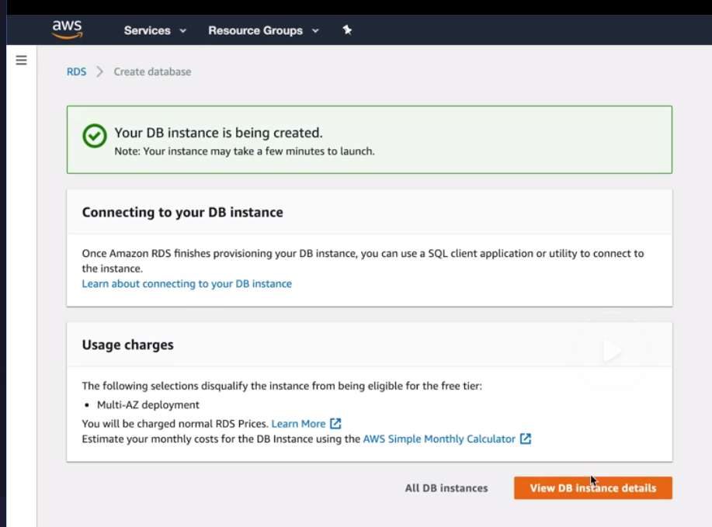

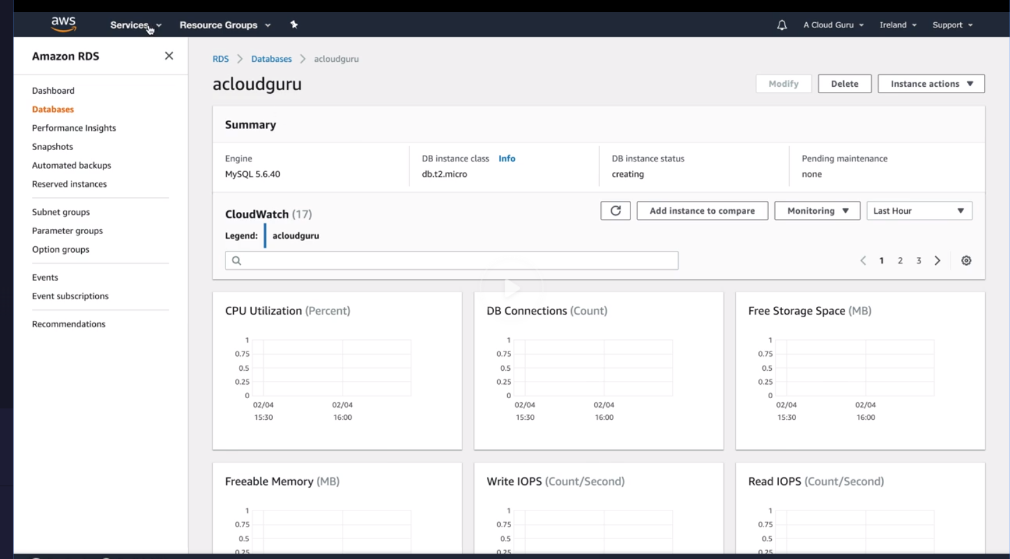

Now lets go to IAM

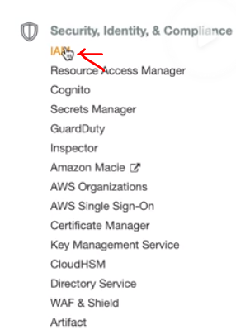

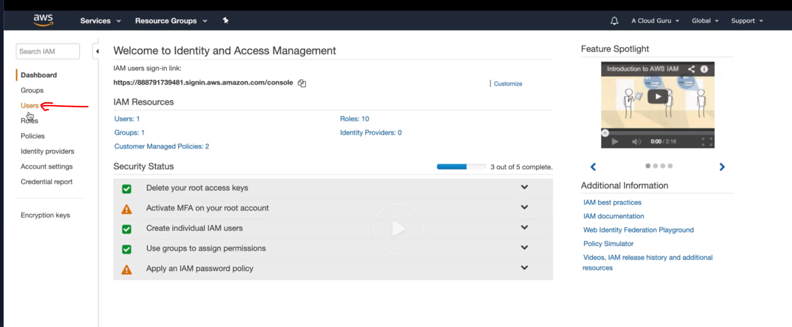 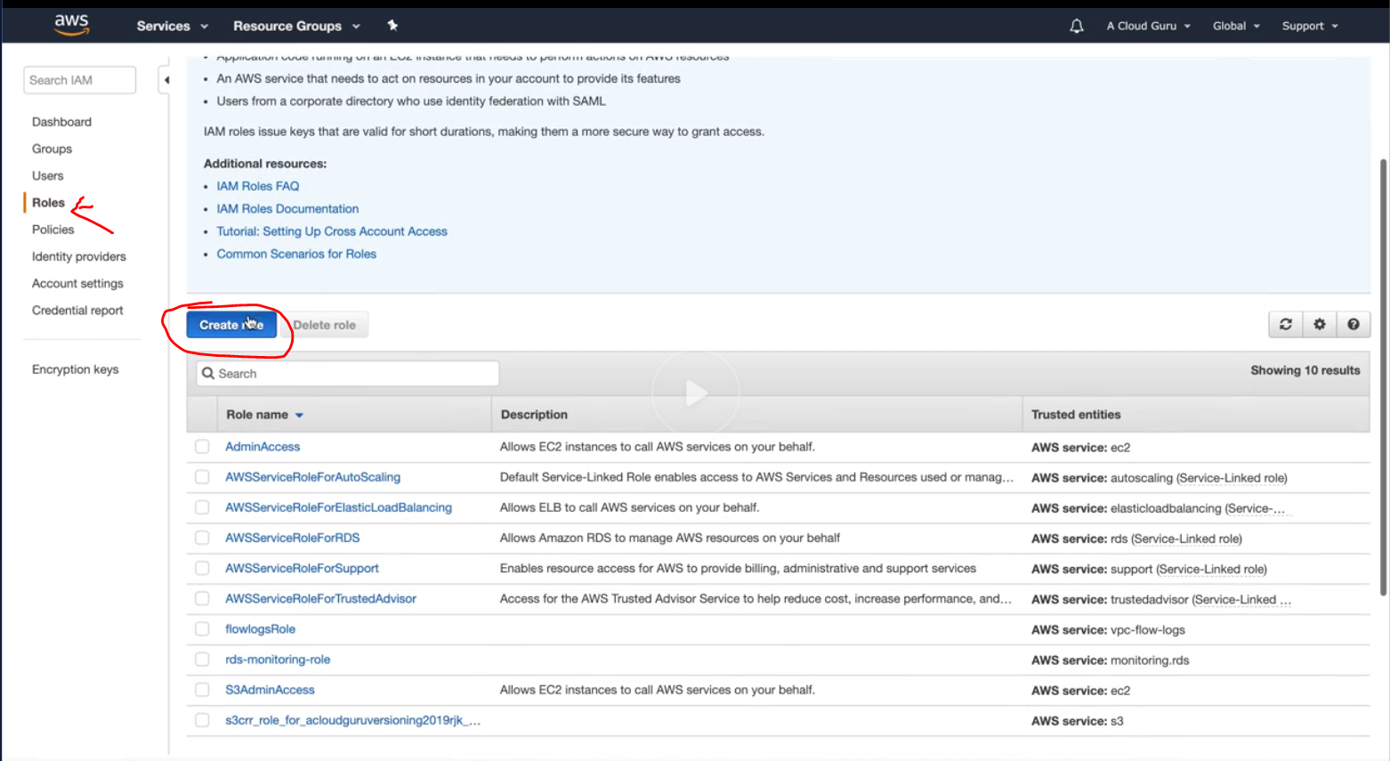 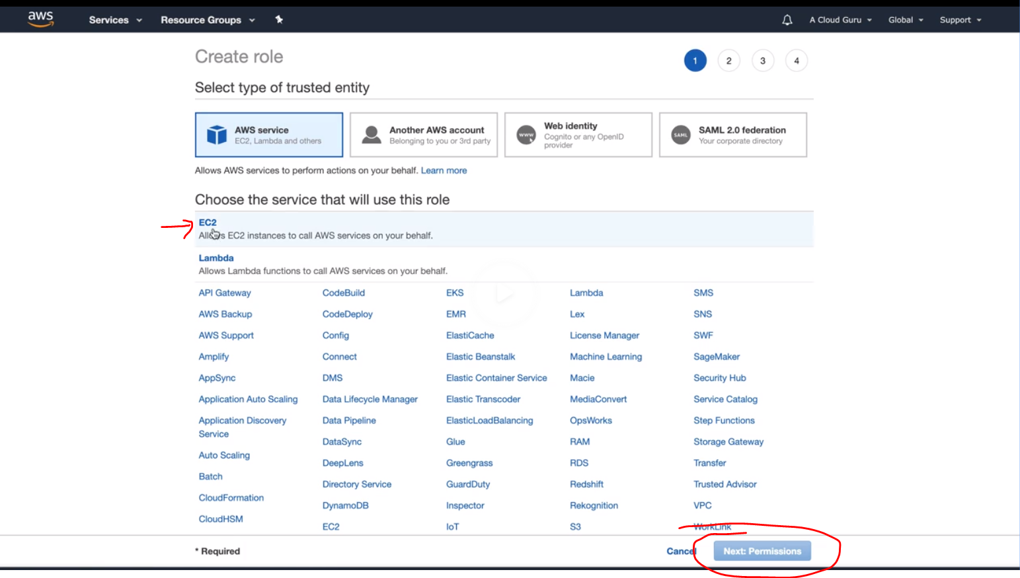

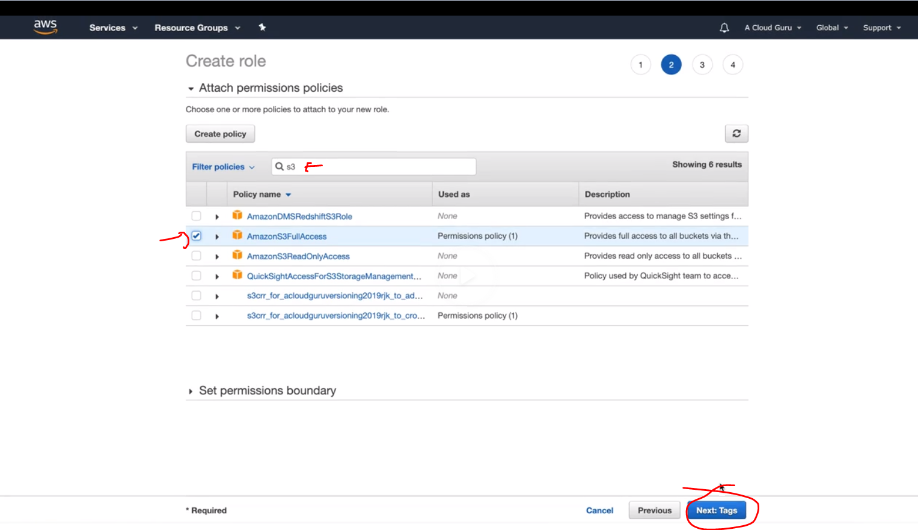 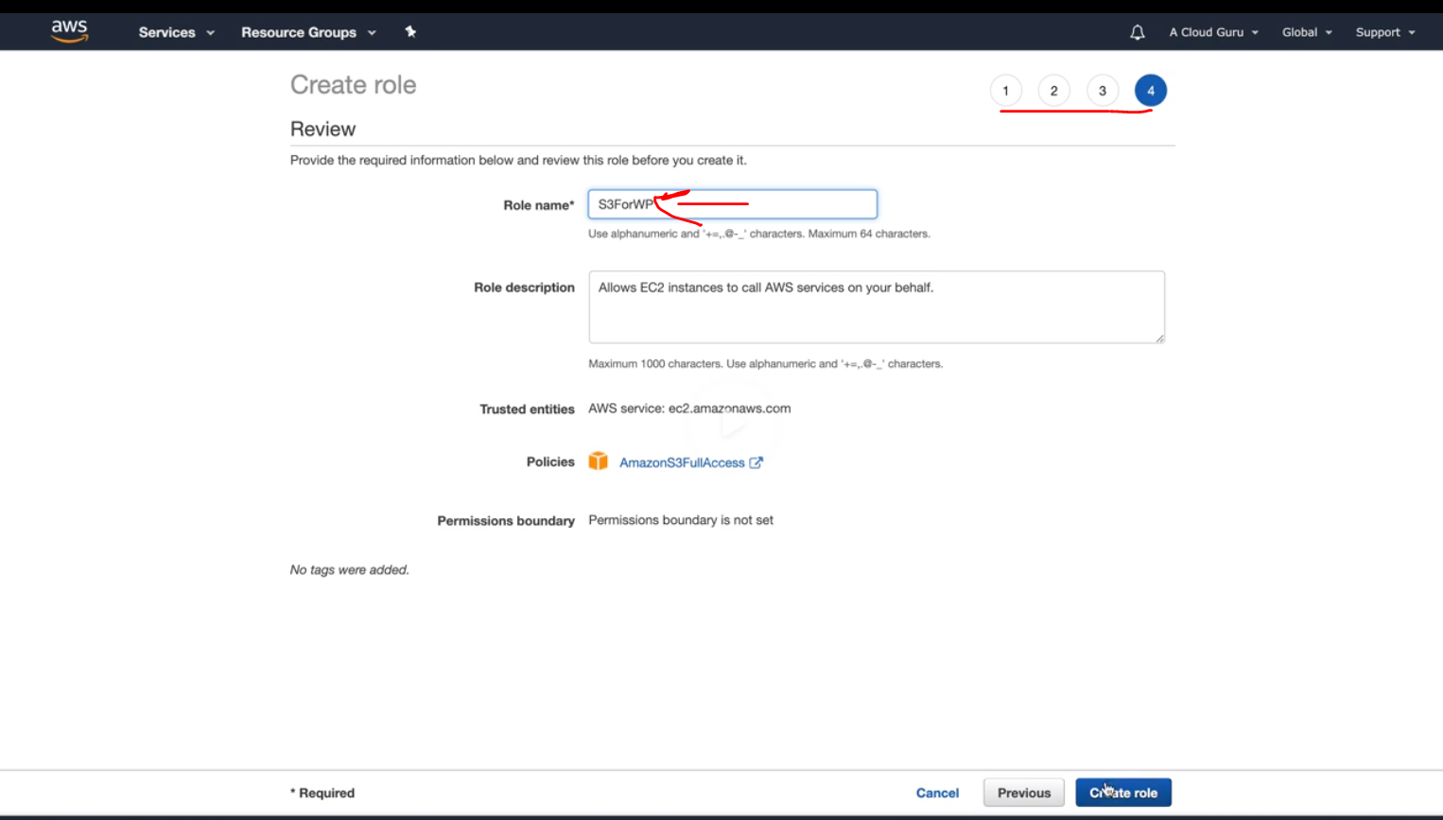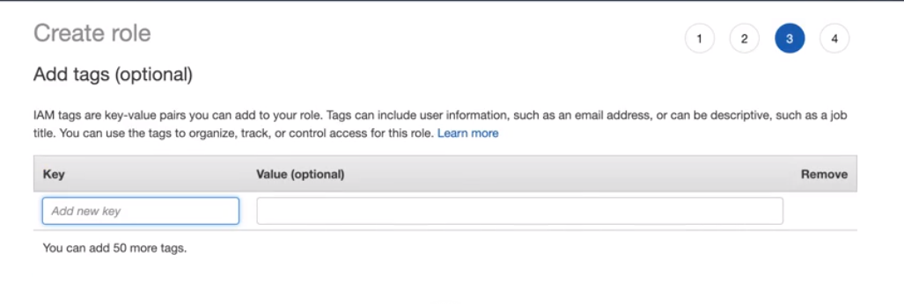 

Now create an EC2 with below bootstrap script

#!/bin/bash

yum update -y

yum install httpd php php-mysql -y

cd /var/www/html

echo "healthy" > healthy.html

wget https://wordpress.org/wordpress-5.1.1.tar.gz

tar -xzf wordpress-5.1.1.tar.gz

cp -r wordpress/* /var/www/html/

rm -rf wordpress

rm -rf wordpress-5.1.1.tar.gz

chmod -R 755 wp-content

chown -R apache:apache wp-content

wget https://s3.amazonaws.com/bucketforwordpresslab-donotdelete/htaccess.txt

mv htaccess.txt .htaccess

chkconfig httpd on

service httpd start

